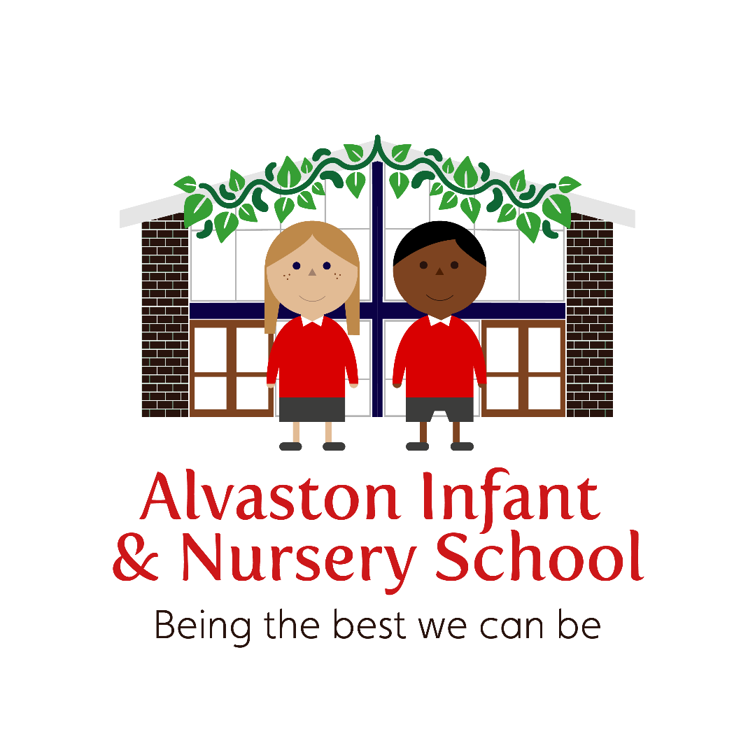

Relationships Policy

Review date | Version number | By whom | Summary of changes made | Date implemented | Date ratified
11.9.23 | 2 | SC | School values added and Alvaston Attitudes removed.  Options added to the logical consequences.  Section on behaviour plans added.  Calm starts updated with specifics to ensure clarity and consistency.  Stopping and listening – attention grabber and 4 step stopping routine added.  Lining up – adult positioning added/  Section on Behaviour plans added.  Playtime and lunchtime routines amended.  Updated Home School-agreement (without attitudes) added.  Tiers of wellbeing updated
21.09.23 | 2.1 | MA | Changed name of Reasonable Force Policy to Positive Handling

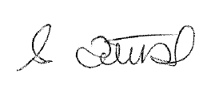
This policy has been written after consultation with staff, parents, children and all stakeholders.
Introduction
The welfare and safeguarding of our children is at the heart of all that we do and is everyone’s responsibly. This policy takes into account the guidance set out in KCSIE. Whilst this policy should be used consistently across the school, we always consider the needs of each individual child and in rare circumstances staff members may deviate from this to get ensure that every child gets the right support, at the right place, at the right time. This encompasses any protected characteristic a child may have.
Due to the excellent relationships our practice is built upon, we pride ourselves on getting to know children as people and as learners.
Therefore, at Alvaston Infant & Nursery School we believe that excellent relationships underpin how children and adults behave. Our inclusive ‘Relationships Pillar’ (see below) creates the foundation for a family ethos to be built. It enables each family member to ‘be the best that they can be’.
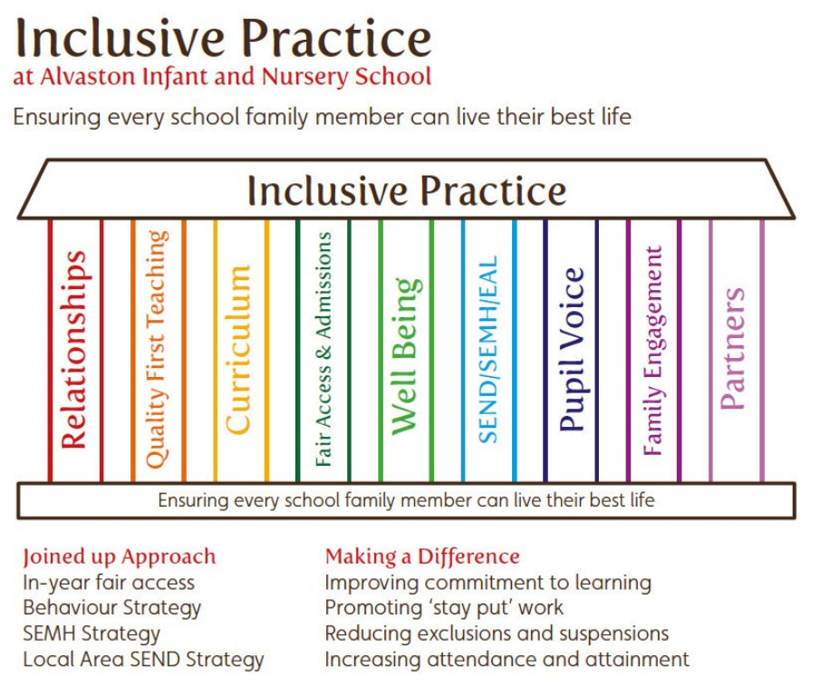

Our home school agreement sets out the promises that we make (children, staff, parents/carers) in order to be the best versions of ourselves (see appendix 1). Our culture of high standards and expectations of behaviour for all, allows us to provide a calm, safe and supportive environment, whereby each child can thrive and succeed.
Our Golden Rule of ‘Being the best that you can be’ and our school values of being ‘Ready’, ‘Respectful’ and ‘Resilient’ support all children to develop personally in a safe environment, where mistakes are made, reflected upon and learnt from. These values will help to equip our children with the lifelong skills they need to become good citizens and make a positive impact in society.

Standards
All children are expected to ‘be the best that they can be’ and display behaviour and attitudes in line with our school values. Children will be taught about rules and why they need them, which ultimately links to keeping children safe.
They will:
- Stop, listen and respond to adult instructions.
- Walk inside the school building.
- Work on their personalised targets.
- Follow their class promises.
All staff are expected to ‘be the best that they can be’ and display behaviour and attitudes in line with the school values and staff code of conduct. All staff are expected to be positive role models and ‘make the weather’ for the children.
They will:
- Have the highest standards of all children in the school.
- Be warm, fair and assertive, when needed.
- Set clear routines.
- Use short precise instructions (including what is coming next, with time frames, where possible).
- Use frequent descriptive praise.
- Use the school’s positive common language (as set out below in the positive reinforcement and logical consequences).

The School Leadership Team are expected to be highly visible, to routinely engage with all family members to ensure that the behaviour standards and culture of the school are set and maintained and that each family member feels safe and supported.
School leaders will ensure that all new staff are inducted into the behaviour culture of the school by the Behaviour Lead, or a member of the Senior Leadership Team, on or before their first day, so that they understand our school rules and routines and they know how they will support all school family members. Any training or coaching required will be provided. Early Career Teachers will be supported through the Early Career Framework and regular discussions on behaviour will occur with the Early Career Teacher Lead.
Positive reinforcement
All staff will ‘catch the children in’ rather than ‘catching them out’. Staff will respond by ‘Praising in Public’ or ‘Praising in Private’ using their knowledge of the child. Praise will be given through;
- Non-verbal gestures and positive body language e.g. thumbs up. These gestures will be explained and worked upon with the children so that they understand what they mean.
- Verbal feedback. All verbal praise given will be specific. E.g. Thank you, Sarah, for being ready by sitting with your legs crossed, instead of ‘good sitting’. Thank you, Molly, for being respectful by looking at me when I am talking, rather than ‘good listening’.
- Proud Postcard messages home. This specific praise will be shared with the child, who will be later shown the postcard, before it is handed to a family member at home time.
At the request of parents, who were consulted before this policy was written (whereby 100% of parents felt stickers had a place in education), stickers will be given, on occasion, to reward our school values. Headteacher stickers and awards may also be given to children for exceptional efforts.
In addition to this immediate praise, there will be a ‘Spot On’ celebration assembly once a week. Two certificates will be given out per class to:
Target child – a child who has worked on their individual target or an Improved child – a child who has shown great improvement with something.
Always child – a child who always does the ‘right thing’.
All certificates will specify why a child has been chosen for the award e.g. Tracy is always respectful by listening to the adults and looking after the resources in class.
Each staff member will endeavour to ‘make the extraordinary out of the ordinary’ with the power of praise and positive reinforcement. They will model the behaviours that they want to see.
Logical Consequences
Our excellent relationships enable preventative measures to be put into place so that behavioural issues are kept to a minimum. These preventative measures are always our first approach to our behaviour management and aim to be ‘non shaming’ and non-confrontational.
For any low level behaviour that does occur the following logical consequences will be applied, in private, where possible:
- A look/gesture/body language will be used by an adult to covey that a behaviour is not desired.
- Ask the child by name if they are alright, followed by an instruction of the behaviour wanted e.g. Sarah, are you alright? Arms crossed and hands to yourself, thank you.
Or
Positive redirection – Chris, bottom, chair, thank you.
Or
Let’s work over here.
- A choice to be given: Sarah, keep your hands to yourself safely or sit on your own, you choose. Repeat, Sarah, hands to self or sit on your own, you choose.
- The child to be escorted to the safe space or time out space, if the undesirable behaviour continues.
- In extreme circumstances, children may be escorted to another area or place in the school. This must be formally recorded on CPOMS – Child Protection Online Manager System.
This list is not exhaustive but examples of low level behaviours are: talking when they should be listening, not responding to an instruction, snatching resources of others, breaking class promises, running inside, not sitting in the expected way, pushing and jostling in the line and shouting at others. The low level behaviours occur when the children are not adhering to the school values and the Golden Rule of ‘being the best you can be’. For example: Taking all the playdough for yourself means that you are not being a Respectful friend.
All staff will take personal responsibility to apply logical consequences to low level behaviours. Children will not be passed on for other, more senior members of staff to deal with. Staff will be supported in this approach by their Team Leader, Year Group Lead, Behaviour Lead and Senior Leadership Team, as appropriate.
If an individual child is persistently displaying low level behaviours in class, this will be recorded on CPOMS and a discussion will take place between the child, parent/carer, class teacher and a member of the Senior Leadership Team, if appropriate.
More Serious Behavioural Incidents
Should more serious, aggressive or physical incidents occur amongst children (such as: kicking, hitting, spitting, swearing or destroying), all staff will use our own, bespoke, restorative justice approach, once the child(ren) are calm. Our common school language, which is discussed in staff training, and emotional coaching will be applied to ensure consistency e.g. I can see that you are angry… when you are calm we will talk about what has happened. This restorative approach will result in an agreement on the way forward from the incident. This may include:
- A signed or verbal apology
- Pictures or letters of apology
- A time out
- A privilege being removed
In all cases, we will not enter into the children’s chaos but will invite them into our calm.
Physical and Verbal Incidents To Staff
If a child is so dysregulated that they lash out, either physically or verbally, towards a member of staff, the child will be supported by another member of staff who will deploy calming techniques. In these instances, staff members must complete a verbal and aggressive incidents form, which will be submitted to the local authority as well as recording this on CPOMS and verbally passing this on to the Designated Safeguarding Lead. Parents/carers must be notified of this incident as soon as practically possible and in all instances, the class teacher should consider if a child needs to be on a bespoke behaviour plan (see appendix) in order to safeguard both the child and staff members. Should there be multiple incidents of this nature, involving the same child, the senior leaders will talk through a risk assessment and will update staff on any outcomes.
Positive Handling (known as reasonable force)
There may be circumstances when it is appropriate for staff to use positive handling to safeguard children. The term ‘reasonable force’ covers the broad range of actions used by staff that involve a degree of physical contact to restrain children. ‘Reasonable’ in these circumstances means ‘using no more force than is needed’.
Members of staff have the power to use reasonable force to prevent pupils committing an offence, injuring themselves or others, or damaging property and to maintain good order and discipline at the school or among pupils. 26
Staff will consider the risks carefully and recognise any specific vulnerabilities of the pupil, including SEND, mental health needs or medical conditions. If a child is being directed to an area of learning e.g. being led by their hand or underneath their arms to a certain area of the classroom or playground, this will not need to be recorded. However, if reasonable force has been used as a result of a child being dysregulated, this must be recorded on CPOMS and the Designated Safeguarding Lead must be informed in the form of a conversation. Please also see Positive Handling Policy.

Racist Behaviours
Racism in school will never be tolerated and through our bespoke curriculum, we aim to educate children and families that this behaviour is wrong and unacceptable. All racists incidents will be logged on CPOMS and the Headteacher will work with the child who has been racially abused and their family members to move forward from the incident. This will always involve educating individuals and holding restorative conversations, where appropriate. The Headteacher will also have a separate log of all racist incidents, documenting the facts and the actions taken.
Persistent Behaviours
During weekly planning, preparation and assessment meetings, class teachers will look for patterns and trends in behaviours, in order to put support in place for any children who is may need it. This support may lead to a referral to the Talk and Sort Lead (who supports children with regulation and their feelings and emotions). These children will be closely monitored and the staff will work with parents to look behind these behaviours in order to secure the best support and outcomes for them. This will also need to be logged on CPOMS so that the Designated Safeguarding Lead is aware.
Behaviour Plans
It may be necessary for some children to have individual behaviour plans (see appendix 2) that outline reasonable adjustments to this policy that are needed in order for all children to be able to succeed and to be the best that they can be. The behaviour plan will provide clear steps in order to keep the child, their peers and the adults safe in school and to be able to give the child the best chance to be ‘ready’, ‘respectful’ and ‘resilient’. Individual behaviour logs will run alongside these plans and will tally specific incidents of behaviour e.g. spitting, meltdowns, biting etc in order to track behaviour patterns and target the specific support that is needed. These logs will be uploaded on to CPOMS at the end of each week as well as daily logging on CPOMS for serious aggressive and physical incidents.
Searching, Screening and Confiscation
As an Infant & Nursery School, all that children are required to bring into school is; suitable clothing, a water bottle, packed lunch, if required, their reading book and diary, their library book and where appropriate spare clothes and toileting items. Children are asked NOT to bring any other items into school, such as toys or trading cards. Transitional objects may be used as appropriate with agreement from the class teacher. All electronic devices and any medication that has not been handed through the proper procedures are banned. In the rare event a child brings an inappropriate item into school, a staff member has the right to confiscate this and will hand it to the parent at the earliest possible time.

Routines
In order for all children to thrive there needs to be clear and consistent routines across the school. Here is a summary of our key daily routines:
- Calm starts
School doors will open at 8.45am – 9.00am to allow children to be greeted at the door by a staff member and enter school calmly. Morning activities that promote calmness and positive wellbeing will be ready to access. A minimum of two calm/mindfulness activities will be on offer. The other activities will be practical tasks linking to prior learning that the children will enjoy. It’s the children’s choice to which activity they do. There will however, be one ‘must do’ job each week that is low demand and not new learning that the children must complete. No catch- up work is to be undertaken during calm starts. Breakfast bagels, fruit and drinks will be provided. The designated adult in the classroom, will be expected to ensure that the children are engaged in a meaningful activity, as soon as it is practically possible. This adult will be available within the provision to listen to any children’s worries.

- Stopping and listening
Staff at Alvaston Infant and Nursery School recognise that teaching is an art and want to ensure that they can use their creative approaches and personalised strategies. However, we recoginise the importance of having a common stopping technique. Therefore, every class in the school will know that when an adult says, “Being the best that,” the children say, “We can be!” This motto will be used as an ‘Attention Grabber’ in order to stop the children as a whole group/class.
(In addition, teachers can use their own ‘Attention Grabber’, such as a tambourine, so long as their class are familiar and respond to the school’s agreed ‘Attention Grabber’. Where behaviour of children has been highlighted as a concern, Senior Leaders reserve the right to prescribe the school’s attention grabber alone).
The attention grabber will be used as both a warning that stopping time is approaching and for children to stop what they are doing and move onto the next thing. Timers such as 3 spot timers and Alexa’s etc will be used as a quality first teaching approach to allow the children time to process that they will be expected to ‘stop’ and ‘change’ activity.
Adults will then specify how to stop and listen with verbal instructions alongside non- verbal cues:
Everyone stop
Voices off
Equipment down
Eyes on me

- Lining up
There will be times, where children are expected to line up in order to ensure that they are safely travelling from one place to another. Children will line up on their class spots at the end of lunchtime. Teachers are able to use their discretion as to whether there needs to be a line, or not during other times in the school day. Adults that are leading children in lines must be aware of their positioning and will either walk backwards or undertake crab walking to ensure that they can see each child in the line.

- Signalling the end of lunchtime and playtime
It is the expectation that every child and adult will stop when they hear a whistle or a bell, no matter if it is for them or not.
- Playtime
As all staff are now expected to form positive relationships with their children during play, it is at the class teacher’s discretion when their class goes to play on the playground. This will be decided at a natural stopping point in learning or if they feel their children need a break for their wellbeing. As this time is not prescribed, they may be on the playground alone or with one, or more, classes. All staff members will signal the end of playtime in the same way so that there is a consistent approach across the school. This will take place as below:
- Blow the whistle. Give verbal instruction with visual cues: “Everyone stop, voices off.”
“Playtime has finished for ‘everyone/year group/class’, please walk with voices off and arms by side to your lines/classroom.”
NB. Children who need it will be given a warning that playtime will be ending, before the whistle goes.
- Children to be collected/ directed to enter the classroom with their voices off and to have a quick drink. Count down from 3 to 0 in order for the children to get to their places. Staff to ensure that this is time effective.
Adults to think carefully about their positioning as they walking and giving instructions for the children to re-enter the classrooms. E.g. crab/ backwards walking and ‘ten to two’.
The staff member who blew the whistle will wait to ensure that all equipment is away and that no child is left on the playground alone. They will ensure all doors are closed so that the school is secure.
Children are not to re-enter classrooms during playtime.

- Lunchtime
All staff will signal the end of lunchtime in the same way so that there is a consistent approach across the school. This will take place as below:
- The adult in ‘Zone 4’ will blow the whistle 3 minutes before playtime ends. Give verbal instruction with visual cues:
Everyone stop, voices off. It’s nearly the end of playtime (for everyone/year group) start putting your equipment away now please. Mini leaders please help with this.
- A teacher who is collecting at 1pm/ 1.15pm will blow the whistle and give verbal instruction with visual cues:
“Everyone stop, voices off. Playtime has finished (for everyone/year group). Please walk with your voices off and arms by side to your lines.
- Children to be collected by their teacher and directed to enter the classroom with their voices off ready for rest and reflect.
- Children will take part in Rest & Reflect, allowing drinks as part of this and toileting where it is needed. Adults to ensure that this is time effective.
Children are not to re -enter their classrooms at lunchtime. All clothing items needed for outside must be taken with them to the dining hall.
In the Early Years, the playtime routines will be used to stop all outdoor learning. Children will be expected to filter into their classrooms in the same manner, forming a line outside the door, if needed.

- Assembly
Children will be expected to enter assembly with their voices off and hands by their sides. Music / mindfulness activities will be ready for when the children enter, with a staff member modelling the expectations of behaviour at the front. Children be expected to put their hands up to answer a question unless invited for a group answer and this will be done through a non-verbal gesture of the teacher stretching their arms out with their palms facing up.
- End of assembly
The staff member leading the assembly will mark the end of the assembly by saying:
“It’s the end of assembly, everyone be ready.”
Children show readiness by sitting with their legs crossed and arms folded, their voices off and their eyes on the teacher leading.
The staff member will then signal which class to stand by using different representations of number or class animal. A staff representative from each class will be expected to collect their child from the hall at 9:30am and will reinforce the desired behaviours of ‘voices off’ and ‘arms by your side’ on the way out.
- Calming strategies
Rest and reflect time and the use of breathing techniques to promote mindfulness and positive wellbeing are part of our daily timetable. These techniques help the children to learn how to regulate their emotions and behaviours. All children have access to ‘calm area’ which promotes the five ways to wellbeing and the different aspects of the ‘Smilers’; Stay connected, Move, Interest, Look, Eat well, Rest and Support. These self- help strategies support the children to make connections, talk about their emotions and solve problems. This feeds into our restorative justice and emotion coaching approaches.
The right support, in the right place, at the right time
As part of our inclusive ‘Wellbeing Pillar’, there is a tiered approach to meet individual children’s needs in order for each child to be able to live their best life. Our Mental Health and Wellbeing Pathway document (see appendix 3) sets out our provision under the three following tiers:
Tier 1- Universal Provision
Tier 2- Targeted Support ~ Non-urgent pathway
Tier 3 - Specialised Support ~ Non-urgent pathway
It is the school’s discretion to deviate from the steps set out in this policy in order to meet individual children’s needs in the varying tiers. Verbal individual agreements will be discussed in collaboration with the child (where possible), parent and a member of the Senior Leadership Team.
Reasonable adjustments will be made for children with special educational needs and disabilities as required in line with the law and our graduated response.
Schools have duties under the Equality Act 2010 to take such steps as reasonable to avoid any substantial disadvantage to a disabled pupil caused by the school’s policies or practises;16
Under the Children and Families Act 2014, relevant settings have a duty to use their best endeavours’ to meet the needs of those with SEND;17 and
If a pupil has an Education, Health and Care plan, the provision set out in that plan must be secured and the school must cooperate with the local authority and other bodies. 18
Preventative measures will be set out for children as appropriate taking into account specific circumstances and requirements of the child.

Exclusions

The Designated Safeguarding Lead will complete a termly At Risk Register, which will document any child who may be at risk of exclusion both now and in the future. At Alvaston Infant and Nursery School under no circumstance will we exclude children for punishment. However, exclusions may need to take place for a child to have some time away from school in order for a safety plan to be put into place. In all circumstances, the Governing Body and the Local Authority will be informed and will be involved in the process. This will always be discussed with the child’s family, who will have an input into the planning and next steps to be taken, including the reintegration process. This process will take account of the Department for Education’s specific guidance on suspensions and exclusions. See exclusions policy.

Child – on- child abuse
All staff are aware that children can abuse other children (this is often referred to as child-on –child abuse). All staff will report any concerns on this to the designated safeguarding lead (or a deputy in her absence) and log any incidents on the Child Protection Online Management System (CPOMS). They will specify what the nature of the child on child abuse is e.g. sexualised.
All staff understand the importance of challenging inappropriate behaviours that are abusive in nature. Staff understand that downplaying certain behaviours can lead to a culture of unacceptable behaviours and an unsafe environment that may lead to a cycle of normalising abusive behaviours.
Child-on – child abuse is most likely to include, but may not be limited to:
- Bullying (including cyberbullying, prejudice-based and discriminatory bullying)
- Abuse in intimate personal relationships between children (sometimes known as ‘teenage relationship abuse’)
- Physical abuse such as hitting, kicking, shaking, biting, hair pulling, or otherwise causing physical harm (this may include an online element which facilities, threatens and/or encourages physical abuse)
- Sexual violence,6 such as rape, assault by penetration and sexual assault; (this may include an online element which facilitates, threatens and /or encourages sexual violence)
- Sexual harassment,7 such as sexual comments, remarks, jokes and online sexual harassment, which may be standalone or part of a broader pattern of abuse
- Causing someone to engage in sexual activity without consent, such as forcing someone to strip, touch themselves sexually, or to engage in sexual activity with a third party.
- Consensual and non-consensual sharing of nude and semi-nude images and/or videos 8 (also known as sexting or youth produced sexual imagery.
- Upskirting, 9 which typically involves taking a picture under a person’s clothing without their permission, with the intention of viewing their genitals or buttocks to obtain sexual gratification, or cause the victim humiliation, distress, or alarm and
- Initiation/hazing type violence and rituals (this could include activities involving harassment, abuse or humiliation used as a way of initiating a person into a group may also include an online element).
Should there be a persistent or serious case of child on child abuse, the school will carry out a risk assessment in order to support all children and to mitigate any further abuse. This may involve restorative conversations, where and if appropriate.

Bullying - Introduction
Our nine pillars of inclusivity form the foundations for our preventive measures for behavioural incidents, with excellent relationships and reciprocal respect being at the heart of everything that we do.
We take bullying seriously and we do not tolerate any bullying behaviour. Pupils and parents/carers should be assured that they will be supported when bullying is reported, whilst it is investigated and be informed of the outcomes and actions taken. The school will seek ways to counter the effects of any bullying that may occur within school or in the local community.

Our school rule, of being the best that you can be, our school values, of being ‘ready’, ‘respectful’, and ‘resilient’, our bespoke PSHCE curriculum, including the ‘Rights of the Child’, and our Gold SMSC provision are all in place to give the children the tools that they need to recognise and talk about healthy and unhealthy relationships, kind and unkind behaviour including bullying. This provision, alongside regular pupil voice through subject monitoring, class and school council meetings and pupil questionnaires ensure that children are regularly consulted about behaviour. Open conversations about bullying, regularly take place, leading to increased confidence in children being able to identify and report bullying incidents as well as knowing who to ask and how to ask for help. Staff model and reinforce positive behaviour expectations and support children in being respectful of everyone’s feelings, not only those of their ‘special friends’.

What is Bullying?
Bullying is behaviour by an individual or group, usually repeated over time, that hurts another individual or group either physically, emotionally and can have an impact on their mental health and wellbeing. Bullying can be short term or take place over long periods of time. Bulling will be classed as child-on-child abuse and will also be logged as a separate bullying incident.
Emotional | Being unfriendly, excluding, tormenting, spreading hurtful rumours, being forced to do things against own will, taking belongings
Physical | Pushing, kicking, hitting, punching or any use of violence
Racial | Racial taunts, graffiti, gestures
Sexual | Unwanted physical contact or sexually abusive comments
Homophobic | Because of, or focusing on the issue of sexuality
Direct or Indirect Verbal | Name-­‐calling, sarcasm, spreading rumours, teasing, mocking, swearing
Cyber | Offensive text messaging, e-­‐mailing, postings on social media and sending degrading or offensive images

Bullying can take place in the classroom, playground, corridors, toilets, on the journey to and from school, on a trip, online, through text messages and the distribution of images via a mobile phone.

Staff must remain vigilant about bullying and approach it in the same way as any other category of Child Abuse; that is, do not wait to be told before you raise concerns or deal directly with the matter. Some children may not be aware that they are being bullied. Staff must not dismiss any claims of bullying without having conducted a full and thorough investigation into the claim.

Staff should be able to identify children who may be vulnerable and who could fall victim to bullying as well as those who may be likely to demonstrate bullying behaviour.
Why is it Important to Respond to Bullying?
We believe that no one deserves to be bullied. Bullying has the potential to damage a person and everybody has the right to be treated with respect. Children who are bullying need support to learn different ways of behaving and to be able to make positive and healthy relationships with others.
Signs and Symptoms of Bullying
Children may indicate by signs or behaviour that they are being bullied. Adults should be aware of these possible signs and that they should investigate if a child:

- Does not want to go to school
- Change in their mental health; i.e. they become withdrawn, anxious, or lacking in confidence
- Self-­‐harms or refers to themselves in a negative fashion
- Cries themselves to sleep at night or has nightmares
- Becomes argumentative or physical with their siblings or parents
- Feels ill in the morning
- Begins to under achieve in school work
- Has possessions which are damaged or " go missing"
- Asks for money or starts stealing money (to pay bully) or other items
- Has unexplained cuts or bruises
- Becomes aggressive, disruptive or unreasonable
- Is bullying other children
- Stops eating or over eats
- Is frightened to say what's wrong
- Gives improbable excuses for any of the above

Procedures for Dealing with Bullying
All known/reported incidences of bullying will be investigated by a member of staff as follows:
  - A child/adult reports a bullying incident to a member of staff in school.
  - The member of staff will reassure the child/adult that they have done the right thing.
  - The member of staff will record details of the incident on the Child Protection Online Manager (CPOMS), tagging child on child abuse and bullying.
  - All children and witnesses concerned will be asked about what has happened.
  - Details of the incident will be passed on to a member of the Senior Leadership Team for further investigation if required. The class teacher will also be informed.
  - Parents/carers of both the bullied child and the bully will be contacted within two working days of the incident and informed of school’s investigations that have been/will be undertaken.
  - Parents/carers will be informed of initial outcomes of any investigations within 3 working days and of any consequences resulting from the bullying behaviour.
  - The bully will be asked to sincerely apologise and if possible, the pupils will be reconciled through our own restorative approach.
  - Actions will be taken to help the bully change his/her behaviour. We expect parents/carers to support us in doing this.
  - In some cases, outside agencies may be requested to support the school or family in dealing with bullying e.g. Police, Counsellor, Social Services.
  - Children will be monitored to ensure that repeated bullying does not take place.

What Children Should Do If They Are Being Bullied?
If a child feels that they are being bullied, there are several procedures that they are encouraged to follow:
- Tell a teacher or adult, who they feel they can trust and if it happens again, tell someone again.
- When they talk to an adult be clear about what happened -­‐ when, what, where and who was involved.
- Tell a parent or adult at home whom they feel they can trust.
- Discuss it as part of PSHCE time in school.
- Write it down and give it to an adult they trust at home or at school.
- Children can ring Childline and follow the advice given (0800 1111) if they feel they have done the above and the bullying continues.

Recording of Bullying Incidents
It is a legal requirement for schools to record all incidents of bullying. To meet this requirement, we keep a record of bullying incidents on CPOMS and report this to governors.
- When an incident of bullying has taken place, staff must record it on the Child Protection Online Manager (CPOMS) under the heading Behaviour and the sub-heading Bullying. Staff members will also tag child on child abuse
- In the case of racist bullying, this will be reported to the Headteacher or SLT member in their absence, to be dealt with. All racist incidents will be logged separately and the DSL will have a log of these incidents with the key actions taken.
- Bullying incidents will be discussed with all relevant staff and parents of the children involved, in order that everyone can be vigilant and that bullying can be prevented from happening in the future.
- Incidents of bullying will be raised with the Governing Body through the governor meetings or as necessary if a serious incident occurs.

Advice to Parents
- Listen to your children if they raise a concern about being bullied at school.
- Advise your child to tell a trusted adult in school or contact the class teacher yourself to share what you have learnt.
- The bullying behaviour will be investigated.

A member of the SLT will contact all parents of the children involved and inform them what our school is doing to resolve the bullying concern.

Please DO NOT take action yourself by:
- Attempting to sort the problem out yourself by speaking to the child who you think may be doing the bullying or by speaking to their parents or contacting them via other means (i.e. text message).
- Encouraging your child to be a ‘bully’ back.
These actions will only make the problem much harder to solve and can complicate matters further.
Please rest assured we will do all we can to enable all children to feel safe and to support them to be respectful and kind.

All stakeholders have been consulted to form this relationships policy.
This policy will be reviewed in September 2024 or sooner if needed.

Appendix 1 – Home School Agreement

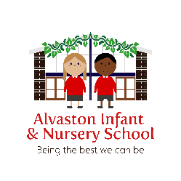
At Alvaston Infant and Nursery School, we value our parents and carers as equal partners and aim to set out the expectations for both the school and families so that we can ensure there is mutual respect and understanding between us all.
Our children will agree to follow the Golden Rule ‘Being The Best That You Can Be.’ They will also agree to follow our values of being ‘Ready’ ‘Respectful’ and ‘Resilient’.
Parents agree to: | School staff will agree to:
- Be positive members of our school family and support your child with their learning journey – attending parents’ evenings and supporting with reading, spellings and targets  - Support and adhere to the school rule: ‘Being the Best We Can Be, the school’s ‘Attitudes for Learning’ and the behaviour/relationship policy  - Contribute any new ideas via the online suggestion box or in person, which will help us improve the school  - Support the school’s values (respect, resilience, teamwork, reflection, creativity, independence) and ensure positive relationships are maintained  - Ensure children are brought into school, on time and are collected on time, so learning is not disrupted  - Send children into school in the correct uniform and bring the correct equipment, as often as possible  - Talk to staff calmly and respectfully  - Listen to concerns that the school raises in a calm manner, responding respectfully and fairly  - Use appropriate language in school and its grounds  - Raise concerns calmly, either by requesting an appointment with the Class Teacher, Assistant Headteacher or Headteacher by making contact Class Dojo, email, telephone or in person  - Communicate any change in arrangements in advance so that staff can make preparations e.g. early collections, appointments, change of person collecting, if needed  - Agree/decline permission for your child to attend school events by the deadline specified and ensure payments are made via the school systems  - Return all relevant paperwork e.g. consent forms for photographs and collection of children in good time  - Inform the school of any medical changes e.g. allergies as soon as practicably possible  - Drive around the school community with care, respect and caution | - Welcome all parents and fully involve them in all areas of school life – recognising them as equal partners  - Treasure every child, making them feel safe, reminding them that they belong and helping them to be happy, thriving individuals who become positive members of society  - Celebrate every child, sharing successes with families  - Seek the child’s voice and involve them in decision making, where appropriate  - See parents as the experts for their child and be willing to learn from them, take advice and accept their views in order for decisions to be made in the best interests of their child  - Do their utmost to offer all children the very best provision and education, this includes teaching them about how they can keep themselves safe, form positive relationships and live a healthy life (mind and body)  - Be open and honest and willing to learn from mistakes, should they occur  - Make reasonable adjustments to practice and policy in order to ensure an inclusive school, where everyone can thrive  - Respond to children’s needs, putting additional support in place when it is needed  - Ensure that families are given a voice that will always be heard  - Welcome new ideas and be willing to make changes, where appropriate  - Communicate events and dates effectively with parents by ensuring letters are sent home and reminders are given  - Be professional and respectful at all times  - Communicate well with parents, informing them of what their child has been learning and addressing any areas of concern or need in a timely manner – e.g. not waiting until parents’ evening to have conversations  - Arrange appointments for parents, should they wish to raise a concern  - Provide parents with opportunities to network with each other  - Help educate parents regarding to help their child, if needed  - Promise they will try to be the best that they can be, daily in order to positively impact the lives of children, their families and their colleagues

Appendix 2 – Behaviour Plan and Log

Behaviour Plan
Pupil name: Class: Year Group:
Date of birth:  Date plan starts:  Date of next review: | Medical conditions/needs:  Staff working with the pupil:
Challenging behaviour  What does it look like?  How often does it happen?  How long does it last? | Targets  What are we working towards?  How do we get there?
Reasons for the behaviour  Consult parents/carers and the pupil (where appropriate) when filling out this box.  What’s going on in the pupil’s life that might be causing this behaviour?  Why might this behaviour happen?  - To get attention  - To avoid something  - To get something tangible  - To meet a sensory need | Any special educational needs (SEN) that may affect behaviour  If the pupil has SEN that affects behaviour, the SENCO should detail them here.  How does the pupil’s SEN affect their behaviour?  How could the school’s behaviour policy be adapted to meet their needs?
Strategies for maintaining positive behaviour  How do we maintain positive behaviour?  What does the pupil like?  - Phrases to use  - Rewards, motivators | Triggers and warning signs  What triggers might cause an incident?  How do we prevent an incident?  - What to look out for  - How to respond (reminders, alternative environment)
Reactive strategies  How do we diffuse the situation?  - What to do and what not to do  - Phrases to use  - Calming techniques  At what stage should another member of staff be informed? Who should this be? | Support after an incident  How do we help the pupil reflect and learn from the incident?  Is there anything that staff can learn about working with this pupil?
Likes | Dislikes
Agreement:  Parent/carer name  Parent/carer signature  Date | Staff name  Staff signature  Date
Steps taken to safeguard staff (if appropriate):
Behaviour plan evaluation and next steps:
How effective is the plan?
Record suggestions to be considered when this plan is reviewed.

To be edited for each child:

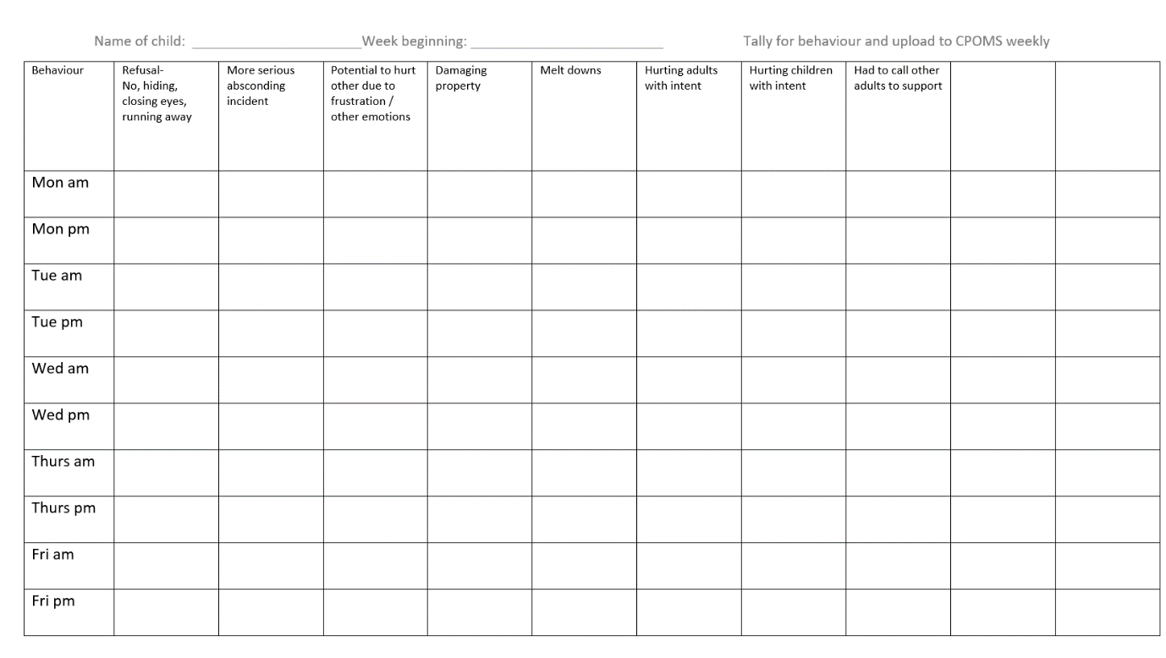

Appendix 3 – Mental Health and Wellbeing

https://alvastoninfant-my.sharepoint.com/:w:/r/personal/scarnall_alvastoni_derby_sch_uk/_layouts/15/Doc.aspx?sourcedoc=%7B0d8e7395-a5ba-4b9a-ab45-26c16d1e8e40%7D&action=edit&wdPreviousSession=2d0a6ba4-549d-616a-b9ee-a8a61960f3da

