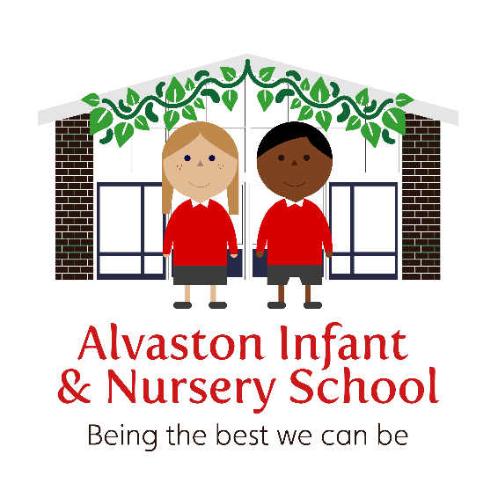

Nursery Admission Policy
September 2023

This policy has been signed / ratified by the Chair of Governors / Head Teacher.

Review date | Version number | By whom | Summary of changes made | Date implemented | Date ratified
March 2020 | 1 | CM/MA/TD | Renewing of 30 hour code, changes to 15 hour ‘top up’, packed lunch clause in 15 hr, discretion regarding start dates, removal of withdrawal after 2 or more sessions | March 2020
May 2021 | 2 | CS | Paying for additional sessions, in advance, pay for additional hours via School Money
November 2021 | 3 | CS | Adding waiting list accessible on school website.  15 hour provision can be accessed 2 long days.  Additional hours may be purchased using School Money.  Attendance criteria added and formal warning / nursery places withdrawn if attendance is poor.
September 2022 | 4 | LD | Page 2 – new nursery times amended.  Page 3 – remove additional option to purchase additional hours  Page 4 – removed ‘additional hours’ section  Page 4 – added reserve the right to hold back spaces  Page 5 – removed section about additional charges  Page 5 – amended point 3 to include funding and able to meet child’s needs | September 2022
November 2022 | 5 | CM | Page 5 – added we must meet the child before a place is offered | January 2023
November 2022 | 5 | CM | Page 6 – added that we may not be able to offer places for children with additional needs if this impacts on the other children negatively | January 2023
November 2022 | 5 | LD | Page 3 – late pick up charges added | January 2023
June 23 | 6 | LD | Page 5 – statement added to consider paid places when we are full, for rising 2s children. | July 23

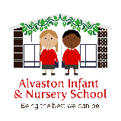

Alvaston Infant and Nursery School

Nursery Admissions Policy

Purpose of this Policy
The purpose of this policy is to inform parents about the fair allocation of school nursery places and to provide clear information on how we prioritise children’s needs when allocating places.

Nursery places are offered in date of birth order from our waiting list. Parents/Carers can place their child’s name on our waiting list after their child’s second birthday. Our aim is to offer provision that best meets the needs of families within our community. Both of our Nurseries are teacher-led and supported by an enthusiastic and hard-working team of teaching assistants. (Please refer to the EYFS Policy for more information on this.)
Parents/carers can sign up to our waiting list using the online link on the school website.

Provision:

At Alvaston Infant and Nursery School, we can provide 26 places for 30 hour provision and up to 52 places for pupils eligible for 15 hours entitlement. The 26 and 52 places may be altered depending on unique situations (please see Offer of Nursery Places). These situations will be at the discretion of the EYFS Leads and the Headteacher.

Basic Eligibility criteria for 15 Hour Funded Places
Child must be three or four years old.

15 Hour Flexible Free Entitlement (FFE)

All children are entitled to a free place in an Early Years Educational Setting to access 15 hours (570 hours per year) of funded Nursery Education per week, over 38 weeks of the year, from the term after their third birthday.

Parents/carers cannot access 15 hours of funded Nursery provision from more than one provider at the same time.

Our session times for children accessing 15 hours of Nursery provision are:
Morning Sessions 8.50 – 11.50am
Afternoon Sessions 12.20 – 3.20pm
Start of the week (2 ½ days) Monday and Tuesday (all day – 8:50am -3:00pm) and Wednesday (8.50am – 11.30am)
End of the week (2 ½ days) Wednesday (12.20pm – 3:00pm) and Thursday and Friday (all day – 8:50am-3:00pm)
2 long days 7.30 – 3pm or 9.00 – 4.30pm

In order to provide flexibility for families, parents may choose for their child to attend 5 morning sessions or 5 afternoon sessions. Alternatively, they may choose for their child to attend for 2 and a half days (see session times above). Please note, the Wednesday ‘half days’ are shortened, as this equates to their 15 hour allocation, over the 2 ½ days. Any child who takes up the 2 ½ day offer will need to be sent to Nursery with their own healthy packed lunch. Nursery children will visit the main school in order to have their lunch.
In addition to this, additional hours can be purchased in advance, using School Money, if we have availability in Nursery. Parents requiring wraparound care are able to access both our Breakfast and After-School Clubs at an additional charge.

Lateness charges
If parents are unable to collect their child from Nursery the following will apply:
The first occasion, this will be overlooked.
The second occasion will be charged £5 per 15 minutes that are late. If a parent is 5 minutes late, this are still required to pay the full £5 fee and the school reserve the right to restrict access to the club until the payments are made.

Eligibility Criteria for 30 Hour Places
- Parents must meet the government criteria for eligibility;
- Child must be three or four years old;
- Both parents must be working, or the sole parent is working in a lone parent family;
- Each parent earns, on average, a weekly minimum equivalent to 16 hours at National Minimum Wage, or National Living Wage and each parent must have an annual income of less than £100,000.

30 Hours Free Extended Education Funding (FEEE)

From September 2017, the government extended the free childcare offer for eligible three and four year olds to 30 hours per week (1140 hours per year) for 38 weeks of the year. Parents can check if they qualify and apply for the extended entitlement at www.childcarechoices.gov.uk.

Parents will be given an eligibility code which must be submitted to the school for verification the term before the child will access their extended entitlement.

This code will need renewing every 3 months.

Parents/Carers can access 30 hours of funded Nursery provision from more than one provider at the same time, however, they must access 15 hours minimum at our Nursery to secure their place here. If you wish to split your 30 hour provision, please contact the school office, prior to your child starting in the Nursery.

Our Nursery session times for children accessing 30 hours of Nursery provision can be taken between 7.30am – 5.30pm during term-time. Parents will need to indicate the hours which they require when enrolling their child for Nursery. The school will endeavour to accommodate family’s individual needs. However, the most popular times for attending are 9-3pm, 5 days per week. For parents wishing to extend this provision, the school also offers ‘wrap around’ care. Please see our Breakfast and After School Club Policy.

If your child will attend the Nursery between 11:30am and 12pm, they will be required to bring a healthy packed lunch. Lunchtimes take place in the main school hall, where the infant children eat their lunch. They are supervised by qualified Early Years Teaching Assistants, to ensure there is a ratio of at least 1 adult to 8 children.

Eligible birth dates (applies to 15 and 30 hour places):

A child born between: | Will be eligible for a free place from:
1st April and 31 August (inclusive) | 1st September (or from the start of the Autumn term following their 3rd birthday)
1st September and 31st December (inclusive) | 1st January (or from the start of the Spring term following their 3rd birthday if spaces are available, if not then from the Autumn term following 3rd birthday)
1st January and 31st March (inclusive) | 1st April (or the start of the Summer term following their 3rd birthday if spaces are available, if not then from Autumn following their 3rd birthday)
Based on families’ individual circumstances, the Early Years Leads and the Headteacher may use their discretion in order to enable children to start prior to their eligible start date. This will incur additional fees, should your request be granted. Please see ‘Charges’ and ‘Additional Sessions’ section below.

Attendance

Children’s attendance will be looked at weekly by the Nursery Lead. If a child’s attendance drops below 91% then a formal letter will be sent home explaining that if their child’s attendance doesn’t improve above 96% then they are at risk of having their child’s nursery place removed. If, at the end of that half term, the child’s attendance hasn’t improved then the Nursery Lead or Head Teacher will contact the parent, and the nursery place will be withdrawn. They will then have to put their child’s name back onto the Nursery waiting list and wait for spaces to become available.
We know that Nursery is not compulsory but due to extensive waiting lists, we feel this is a fair process.
If pupils fail to attend for a period exceeding 20 days, then their place may be removed, (depending upon the specific circumstances) and they will have to return to the waiting list until a place becomes available.

Offer of Nursery places

Nursery staff or a member of the office team will need to verify your child’s original birth certificate. All parents must complete an admissions form documenting contact numbers, medical needs etc. Both of the above will need to be completed prior to the child starting in our setting. If a parent/carer fails to complete the appropriate documentation, your child will not be admitted. This is a safeguarding requirement. Ideally, we would hope that your child is toilet trained, before starting Nursery. Please see our intimate care policy for further information.

Prior to being offered a place, we ask that we meet your child in person. If a parent/carer fails to meet with us, your child will not be admitted.

Offers of a Nursery place are usually made in the term prior to children being eligible to start. The majority of children will usually start attending Nursery in September each year, with an ongoing admission of children as they become three years old. At the discretion of the Head Teacher we may be able to offer a place as soon as your child turns 3 and this may incur additional fees. Every Nursery application will be looked at individually and places offered according to our Admission Policy. If we are unable to offer a child a Nursery place, their name can remain on our waiting list, when a place becomes available throughout the year, we offer places in date of birth order. We reserve the right to hold back spaces until the following January, to ensure we best meet the needs of all our children.

Our school is fully inclusive and our policies promote equality of opportunity for all children. We feel it is our duty to offer any disabled pupil or pupil with individual needs, a place at our Nursery, providing that we can meet their needs and that supporting agencies feel that it is an appropriate placement. However, if we feel that the admission of a new pupil with additional needs would impact negatively on the education and/or wellbeing of those pupils who already have a nursery place, then we may not be able to offer a place.

Admission Criteria

Places are offered in order of priority according to our admissions criteria below:
1. Children who are ‘Looked after’ in accordance with section 22 of the Children Act 1989.
2. Children who are on the Child Protection Register and live in the normal catchment area served by the school.
3. Children who are the subject of a statutory assessment of special educational needs and live in the normal catchment area served by the school subject, provided funding is in place and the school provision can meet the needs of the child.
4. Children who are both living in the normal catchment area of the school and have siblings of compulsory school age attending the school at the time of admission. Priority will be given to those children living closest to the school.
5. Children from the normal catchment area of the school. Priority will be given to those children living closest to the school.
6. Children from the wider area of the school, who have siblings attending school at the time of admission. Priority will be given to those children living closest to the school.
7. Children from the wider area of the school. Priority will be given to those children living closest to the school.
8. In exceptional circumstances, where places have been allocated in nursery from the eligible waiting list, we will consider the next children on the waiting list (rising 2s) to join our provision. This is conditional to supporting working families and will incur a cost to the parent/carer of £30 per day, until funding can be claimed the following term.

Admission to School

Please note that by attending the Nursery provision at Alvaston Infant and Nursery School, it does not guarantee your child a place in Reception. Parents should apply through Derby City central admissions.

This policy has been drawn up with the agreement of the Governing Body of Alvaston Infant and Nursery School and will be reviewed in September 2023 by the Governing Body.

Related Policies:
Safeguarding Policy
SEND Policy
Attendance Policy
Equality policy
Charging & Remissions Policy
Equality Policy
Complaints Policy
Debt Policy
EYFS Policy
Breakfast and After School Club Policy
Intimate Care Policy

