

**Handwriting and Presentation Policy**

**This policy has been signed by the Headteacher and Chair of Governors. A copy of this policy is stored in the School Office.**

|  |  |  |  |  |  |
| --- | --- | --- | --- | --- | --- |
| **Review date** | **Version number** | **By whom** | **Summary of changes made** | **Date implemented** | **Date ratified** |
|  |  |  |  |  |  |
|  |  |  |  |  |  |
|  |  |  |  |  |  |

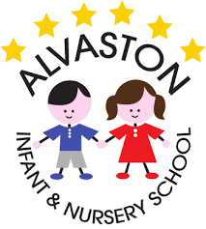Alvaston Infant and Nursery School

Handwriting and Presentation Policy:

October 2019

**Aims:**

At Alvaston Infant and Nursery School, we always encourage to ‘be the best they can be’ by taking pride in the work that they produce. In order to achieve this, all teaching and support staff hold the highest expectations of all children in relation to presentation and handwriting so that writing is neat, legible and consistent in order to communicate children’s thoughts effectively. By the end of Key Stage 1, we aim to ensure that all children:

* Form all letters and digits correctly
* Write letters at an appropriate size in relation to each other
* Sit letters on the line

We aim for most children, by the end of year 2, to be using a neat, cursive script.

**Teaching of Handwriting:**

All children develop at different stages and our teaching reflects this. We adapt to individual children’s developmental needs. Initial teaching of handwriting takes a multi-sensory approach to develop the necessary fine and gross motor skills. Children explore letters and digits within the environment. Once the child has reached a stage where the teacher deems they are ready for formal writing, they will begin handwriting lessons, which will follow the Nelson Thornes Handwriting Scheme. This progressive scheme initially teaches individual letters and digit formation through the blue stage and when the child has mastered this, they will progress on to the red and yellow stages where they will be taught how to join letters. Explicit teaching takes place 2/3 times per week for 15-minute sessions which are differentiated to meet the needs of all children. All teachers will support the children with formation of letters during this time and provide them with feedback.

**Assessment:**

Teachers regularly provide feedback to children on their handwriting and if they notice that a child needs more support, this will be provided. Children will be encouraged to self-assess their handwriting by crossing through any letters which do not look correct and by using a star or a smiley face to show the letters they are proud of. This will also be carried out by teaching and support staff. If a child forms a letter incorrectly in their writing, they will be asked to practise writing this letter after the teacher has modelled it to them. They will be supported and guided through this to improve their muscle memory. Handwriting will be assessed against the expectations set out in the Development Matters Framework for Early Years and the National Curriculum for Key Stage 1.

**Early Years Foundation Stage:**

Throughout the Early Years, children will focus on developing their pencil grip, discovering a preference for a dominant hand and develop their fine and gross motor skills needed for pencil control. They will begin to write letters, most of which should be formed correctly by the end of Reception.

**Year One:**

By the end of year one, it is expected that children will have developed appropriate posture for writing so that they sit correctly at their tables and hold their pencil correctly. They should be taught to form letters (lower case and capital) and digits in the correct direction and start and end in the right place. The vast majority of children will have mastered letter and digit formation by the end of Year One and it is rare that children miss-form these in their writing.

**Year Two:**

At the end of Key Stage 1, children’s handwriting is formally assessed as part of the Teacher Assessment Framework. Children should:

* Form letters by starting and finishing in the correct place.
* Ensure letters are an appropriate size in relation to one another.
* Spacing reflects the size of the letters.

Some children will also begin to use some of the diagonal and horizontal strokes needed to join letters and understand which letters are best left alone.

**Progression in Handwriting:**

Step 1: Motor Skill Development and Mark Making

Physical development is paramount in the early stages of writing. Children will begin by developing fine and gross motor skills through exploring a range of whole-body movements using both sides of their bodies by creating shapes and letters in the sky, performing ‘dough disco’ activities, drawing on each other’s backs, using sticks with ribbons attached to the ends and making shapes with their bodies in response to music. After this, children will then mark make by being given the opportunity to explore a variety of writing implements and paper types in order to make marks and recognise patterns needed to make shapes and letters. This is an important step as it helps the child to develop their hand-eye co-ordination and it provides them with an opportunity to express themselves in non-verbal forms. When a child can draw the shapes below, it is considered that they have developed the skills needed to write all letters and numbers. Therefore, they can progress onto the next process.

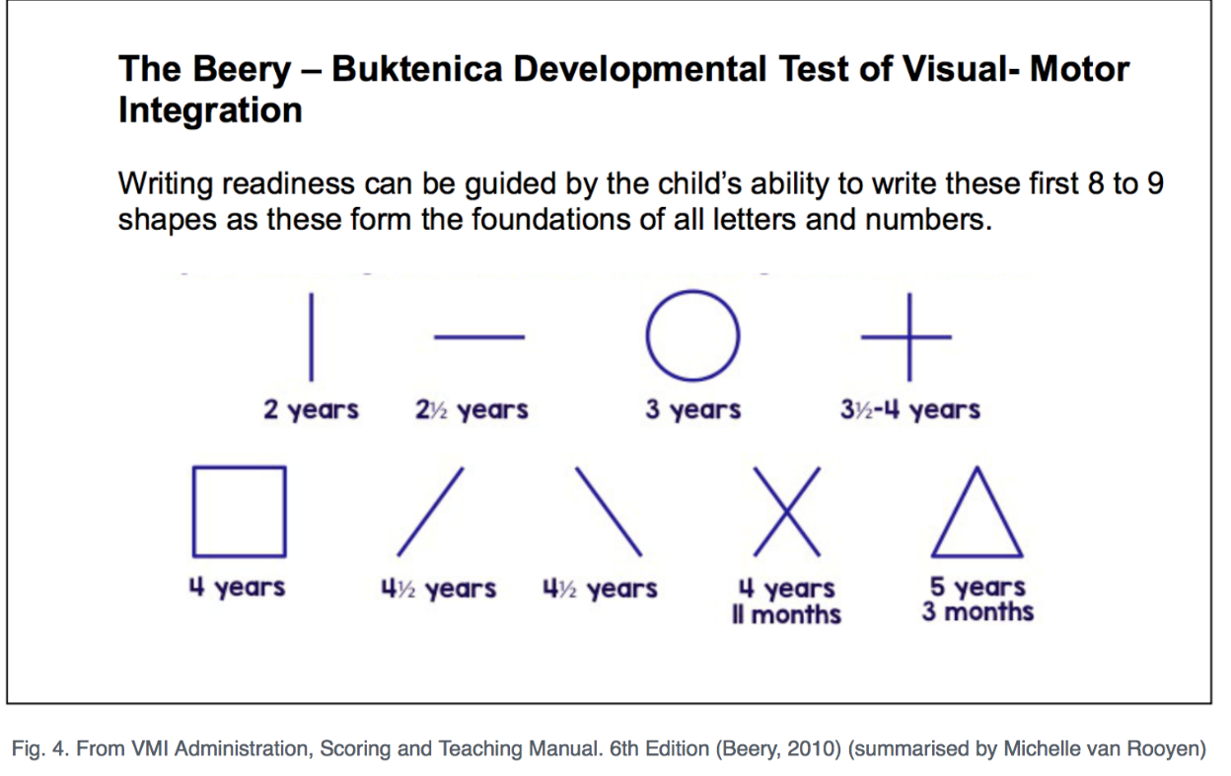

Step 2: Posture and Positioning

Research suggest that if children exhibit good writing habits from an early age, it will encourage neater handwriting and it will prevent any discomfort forming which may lead to reluctancy when writing. Therefore, we insist that all pupils display the following posture and positioning guidelines (see below).

Posture Guidelines:

* Feet flat on the floor
* Knees at a right angle
* Sit on the chair so the hips are at a 90-degree angle with the back support
* Sit approximately a fist-distance away from the table
* Ensure the surface is clean, smooth and uncluttered

If necessary, classroom furniture may need to be changed so that children of different heights can be accommodated and can sit comfortably at their table. Reasonable adjustments will be made to accommodate any child with a physical disability.

Paper should be tilted to allow the writer to follow the naturally angled path in relation to their body.



Right handers should have the paper angled down to the left.

Left handers should have the right-hand side angled down.

The non-writing hand should be used to hold the paper still.

Step 3: Pencil Grip

As children begin to develop their muscles in their hand, they will change the way that they hold their pencil as they mature and begin to develop stronger fine and gross motor skills. When the child becomes more comfortable with writing, the way they hold their pencil will change. When a child is ready to begin formal writing, they should be encouraged to use the Tripod Grasp where the pencil is held between the thumb and first finger with the middle finger being placed behind, to support. By holding the pencil in this way, the child has greater control over the letters they are producing so that are more likely to form these correctly. See below for progression of pencil grip.

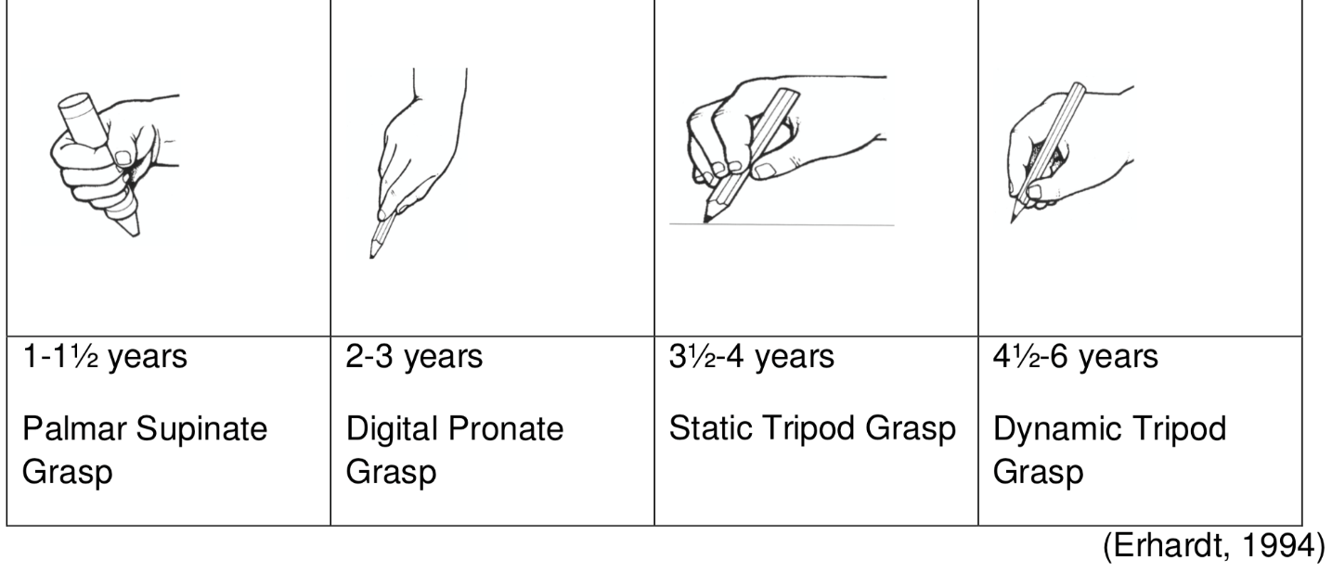

Step 4: Letter Exploration

Initially, the children should be exploring individual letters through gross and fine motor skill activities. They begin by watching letters being formed and learning associated rhymes. Children will use a variety of different writing implements and other materials to gain a ‘feel’ for their writing. Here, children will begin to use spaces to separate words, which should be approximately the size of two letter ‘O’s. As children begin to use spacing, a lolly pop stick may help ensure that spaces remain consistent, however, as the children progress, a coffee stirrer would be a more appropriate size. Children will use X spaced lines whilst they are becoming familiar with the letter formation in their handwriting books.

Step 5: Individual Letter Mastery

As a school, we follow the Nelson Handwriting scheme which encourages the children to master the formation of each letter by learning letters in similar families, which will require similar strokes to produce them. As children begin to form their letters correctly, they will also begin to focus on sitting their letters and words correctly on the line. During handwriting sessions, children will begin to use tramlined paper, which will allow the children to understand where the letters sit on the line and will allow them to consider their size, in relation to each other. This also compliments the Nelson Handwriting scheme and provides the foundations needed for when the children begin joining their writing.

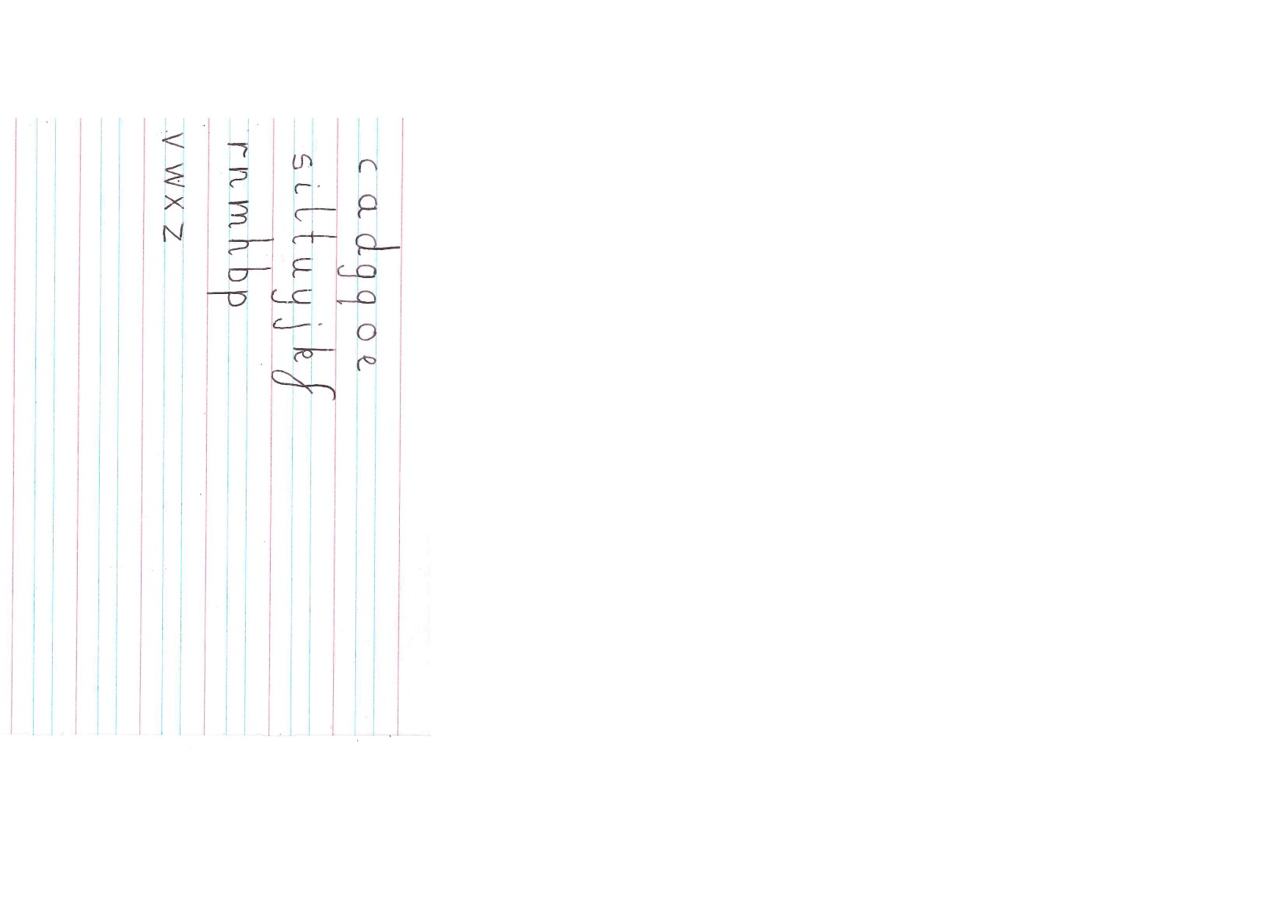

Formation of letters at Alvaston Infant and Nursery School

Step 6: Joining letters

Once a child can form all their letters correctly and the teacher is certain of this, they are then ready to learn how to join certain letters. Children will begin joining letters which share the same joining method. This will be done through families of joins. The children will also learn the letters that we do not join as this allows the children to have a ‘break’. These letters are:

**g j q x y z**

**Handwriting Books and Line Width:**

|  |  |
| --- | --- |
| **Year Group** | **Writing book line width** |
| Reception | 15mm |
| Year 1 | 12mm |
| Year 2 | 8mm |

When practising digit formation, children will use their maths jotters.

**Left-handed Writers:**

Teachers will model writing appropriately for both left and right handed children so that they are all able to see how to correctly form each letter. Also, teachers will take into consideration any adaptations that may need to be made to make the child comfortable which may include:

* Seating a left-handed child to the left of a right handed child so that their arms do not collide when writing.
* Ensuring that paper is tilted in the correct direction.
* Checking to see if the pencil is being held correctly, to avoid smudging when writing.
* Ensuring the pencil is not held too close to the point, so that the child can clearly see what they are writing.

**Children with Special Educational Needs:**

At Alvaston Infant and Nursery School, we understand that children all progress at different stages and that a one-size-fits-all approach to handwriting is not in the best interests of the children. Instead, we ensure that the teaching of handwriting reflects a child’s readiness to write, in accordance with their developmental needs. If a teacher notices that a child is having persistent difficult with their writing, they will be able to discuss this with the Special Education Needs Co-ordinator who will be able to provide appropriate advice and contact any other external agencies who may be required. The computer program ‘Clicker 7’ may also be used to support children with physical impairments.

**Children who join the school later:**

When a child joins our school and already has an established handwriting style that differs from the school’s model, they may continue to use this with support from teaching staff. These children will follow the same progression model as other children to ensure they continue to make progress with their handwriting.