Alvaston Infant and Nursery School 2022-2023

Remote Education Provision: Information for Parents and Carers
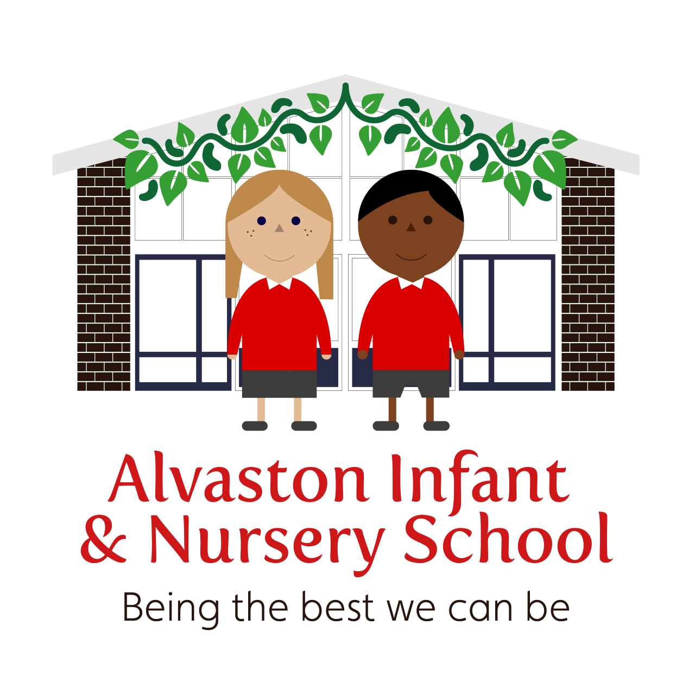

Remote Education Provision: Information for Parents
This information is intended to provide clarity and transparency to pupils and parents or carers about what to expect from remote education where national or local restrictions require entire cohorts (or bubbles) to remain at home.
For details of what to expect where individual pupils are self-isolating, please see the final section of this page.

The remote curriculum: what is taught to pupils at home
A pupil’s first day or two of being educated remotely might look different from the approach which follows while we take all necessary actions to prepare for a longer period of remote teaching.

What should my child expect from immediate remote education in the first day or two of pupils being sent home?
In the event of national or local restrictions requiring whole classes or ‘bubbles’ of children to remain at home, there will be instructions on each child’s Class Dojo Page to inform parents and carers of the details for each child’s remote education for that day (or for the following day if the announcement is made the previous evening). This will give the teaching staff sufficient time to put detailed planning in place for the remote education which will follow. The children might need access to their Purple Mash account and their Bug Club reading account to enable them to access appropriate resources. Log ins for these systems will be sent to you within the first 24 hours of children accessing remote education. If you have not accessed this information, after this time, they can send a message, via Dojo, or via email, to their child’s Class Teacher. Parents and carers might be signposted to the school’s website by the child’s class teacher to pre-prepared videos and teaching resources to support the children’s learning at home. For families who do not have access to Class Dojo, an email will be sent to all parents/carers documenting the approach that will be taken. Should families not have internet access, a phone call will be made to the parent or carer within 24 hours.
- The Remote Learning Lead, Miss Allen, will be available via telephone, to deal with any issues regarding technology resources and help to support families without access to the internet or devices to access remote education digitally. This might include providing laptops and chargers to identified families with any usage or loan agreements necessary to help safeguard school property.
- The school will continue to maintain an up-to-date record of which pupils and families do not have sufficient devices or appropriate internet access so it can support those families appropriately as quickly as possible. If families are unable to access resources digitally during the first day or two of remote learning, the school will endeavor to provide paper-based resources, which will be made available for collection from school. In extreme circumstances, resources may be delivered to support the families that require it but this will be at the discretion of the Remote Learning Lead.

By the second day of Remote Education commencing, Microsoft Teams will be activated and pupils will be able to log on using their user name and password. If parents have any difficulties, they can contact their child’s class teacher through the Dojo platform or via email. In the event of the class teacher being uncontactable, parents and carers can contact the Remote Learning Lead, Miss Allen.

Following the first few days of remote education, will my child be taught broadly the same curriculum as they would if they were in school?
- Our aim for our remote education is to teach the normal planned curriculum as the children would be taught in school. We recognise that this is more challenging for subjects that would normally include significant elements of practical work in the live classroom, for example sciences, music or technology. However, in these and other cases, teachers will endeavour to find creative platforms through which meaningful teaching and learning opportunities can still take place. For example, video demonstrations could be used in place of practical work in art and design or design and technology, particularly if accompanied by teacher explanation or commentary.

Remote teaching and study time each day

How long can I expect work set by the school to take my child each day?
We expect that remote education (including remote teaching and independent work) will take pupils broadly the following number of hours each day:
 | Minimum expectations
Nursery | Nursery Teachers will decide upon the most appropriate provision / support for their children, depending upon the children and their needs and this will encompass the EYFS Curriculum as much as practically possible
EYFS | 2.5 hours
Key Stage 1 | 3 hours

Accessing remote education

How will my child access any online remote education you are providing?
- Microsoft Teams
- Class Dojo
- School Website https://www.alvastoni.derby.sch.uk/
- Our school YouTube channel - https://www.youtube.com/channel/UC21_jLc2cAIO9h_9HRy-sdw

If my child does not have digital or online access at home, how will you support them to access remote education?
We recognise that some pupils may not have suitable online access at home. We take the following approaches to support those pupils to access remote education:
- The school will continue to maintain an up-to-date record of which pupils and families do not have sufficient devices or appropriate internet access so it can support those families appropriately as quickly as possible.
- The Remote Learning Lead, Miss Allen, will be available via telephone, to deal with any issues regarding technology resources and help to support families without access to the internet or devices to access remote education digitally. This might include providing laptops / tablets and chargers to identified families with any usage or loan agreements necessary to help safeguard school property or lending dongles to enable internet connection.
- As a last resort, if families are unable to access resources digitally, the school will endeavor to provide paper-based resources, which will be made available for collection from the school, or in some circumstances, these may be delivered to homes at the discretion of the Remote Learning Lead, Miss Allen.
- Class teachers will liaise with parents regarding how work can be submitted and feedback given, if they do not have online access. Telephone conversations will be agreed to provide support on wellbeing and progress with remote education.

How will my child be taught remotely?
We use a combination of the following approaches to teach pupils remotely:
- A recommended timetable of learning will be shared for the week via Class Dojo and this will consist of both recorded lessons, live teaching, live ‘check ins’ and time to complete set activities.
- Recorded teaching by class and year group teachers (e.g.videos and resources uploaded on the school website https://www.alvastoni.derby.sch.uk/ and the school Youtube Channel https://www.youtube.com/channel/UC21_jLc2cAIO9h_9HRy-sdw)
- There will be some live lessons/check ins via Microsoft Teams, whereby children will be invited to turn their cameras on and ‘connect’ with one another. This will happen at least twice per day. Children do not have to turn their cameras or microphones on, if their parents or they themselves do not want to be on screen. This is optional and these will be recorded and disposed of after 48 hours. This will enable the teacher, parent or child sufficient time to share any behaviours that may have been a concern. The Class Teacher will be responsible for deleting these videos off their device.
- Activities and worksheets set by the teachers, for completion on paper, in Teams Workbooks or to be sent via Dojo.
- Commercially available websites supporting the teaching of specific subjects or areas, including video clips or sequences.
- The Bug Club website will be made available to parents and children so children can
- continue to read books matched closely to their phonic ability easily at home. If parents do not have access to devices with internet connection, they can consult with The Remote Learning Lead, Miss Allen.

Engagement and feedback

What are your expectations for my child’s engagement and the support that we as parents and carers should provide at home?
We hope that we are able to work in partnership to provide the best possible remote learning experience. We kindly ask that you support your child with the remote learning offer that their class teacher provides. This includes:
- Ensuring your child engages with their remote learning for at least the daily minimum amount of time, as outlined in the guidance above. This might involve having a daily routine so your child is clear of the expectations for the day. Staff will be on hand to support with this as we know that this transition and change of routine may be difficult for children.
- Encouraging your child to engage with the activities asked of them and supporting them as required.
- Making contact with their class teacher if there are any queries or concerns.
- We recognise that there might be a variety of challenges, which could present themselves in these difficult circumstances, however please ensure you have an open and honest dialogue with your child’s class teacher so we can all do our best to support your child.
- Once per week, we will expect to have a phone conversation with yourself and your child regarding how they are getting on and the school will track and document any relevant conversation points, following up where necessary.

How will you check whether my child is engaging with their work and how will I be informed if there are concerns?
- Class teachers will monitor daily how each child is engaging with the remote education offer through work collection, marking work, giving feedback and through noting attendance during live lessons and check ins. Each child and their parents / carers will have a weekly telephone conversation or Teams meeting.
- Where engagement is a concern, parents and carers will be informed by their child’s class teacher and a longer telephone conversation / Teams meeting will be arranged so that strategies can be put in place and any barriers to a successful remote experience can be broken down.
- If engagement continues to be problematic, Miss Allen will be informed and a dialogue arranged between all parties concerned (Miss Allen, the class teacher, the parents / carers and the child, as appropriate). T
- Should engagement still be poor, the school may conduct home visits or may also involve or refer families to external agencies such as the Police or Social Care.

How will you assess my child’s work and progress?
Feedback can take many forms and may not always mean extensive written comments for individual children. For example, whole-class feedback or quizzes marked automatically via digital platforms are also valid and effective methods, amongst many others. Our approach to feeding back on pupil work is as follows:
- The whole school feedback and marking policy will be used, as appropriate, to feedback to pupils. This might include written feedback (e.g. purple ticks to show what the children are doing well and green for growth flowers to show the children what they need to do to improve their work or next steps).
- Due to the age of our Infant and Nursery School children, staff will have a discussion with parents or carers who have supported or supervised their children with the weekly activities.
- During the weekly telephone conversation / Teams meeting, teachers will be able to feedback verbally to both the parents / carers and the children regarding what is going well and if there are specific targets or areas of development to be supported with at home.
- Mini quizzes and mini assessment tasks will be implemented during the sequence of lessons to check pupils’ understanding and inform teaching, these records will be retained so that they can be used to inform progress and attainment scores.
- Pupils will be given the opportunity to engage with their teacher and their peer group through the Teams platform on a daily basis. This will include receiving feedback about their learning.

Additional support for pupils with particular needs

How will you work with me to help my child who needs additional support from adults at home to access remote education?
We recognise that some pupils, for example some pupils with special educational needs and disabilities (SEND), may not be able to access remote education without support from adults at home. We acknowledge the difficulties this may place on families, and we will work with parents and carers to support those pupils in the following ways:
- If pupils with special educational needs or disabilities (SEND) are not able to be in school and require remote education we appreciate that their parent and carer alongside the class teacher will know how to support them most effectively. We also know that this will differ from pupil to pupil. In all cases, we will work with our parents as equal parents in order to ensure that we are aspirational for our SEND learners and that their wellbeing is at the centre of all that we do.
- We will work collaboratively with families and put in place reasonable adjustments so that pupils with SEND can successfully access remote education. In this situation, decisions on how provision can be delivered will be informed by relevant considerations including the support families will require and types of services that the pupil can access remotely.
- Our SEND Coordinators in school, Mr Mabbutt and Mrs Darby, will work closely with the class teacher and parents / carers to put a remote education plan in place to address the needs of the child. Our aim would be to complete this plan within the first two days of remote education commencing. The SEND Coordinators will oversee and monitor the provision for these SEND children and check it is well matched to their needs and is ambitious. This may take many forms such as discussions with the class teacher and holding meetings with parents who have SEND children, if required.
- The requirement within the 2014 Children and Families Act for schools to use their best endeavours to secure the special educational provision called for by the pupils’ special educational needs remains in place.
- As an Infant School, we will work closely with the families of our younger children to ensure that they can support their children effectively at home. Through the Class Dojo, school website and Teams platform, our experienced teaching staff will ensure that appropriate activities, suitable for the home environment, are carefully planned and sequenced. Clear explanations and guidance will also be given to parents / carers to enable the youngest pupils to continue with their education remotely.
- The Designated Safeguarding Lead, Miss Allen will ensure that any family, who has ever had social worker involvement will be provided additional support. A Designated Safeguarding Lead will be in touch at least once per week and the school will do all in its power to ensure families get the right support, in the right place, at the right time.

Remote education for self-isolating pupils or pupils who cannot attend school, but are able to learn
Where individual pupils need to self-isolate or for those who are well but not able to attend, (e.g. preparing for operations) but the majority of their peer group remains in school, the remote provided will differ from the approach for whole groups. This is due to the challenges of teaching pupils both at home and in school. For example, children who may be isolating due to recovering from illness or preparing for an operation will be offered remote education for a short period of time, and the school will work with medical professionals to ensure that their return to school is built up safely. These circumstances would be extremely rare and there will be a clear time limit as to how we would enable these children to return back to attending school.

If my child is not in school because they are self-isolating, how will their remote education differ from the approaches described above?
This section refers to individual pupils who are self-isolating but are ‘well enough’ to work at home (e.g. a child with a contagious illness but ‘well’ in themselves) not ‘bubbles’ / cohorts of children. It also applies to pupils that may be unable to attend due to an exceptional circumstance, and this would be made at the discretion of the Head Teacher and in conjunction with other relevant professionals. This remote education offer is not intended for pupils who are absent from school because they are too poorly to be in school.
- After notification from the parent/carer, the class teachers will contact the parents / carers of any child who falls into this category to arrange a meeting within 48 hours. This meeting can be virtual, over the phone or in person and an action plan will be put in place in order to establish the remote learning offer. During this meeting, the class teacher, initially will signpost the adult to the Class Dojo page where there will be up-to-date explanations regarding the current phonics and mathematical learning taking place in their child’s class. Paper resources will also be provided and an arranged time will be agreed for parents to collect these, or in some circumstances, these may be delivered, if required. These paper resources will be as closely matched to the teaching and learning that is going on in the classroom as much as possible. This will enable the parents / carers to support their child in these areas. There will also be regular checkups / meetings planned in in order to review the child’s progress and to check that the offer is well matched to the child’s needs and that in encompasses the full curriculum, as well as practically possible.
- To enable the child to continue to read books matched to their phonic ability, the parent / carer can either arrange to collect further books from school, or they can access the Bug Club Reading Scheme which is an online resource. The class teacher will support them with accessing the appropriate level of reading material and issuing a login / password.
- The Class Teacher might signpost the parent / carer to further resources which are already uploaded onto the school ‘Remote Learning’ section of the school’s website. This might include pre-recorded teaching videos made by the relevant staff members.
- The class teacher and the parent / carer will decide on a mutually convenient time to discuss the progress of the child at regular intervals and will be expected to check in with the child at least every 2 days.

Online Safety Advice for Parents and Carers

How can I help to keep my child safe online?

All of our children learn about the importance of ‘staying safe’ when working online, at an age-appropriate level, and this is built into our Computing and PSHCE Curriculums, but reinforced continually during day-to-day teaching and learning. Both the Computing and PSHCE Curriculums at Alvaston Infant and Nursery School explicitly detail what the children need to know and be able to do to help keep them safe when working online.
In order to help keep our children safe when working online, we encourage all of our parents and carers to provide age-appropriate supervision for their children when they are using the internet. Amongst other things, this should include:
- Supervising children when they are on their devices
- talking to their children about not accessing age-inappropriate material on devices
- not allowing the children to talk with any strangers online
- setting up age-appropriate parental controls on digital devices
- encouraging children to take a break from the screen
Internet filters should be used to block malicious websites. These are usually free, but often need to be turned on.
The following information and resources will help to support parents and carers to keep their children safe online:
- support for parents and carers to keep children safe from online harm
- which provides extensive resources to help keep children safe online and details of specific online risks, including sexual abuse, criminal exploitation and radicalisation
- CEOP Education provides advice from the NCA on staying safe online
- Childnet offers a toolkit to support parents and carers of children of any age to start discussions about their online life, to set boundaries around online behaviour and technology use, and to find out where to get more help and support
- Internet matters provides age-specific online safety checklists, guides on how to set parental controls on a range of devices, and a host of practical tips to help children get the most out of their digital world
- London Grid for Learning (LGfL) has support for parents and carers to keep their children safe online, including tips to keep primary aged children safe online
- Keeping children safe online has support for parents and carers from the NSPCC, including guides on social media, internet connected devices and toys and online games.
- Let’s talk about it has advice for parents and carers to keep children safe from online radicalisation
- UK Safer Internet Centre has tips, advice, guides, and other resources to help keep children safe online, including parental controls offered by home internet providers and safety tools on social networks and other online services
- As set out in NHS every mind matters guidance, building positive routines are really important for children. A structured routine can give children and young people an increased feeling of safety in the context of uncertainty and it is helpful to try to maintain the same routine they would usually follow at school or college where possible.

