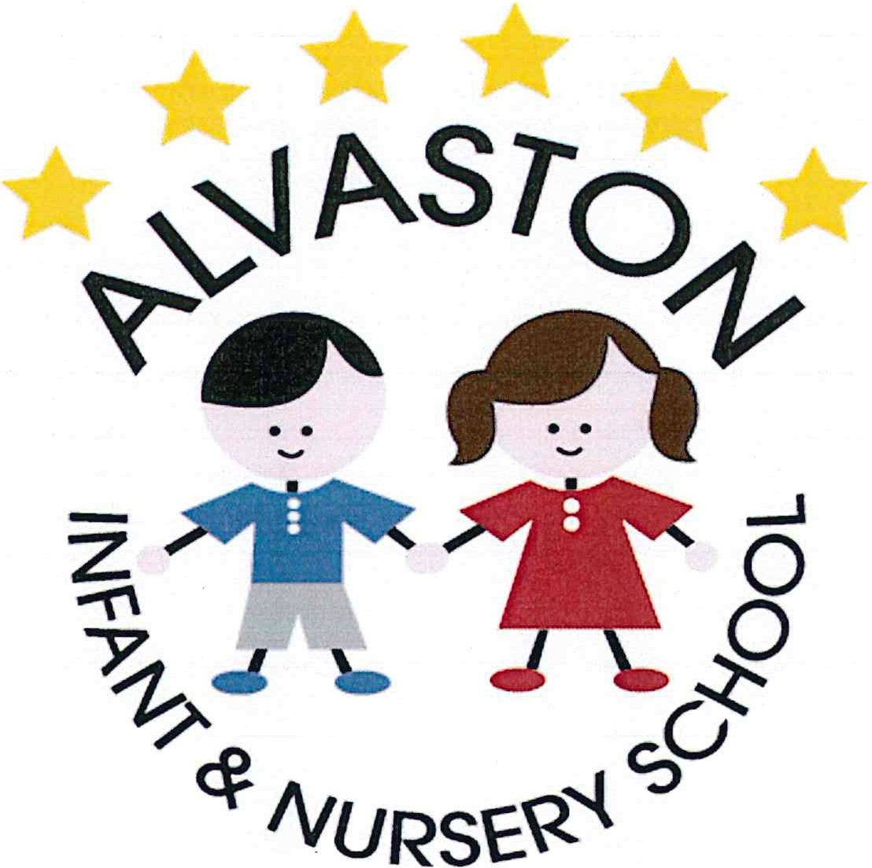

Religious Education Policy

This policy has not yet been ratified and agreed by the Chair of Governors / Headteacher.
Review date | Version number | By whom | Summary of changes made | Date implemented | Date ratified
May 2019 | 1 | TD | New changes to selections | May 2019

Alvaston Infant and Nursery School
Religious Education Policy: May 2019

Introduction:
Religious Education enables children to investigate and reflect on some of the most fundamental questions asked by people. At Alvaston Infant and Nursery School, we develop the children’s knowledge and understanding of the major world faiths. We enable children to develop a sound knowledge not only of Christianity but also of other world religions. Children reflect on what it means to have a faith and have the opportunity to develop their own spiritual knowledge and understanding. We help the children learn from religions as well as about religions so that children appreciate and respect others.

This policy aims to:
- Outline the legal requirements.
- Inform all stakeholders of the approaches used to teach Religious Education (RE) at Alvaston Infant and Nursery School.

The Importance of RE at Alvaston Infant and Nursery School

Religion and beliefs inform our values and are reflected in what we say and how we behave. RE is an important subject in itself, developing an individual’s knowledge and understanding of the religions and beliefs which form part of contemporary society.
Religious Education provokes challenging questions about the ultimate meaning and purpose of life, beliefs about God, the self and the nature of reality, issues of right and wrong, and what it means to be human. It can develop pupils’ knowledge and understanding of Christianity, of other principal religions, other religious traditions and worldviews that offer answers to questions such as these.
RE also contributes to pupils’ personal development and well-being and to community cohesion by promoting mutual respect and tolerance in a diverse society. RE can also make important contributions to other parts of the school curriculum such as citizenship, personal, social, health and economic education (PSHE education), the humanities, education for sustainable development and others. It offers opportunities for personal reflection and spiritual development, deepening the understanding of the significance of religion in the lives of others – individually, communally and cross-culturally.
Spiritual, moral, social and cultural development
Section 78 (1) of the 2002 Education Act states that all pupils should follow a balanced and broadly based curriculum which ‘promotes the spiritual, moral, cultural, social, mental and physical development of pupils and of society, and prepares pupils for the opportunities, responsibilities and experiences of later life’. Learning about and from religions and beliefs, through the distinct knowledge, understanding and skills contained in RE within a broad-based curriculum, is essential to achieving these aims. Exploring the concepts of religion and belief and their roles in the spiritual, moral and cultural lives of people in a diverse society helps individuals develop moral awareness and social understanding.
Personal development and well-being
RE plays an important role in preparing pupils for adult life, employment and lifelong learning. It helps children and young people become successful learners, confident individuals and responsible citizens. It gives them the knowledge, skills and understanding to discern and value truth and goodness, strengthening their capacity for making moral judgements and for evaluating different types of commitment to make positive and healthy choices.
Community cohesion
RE makes an important contribution to a school’s duty to promote community cohesion. It provides a key context to develop young people’s understanding and appreciation of diversity, to promote shared values and to challenge racism and discrimination.
At Alvaston Infant and Nursery School, through our RE curriculum, staff aim to:

- Provoke challenging questions about the ultimate meaning and purpose of life, beliefs about God, the self and the nature of reality, issues of right and wrong and what it means to be human.

- Develop pupils’ knowledge and understanding of Christianity, other principal religions, other religious traditions and other world views that offer answers to questions such as these.

- Offer opportunities for personal reflection and spiritual development.

- Enhance pupils’ awareness and understanding of religions and beliefs, teachings, practices and forms of expression, as well as of the influence of religion on individuals, families, communities and cultures.

- Encourage pupils to learn from different religions, beliefs, values and traditions while exploring their own beliefs and questions of meaning.

- Challenge pupils to reflect on, consider, analyse, interpret and evaluate issues of truth, belief, faith and ethics and to communicate their responses.

- Encourage pupils to develop their sense of identity and belonging.

- Enable pupils to flourish individually within their communities and as citizens in a pluralistic society and global community

- Teach pupils to develop respect for and sensitivity to others, in particular those whose faiths and beliefs are different from their own.

- Promote discernment and enable pupils to combat prejudice.

At Alvaston Infants and Nursery School we meet these aims through the two attainment targets:

- AT1 – Learning about religion
- AT2 – Learning from religion

Religious Education Programmes of Study at Alvaston Infant and Nursery School:

In selecting content to teach we should be mindful of: the legal requirement that ‘syllabuses reflect the fact that the religious traditions in Great Britain are in the main Christian, whilst taking account of the teaching and practices of the other principle religions represented in GB.’ (1988 ERA).
- All pupils must be taught RE in accordance with the Locally Agreed Syllabus. This provides core content and units of work for pupils aged 5 to 16. RE should be allocated a minimum of 5% curriculum time, which is 36 hours at KS1. This is a legal requirement.
- For Foundation Stage pupils the agreed syllabus sets out broad requirements for RE that are consistent with the EYFS framework and outcomes.
- For Key Stage 1 the agreed syllabus sets out core content and units of work detailing what pupils should be taught and what they should learn.
- The need to have a balance in all schemes of work between explicit RE (A.T,1) and implicit (A.T.2).
- At Key Stage 1 pupils should study Christianity and a minimum of one other world faith. We focus upon Judaism, Islam, and Sikhism. Pupils will also experience other world faiths from time to time and other religions which are of interest to pupils.
- Parents of pupils have the right to withdraw their child from any Religious Education.

More information about our RE curriculum can be obtained upon request from the school’s RE Co-ordinator.

Assessment of RE at Alvaston Infant and Nursery School:

The most recent Department for Education statement on assessment (2013) removes the use of levels in assessment in the National Curriculum, encouraging schools to create their own approaches to formative assessment, to support pupil attainment and progression. As recommended by SACRE, Alvaston Infant and Nursery School have developed their own assessment system in KS1. In EYFS, teachers use Development Matters in order to assess progress and attainment in RE.

RE and Collective Worship and Alvaston Infant and Nursery School:
At Alvaston Infant and Nursery School, all children participate in daily assemblies. During assemblies, children are invited to learn about different religious faiths and areas of Personal, Social, Health Education.

Visits Church and other places of worship:
We aim to provide an entitlement for all pupils to visit different places of worship during their time at Alvaston Infants and Nursery School. This will be through planned though appropriately planned visits linked to our Scheme of Work. Parental consent for these visits will always be obtained.
Monitoring and Review
This policy will be reviewed by staff and governors bi - annually. However, we are aware of the need to monitor the policy, and we take account of new initiatives and research, changes in the curriculum and developments in Religious Education. Therefore, the review may be brought forward if necessary.

