Alvaston Infant & Nursery School
‘Being the Best We Can Be’

Tackling Extremism and Radicalisation Policy

This policy has been ratified by the Headteacher and Chair of Governors and a signed copy is kept in the Office.

Date of next review: February 2024 (or sooner if required)

Review date | By whom | Summary of changes made | Date implemented | Date ratified
25.2.20 | CM | This replaces AIS Prevention of Radicalisation and Extremism Policy | February 2020
09.02.22 | MA | Prevent action plan added | Feb 22
29/2/24 | JH | Section 4- more indicators added in line with advice from NSPCC  6- additional information added about how our curriculum supports tackling radicalisation and extremism. | Feb 2024

Alvaston Infant and Nursery School

Tackling Extremism & Radicalisation Policy

This policy replaces the Preventing Radicalisation and Extremism Policy (2016).

Alvaston Infant and Nursery School fully recognises its responsibilities to prevent people from being radicalised, become extremists or be drawn in to terrorism.

“The Prevent Strategy 2011”, published by the Government is part of the overall counter-terrorism strategy. The aim of the strategy is to reduce the threat to the UK from terrorism, by stopping people becoming terrorists or supporting terrorism. In the Act this has simply been expressed as the need to “prevent people from being drawn into terrorism”.

The “Counter-terrorism and Security Act 2015” (CT&S) identifies schools as having a key role to play in protecting pupils from the risk of extremism and radicalisation.

Chapter 1 Par 26 (1) of the Act places a general duty on specified authorities, in the exercise of its functions, to have due regard to the need to prevent people from being drawn into terrorism.

Schedule 6 of the Counter-Terrorism and Security Act 2015 outlines the specified authorities. As a maintained school, Alvaston Infant and Nursery School is included in the category of ‘Education, child care etc.’ Therefore, our school has a key role in protecting pupils from the risks of extremism and radicalisation and has due regard to the need to prevent people from being drawn into terrorism.

This policy should be read alongside the following other school policies:

- Anti-Bullying Policy
- Attendance Policy
- Complaints Policy
- Data Protection Policy
- E-safety Policy
- Freedom of Information and Publications
- Information Sharing Policy
- Medication for Pupils Policy
- Single Equalities Policy
- Special Educational Needs Policy
- Whistle Blowing Policy.

This policy should be read alongside the following national government policies:
- Working together to safeguard children
- Keeping children safe in education 2019
- What to do if you are worried a child is being abused- Advice for practitioners.
- Prevent Duty Guidance 2015 Channel

1. Purpose of this Policy

This “Tackling Extremism and Radicalisation” policy sets out our beliefs, strategies and procedures to protect vulnerable individuals from being radicalised or exposed to extremist views, by identifying who they are and promptly providing them with support.

2. Aims of this Policy

The aims of this policy are to ensure that:
- all members of the school community have an understanding of what extremism and radicalisation is and why we need to be vigilant in school
- staff are fully engaged and are vigilant about radicalisation; that they suspend professional disbelief that such issues will not happen here
- staff understand their roles and responsibilities in protecting pupils from the risks of extremism and radicalisation and have due regard to the need to prevent people from being drawn into terrorism
- pupils understand how to keep themselves safe
- parents/carers have confidence in the school’s policies and understand how the school works to keep pupils safe.

3. Risks

Risks are defined as:
- Terrorism: The Terrorism Act 2000 (TACT 2000) in summary defines terrorism as an action that endangers or causes serious violence to a person/people; causes serious damage to property; or seriously interferes or disrupts an electronic system. The use or threat must be designed to influence the government or to intimidate the public and is made for the purpose of advancing a political, religious or ideological cause.
- Extremism is defined in The Prevent Strategy 2011 as “vocal or active opposition to fundamental British values, including democracy, the rule of law, individual liberty and mutual respect and tolerance of different faiths and beliefs.” The Prevent Strategy (2011) also includes in its definition of extremism; calls for the death of members of our armed forces, whether in this country or overseas.
- Radicalisation as defined by The Prevent Strategy (2011) refers to the process by which a person comes to support terrorism and extremist ideologies associated with terrorist groups.
- ‘Non-violent extremism’ is defined in The Prevent Strategy (2011) as extremism, as defined above, which is not accompanied by violence.

The school continually assesses the risk of children being drawn into terrorism, including support for extremist ideas, which are part of terrorist ideology. This is based on an understanding shared with partners of the potential risk in the local area.

All visiting speakers follow the agreed protocols for visiting speakers. The head teacher ensures they are suitably and appropriately supervised during the visit.

4. Indicators

There are a number of behaviours which may indicate a pupil is at risk of being radicalised or exposed to extreme views. These include;
- spending increasing time in the company of other suspected extremists
- changing their style of dress or personal appearance to accord with the group
- day-to-day behaviour becoming increasingly centred on an extremist ideology, group or cause
- loss of interest in friends and family, and activities not associated with the extremist ideology, group or cause leading to isolation
- possession of materials or symbols associated with an extremist cause
- attempts to recruit others to the group/cause
- communications with others that suggests identification with a group, cause or ideology
- using insulting or derogatory names for another group
- increase in prejudice-related incidents committed by that person, these may include; physical or verbal assault, provocative behaviour, damage to property, derogatory name calling, possession of prejudice-related materials, prejudice related ridicule or name calling, inappropriate forms of address, refusal to co-operate, attempts to recruit to prejudice-related organisations and condoning or supporting violence towards others.
- Increased levels of anger
- talking as if from a scripted speech
- a sudden disrespectful attitude towards others
- increased secretiveness, especially around internet use

5. Implementing “due regard” (Over-arching Practice)

Effective Leadership:
- The school’s leadership team are aware of and understand the importance of their duties and have read the relevant sections of “Prevent Duty Guidance 2015” (p13- 15)
- The headteacher and governors ensure that the existing safeguarding procedures and school policies are used to safeguard pupils from radicalisation and extremism by including information in the Staff Handbook, through annual staff training and by linking relevant policies together
- Training is provided to ensure staff understand the risks and have the capability to deal with it. All staff receive induction training which includes written information (see Appendix 1,2,3) and is included in annual Child Protection update training to staff conducted annually
- The Governing Body ensure the staff members implement their duties effectively by observation, monitoring the effectiveness of policies including the Complaints Procedures and through discussion with pupils during Governor Monitoring visits.

Working in Partnership:

- The school is aware that effective partnerships are crucial to “Prevent” work. The school is able to seek support from the police and local authorities through existing multi-agency forums such as the Multi- Agency Safeguarding Hub (MASH) and the Derby City Safe-guarding Children Board (DSCB).

Appropriate Capabilities:

- Frontline staff members who engage with the public understand what radicalisation means and why people may be vulnerable to being drawn into terrorism as a consequence of it. They are aware of what the term “extremism” means and the relationship between extremism and radicalisation/ terrorism. Information is provided for staff members in the Staff Handbook, through annual staff training and by linking relevant policies together (See Appendix 1). The Derby Safeguarding Children’s Board website also provides information for staff https://www.derbyscb.org.uk/staff-and-volunteers/info-and-resources/extremism/
- Staff understand how to obtain support for people, (through Channel) who may be being exploited by radicalising influences and know they are subject to the duties specified in “Prevent Duty Guidance 2015” (See Appendix 2)

6. Implementing “due regard” (Day-to-day practice)
The school teaches a broad and balanced curriculum which caters effectively for the spiritual, moral, cultural, mental and physical development of its pupils. The school actively promotes community cohesion through its work with parents and local community groups.Our curriculum is carefully crafted to support our children in becoming well-informed, educated and confident people who have a strong sense of right and wrong. Our curriculum incorporates the fundamental British Values of democracy, rule of law, individual liberty, mutual respect and tolerance of those with different faiths and beliefs. Teaching aims to explicitly guide the children to understand these British Values so that these become a part of their Spiritual, Moral, Social and Cultural development. The aim of this is to impower children by insitiling a strong sense of right and wrong so that they are less vulnerable to being attracted into extremist views and the potential of this leading to radicalisation.
The school is mindful of its duties to keep our young and therefore vulnerable and impressionable pupils safe. We regard the welfare of pupils as being of the utmost importance. Through our curriculum and pastoral work, the school aims to teach the pupils to;
- know the difference between “right and wrong”
- know the similarities and differences between themselves and others and are able to celebrate them
- are able to challenge negative attitudes and stereotypes
- grow into confident young people who are able to say, “no”, “change their mind” and be able to articulate their feelings and opinions
- value life and all living things
- learn about and know how to keep themselves and others safe
- feel valued for who they are and feel comfortable “in their own skin” as part of the school community.

7. Sharing Information

The school recognises that:
- under the Prevent programme it must not be involved in any covert activity against people or communities.
- the sharing of personal information may need to take place in order to ensure, for example, that a person at risk of radicalisation is given appropriate support (for example on the Channel programme).
- information sharing should be and is assessed on a case-by-case basis and is governed by legislation.

To ensure the rights of individuals are fully protected. When considering sharing personal information, the school takes account of the following:

- necessity and proportionality: personal information is only shared where it is strictly necessary to the intended outcome and proportionate to it. Key to determining the necessity and proportionality of sharing information will be the professional judgement of the risks to an individual or the public;
- consent: wherever possible the consent of the person concerned is obtained before sharing any information about them;
- power to share: the sharing of data by public sector bodies requires the existence of a power to do so, in addition to satisfying the requirements of the Data Protection Act 2018 and the Human Rights Act 1998;
- Data Protection Act and the Common Law Duty of Confidentiality: in engaging with non-public bodies, the school ensures that it is aware of its own responsibilities under the Data Protection Act and any confidentiality obligations that exist.

There may be some circumstances where the school, in the course of Prevent related work, identifies someone who may already be engaged in illegal terrorist-related activity. People suspected of being involved in such activity will be referred to the police.

8. Procedures for dealing with concerns

Where any adult in the school has concerns about a child they should discuss these in the first instance with the Designated Safeguarding Lead, or in their absence, the Deputy Safeguarding Lead.

The school is aware of the support available to schools to help them safeguard pupils from the risks outlined in this policy and highlighted by the DFE. A dedicated telephone helpline (0800 789 321) enables school staff and governors to raise concerns relating to extremism in confidence. There is also an email address https://www.gov.uk/report-terrorism that staff can use to raise their concerns.

The school has a dedicated Prevent Education Officer (PEO) Sally Siner who is able to advise and support schools regarding referrals Completed forms (Appendix 4) should be returned to Sally.Siner@derby.gov.uk Tel: 07765222032

In emergency situations, such as a child being at immediate risk of harm, the police must be contacted on 999 and the normal safeguarding procedures are followed. (See Safeguarding and Child Protection Policy 2019). Alternatively, Derby Police can be contacted on 101.

9. Monitoring and Enforcement
The school keeps and maintains appropriate records in line with its duty. Concerns and observations are noted on the school’s Child Protection records for individual pupils. (See Child Protection Policy 2019).

We will, when required, ensure liaison with Derby City Local Authority, DSCB, the Home Office, local partners and multi-agency forums on issues relating to The Prevent Strategy and Channel. The school will provide appropriate monitoring information and support as requested.

Appendix One

Tackling Extremism & Radicalisation (Information for staff)
(Extracts from a report from the Prime Minister’s Task Force on Tackling Radicalisation and Extremism in 2013)

Extremism can flourish where different parts of a community remain isolated from each other. More integrated communities will be more resilient to the influence of extremists.

While protecting society from extremism, we will also continue to protect the right to freedom of expression. These proposals are not intended or designed to restrict or prevent legitimate and lawful comment and debate.
This is a distinct ideology which should not be confused with traditional religious practice. It is an ideology which is based on a distorted interpretation of Islam, which betrays Islam’s peaceful principles, and draws on the teachings of the likes of Sayyid Qutb. Islamist extremists deem Western intervention in Muslim-majority countries as a ‘war on Islam’, creating a narrative of ‘them’ and ‘us’. They seek to impose a global Islamic state governed by their interpretation of Shari’ah as state law, rejecting liberal values such as democracy, the rule of law and equality. Their ideology also includes the uncompromising belief that people cannot be Muslim and British, and insists that those who do not agree with them are not true Muslims.

Definitions:
- Terrorism: The Terrorism Act 2000 (TACT 2000) in summary defines terrorism as an action that endangers or causes serious violence to a person/people; causes serious damage to property; or seriously interferes or disrupts an electronic system. The use or threat must be designed to influence the government or to intimidate the public and is made for the purpose of advancing a political, religious or ideological cause.

- Extremism is defined in The Prevent Strategy (2011) as “vocal or active opposition to fundamental British values, including democracy, the rule of law, individual liberty and mutual respect and tolerance of different faiths and beliefs.” The Prevent Strategy 2011 also includes in its definition of extremism; calls for the death of members of our armed forces, whether in this country or overseas.

- Radicalisation as defined by The Prevent Strategy (2011) refers to the process by which a person comes to support terrorism and extremist ideologies associated with terrorist groups.

- ‘Non-violent extremism’ is defined in The Prevent Strategy (2011) as extremism, as defined above, which is not accompanied by violence.

Appendix Two

Tackling Extremism & Radicalisation (Information for staff)

The Prevent Strategy: a summary

The Prevent strategy, published by the Government in 2011, is part of the overall counter-terrorism strategy, CONTEST. The aim of the Prevent strategy is to reduce the threat to the UK from terrorism by stopping people becoming terrorists or supporting terrorism.

The Prevent strategy addresses all forms of terrorism and continues to prioritise according to the threat posed to our national security; the allocation of resources aim to be proportionate to the threats we face. The Prevent strategy has three specific strategic objectives:

1. respond to the ideological challenge of terrorism and the threat we face from those who promote it;
2. prevent people from being drawn into terrorism and ensure that they are given appropriate advice and support; and
3. work with sectors and institutions where there are risks of radicalisation that we need to address.

The Government remains absolutely committed to protecting freedom of speech in England and Wales. But preventing terrorism will mean challenging extremist (and non-violent) ideas that are also part of a terrorist ideology. Prevent will also mean intervening to stop people moving from extremist groups or from extremism into terrorist-related activity.

‘Extremism’ is defined as vocal or active opposition to fundamental British values, including democracy, the rule of law, individual liberty and mutual respect and tolerance of different faiths and beliefs. The definition of extremism includes calls for death of members of our armed forces, whether in this country or overseas.
Section 26 of the CT&S Act 2015 places a duty on certain bodies in the exercise of their functions to have ‘due regard to the need to prevent people from being drawn into terrorism’. Separate guidance has been issued on the Prevent duty. THIS INCLUDES SCHOOLS.

Channel forms a key part of the Prevent strategy. The process is a multi-agency approach to identify and provide support to individuals who are at risk of being drawn into terrorism. Schools must co-operate with Channel panels and the police in the carrying out of their respective functions in Chapter 2 of Part 5 of the CT&S Act.

Channel: A summary
The CT&S Act is intended to secure effective local co-operation and delivery of Channel in all areas and to build on the good practice already operating in many areas. In practice, the legislation requires:
- local authorities to ensure that a multi-agency panel exists in their area;
- the local authority to chair the panel;
- the panel to develop a support plan for individuals accepted as Channel cases;
- the panel to consider alternative forms of support, including health and social services, where Channel is not appropriate; and all partners of a panel, so far as appropriate and reasonably practicable, to cooperate with the police and the panel in the carrying out of their functions.

Channel is programme which focuses on providing support at an early stage to people who are identified as being vulnerable to being drawn into terrorism. The programme uses a multi-agency approach to protect vulnerable people by:
- identifying individuals at risk
- assessing the nature and extent of that risk
- developing the most appropriate support plan for the individuals concerned

Sections 36 to 41 of the Counter-Terrorism and Security Act 2015 set out the duty on local authorities and partners of local panels to provide support for people vulnerable to being drawn into any form of terrorism.
This guidance has been issued under sections 36(7) and 38(6) of the act to support panel members and partners of local panels.

Channel may be appropriate for anyone who is vulnerable to being drawn into any form of terrorism. Channel is about ensuring that vulnerable children and adults of any faith, ethnicity or background receive support before their vulnerabilities are exploited by those that would want them to embrace terrorism, and before they become involved in criminal terrorist activity.

An individual’s engagement with the Channel programme is entirely voluntary at all stages

Appendix Three

Sources of further information:

Advice for schools on the Prevent duty, which came into force on 1 July, 2015.

The advice also explains what governors and staff can do if they have any concerns relating to extremism. The Department for Education has set up a telephone helpline to enable people to raise concerns directly 0800 789 321.

There is also a briefing note on how social media is used to encourage travel to Syria and Iraq, which is being published jointly by the Department for Education and the Home Office.

An individual’s engagement with the programme is entirely voluntary at all stages. Detailed guidance on Channel is available.

An online general awareness training module on Channel is available.
https://www.elearning.prevent.homeoffice.gov.uk/edu/screen1.html

The module is suitable for school staff and other front-line workers. It provides an introduction to the topics covered by this advice, including how to identify factors that can make people vulnerable to radicalisation, and case studies illustrating the types of intervention that may be appropriate, in addition to Channel.

Anti-terrorist hotline: 0800 789 321

Appendix 4

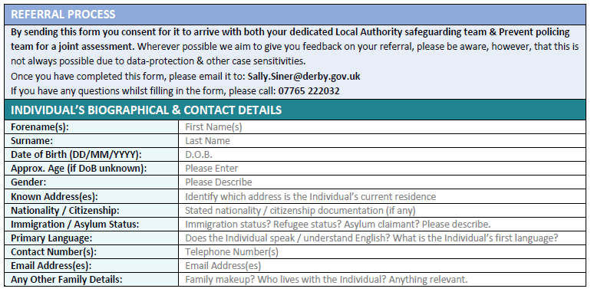

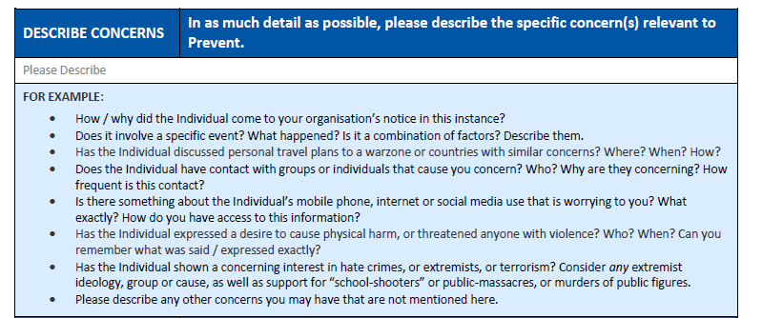

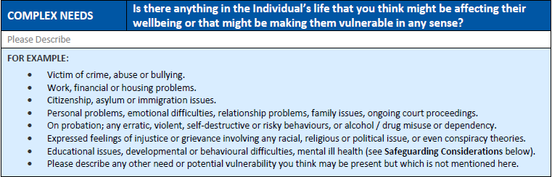

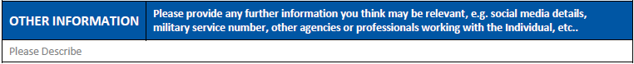

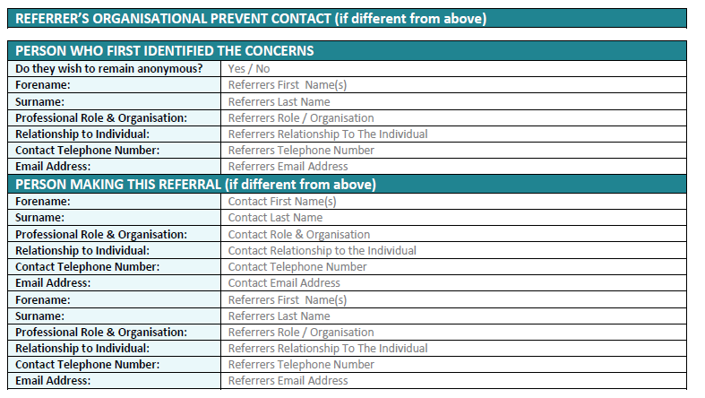
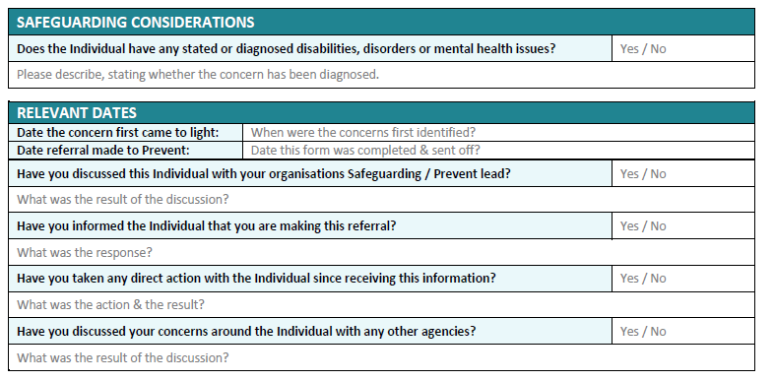

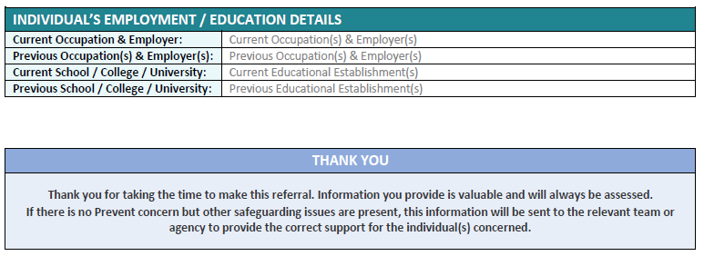

Appendix 6

Alvaston Infant and Nursery School - PREVENT Plan 2021-2022
Alvaston Infant and Nursery School recognises that it has a duty under Section 26 of the Counter-Terrorism and Security Act, 2015, in the exercise of its functions, to have due regard to the need to prevent people from being drawn into terrorism.

Duty | What this means? | Action | By whom? | Desired outcome?
Assess the risk of children being drawn into terrorism | Staff can demonstrate a general understanding of the risks affecting children and young people | • All staff have read “Keeping Children Safe in  Education”, September 2018  • The Prevent Lead has informed staff of their duties as set out in “The Prevent Duty” (DfE,  June 2015). | - All staff  - Prevent Lead | Staff survey shows that majority of staff are aware of their duties.
 | Staff can identify individual children who may be at risk of radicalisation and how to support them. | • The Prevent Lead has informed staff about signs and indicators of radicalisation. | - Prevent Lead | Staff survey shows that the majority of staff are aware of the indicators of radicalisation.
 | There is a clear procedure in place for protecting children at risk of radicalisation. | • All staff have read the Schools Safeguarding Policy, which includes a statement regarding the school’s “Prevent” duty.  • All staff understand how to record and report concerns regarding risk of radicalisation on CPOMs. | - All staff  - Prevent Lead | Staff survey shows that all staff know how to record and report incidents.
 | The school has identified a Prevent Lead. | • All staff and parents know who the Prevent Lead is and that this person acts as a source of advice and support.  • Prevent Lead to feature on school website. | - All staff  - Prevent Lead | Staff and parental surveys show that majority know who is the Prevent lead within school and who to talk to if they have concerns.
Prohibit extremist speakers and events in and outside of the school | The school exercises “due diligence” in relation to requests from external speakers and organisations using school premises | Prior to external speakers or organisations visiting:  • Request an outline of what the speaker intends to cover  • Research the person/organisation to establish whether they have demonstrated extreme views/actions.  • Deny permission for people/organisations to use school premises if they have links to extreme groups or movements.  • Provide justification for their decisions in writing.  • Staff are present during visits and know what to do if the content is inappropriate. | - All staff  - Prevent Lead | Staff survey shows that majority of staff know what to do prior to speaker/organisation attending.
 | The school exercise ‘due diligence’ in relation to speakers and organisations that pupils come into contact with outside of the school. | Prior to attending setting:  • Staff to conduct a pre-visit risk assessment.  • Request an outline of what the speaker intends to cover and/or the activities that the children will partake in (e.g. itinerary). This should include who else is will be present at time of children visiting.  • Research the person/organisation to establish whether they have demonstrated extreme views/actions.  • Deny permission for school to visit organisations/settings if they have links to extreme groups or movements.  • Staff are present during visits and know what to do if the content is inappropriate. | - All staff  - Prevent Lead | Staff survey shows that majority of staff know what to do prior to attending another setting.
Working in Partnership
The school is using existing local partnership arrangements in exercising its Prevent duty. | Staff record and report concerns in line with existing policies and procedures. | • All staff record and report concerns on CPOMS ensuring that they share with the Prevent Lead. | - All staff | Staff survey shows that all staff know how to record and report incidents.
 | The Prevent Lead makes appropriate referrals to other agencies including the MultiAgency Safeguarding Hub (MASH) and Channel Panel. | • Records of referrals are on CPOMS.  • Referrals are followed up appropriately. | - All staff  - Prevent Lead | Staff survey shows that all majority of staff feel that the Prevent lead would take appropriate action.
Staff training
Equip staff to identify children at risk of being drawn into terrorism and to challenge extremist ideas. | Assess the training needs of staff in the light of the school’s assessment of the risk to pupils at the school of being drawn into terrorism. | We:  • Ensure that the Designated Safeguarding Lead and Deputy Designated Safeguarding Lead/s undertake/s Prevent Awareness Training.  • Ensure that the Designated Safeguarding Lead and Deputy Designated Safeguarding Lead/s is/are able to provide advice and support to other members of staff on protecting children from the risk of radicalisation.  • Relevant staff have completed the “General Awareness Training on Channel”. (Referred to in the DfE guidance cited below). | Designated Safeguarding Lead/Prevent Lead  Relevant staff identified by the Prevent Lead | Staff continuous professional develop shows training for all staff.
 | Ensuring that the Prevent Lead has the most up to date guidance so that they are able to advise stakeholders of appropriate actions. | • Keep in touch with all relevant updates and ensure information/resources is stored and accessible.  • Attend DSL network events and strengthen links with local agencies and local Prevent Team. | - Prevent Lead | Prevent Lead feels confident in role and has support from local Prevent team.
 | Ensure that all new staff, student, volunteers are aware of procedures. | • Ensure that new arrivals receive Prevent overview as part of their induction  • Consider need for new intake Prevent training or refresher | - New staff  - Prevent Lead | Induction survey shows that new staff/visitors have had Prevent awareness as part of their induction and know procedure for reporting.
Policies
Ensure that children are safe from terrorist and extremist material when accessing the internet in schools | The school has policies in place, which make reference to the “Prevent” duty. | • A range of School Polices are available of the website for parents linked to the Prevent duty including:  - Preventing Radicalisation and Extremism  - Safeguarding  • A Prevent Strategy leaflet is available on the school website | - Prevent Lead  - DSL | Staff and parent surveys show that the majority know where to find school policies.
 | Children are taught about on-line safety with specific reference to the risk of radicalisation. | • The curriculum reflects this duty (e.g. PSHE and E-safety).  • Children are made aware of their rights through regular revisitation of the book ‘For Every Child’. This book is made visible in every classroom. | - Curriculum leads  - All staff | Pupil voice shows that children have awareness of on-line safety and what to do if they feel unsafe.
Building children’s resilience to radicalisation
Ensure that pupils have a “safe environment” in which to discuss “controversial issues”. | Pupils develop “the knowledge, skills and understanding to prepare them to play a full and active part in society”. | • Through PSHE/Citizenship, and other curriculum activities, pupils are able to explore political, religious and social issues.  • ‘Picture News’ allows pupils to respond to any relevant news stories through classroom discussions and related lessons  • Pupils are taught about the diverse national, regional and ethnic identities in the UK and the need for mutual respect.  • Diversity is celebrated and welcomed – e.g. links with schools in contrasting locality.  • Relevant staff are aware of the government guidance: https://www.gov.uk/government/news/guidanceon-promoting-british-values-in-schoolspublished/ | - Curriculum leads  - All staff | Pupil voice shows that children have awareness of on-line safety and what to do if they feel unsafe.

References:
- “Keeping Children Safe in Education: Information for all school and college staff” DfE, September 2018 - https://www.gov.uk/government/publications/keeping-children-safe-in-education--2
- “The Prevent Duty: Departmental advice for schools and childcare providers”, DfE, June 2015- https://www.gov.uk/government/publications/prevent-duty-guidance
- Promoting fundamental British values through SMSC - https://www.gov.uk/government/publications/promoting-fundamental-british-values-through-smsc
- Education Act 1996 - https://www.legislation.gov.uk/ukpga/1996/56/contents/data.pdf
- The Equality Act 2010 - https://assets.publishing.service.gov.uk/government/uploads/system/uploads/attachment_data/file/315587/Equality_Act_Advice_Final.pdf

