Alvaston Infant & Nursery School
Low Level Concerns Policy

Date policy written – Sept 22

Date policy reviewed – Sept 23

This policy has been ratified by the Headteacher / Governing Body and a signed copy is in the school office.

Review date | By whom | Summary of changes made | Date implemented | Date ratified

Introduction

At Alvaston Infant and Nursery School, we aim to create an open and transparent culture where all concerns about all adults involved with our school are dealt with promptly and appropriately. We aim to identify any concerning, problematic or inappropriate behaviour early; minimise the risk of abuse; and ensure that adults working in or on behalf of our school are clear about professional boundaries and act within these boundaries, and in accordance with our school ethos. This policy should be read alongside our Safeguarding and Child Protection and Staff Code of Conduct Policies.

Creating a culture in which all concerns about adults (including allegations that do not meet the harm threshold) are shared responsibly and with the right person, and recorded and dealt with appropriately is crucial. If implemented well this should encourage an open and transparent culture; enable our school to identify concerning, problematic or inappropriate behaviour early; minimise the risk of abuse; and ensure that adults working in or on behalf of the school are clear about professional boundaries and act within them, in accordance with the ethos and values of the school.

It is important to recognise that, in practice, the words ‘allegation’ and ‘concern’ can be and are used interchangeably by different people. Sometimes individuals may shy away from the word ‘allegation’ and express it as a ‘concern’ instead. The crucial point is that whatever the language used, the behaviour referred to may, on the one hand, be capable of meeting the harm threshold (and hence be referable), or, on the other, it does not meet the harm threshold (in which case it should be treated as a low-level concern). Therefore, the focus should not be on the language used by the person disclosing it; the focus should, instead, be on the behaviour being described.

Purpose of a Low-Level Concerns Policy

It may be possible that a member of staff acts in a way that does not cause risk to children, but is however inappropriate. A member of staff who has a concern about another member of staff, volunteer, contractor or who, on reflection, recognises that their actions could have been viewed as a risk should inform the Headteacher about their concern using a Low-Level Record of Concern Form. If the Headteacher cannot be contacted, the Chair of Governors should be contacted instead.

Sharing Low Level Concerns

It is critical that all low-level concerns are ultimately received by the Headteacher, Molly Allen, who is also the Designated Safeguard Lead (DSL). Having one recipient of all such concerns should allow any potential patterns of concerning, problematic or inappropriate behaviour to be identified, and ensure that no information is potentially lost.

It is important that low-level concerns are shared with the Headteacher as soon as reasonably possible and, in any event, within 24 hours of becoming aware of it (where the concern relates to a particular incident) - although it should also be emphasised that it is never too late to share a low-level concern and a delay should never been seen as a barrier to sharing.

If the Headteacher is absent for any reason, low-level concerns should be shared with the deputy Designated Safeguard Lead (DSL) who should ensure that they inform the Headteacher immediately on their return.

Where an allegation is made against the Headteacher, the chair of Governors, Julian Bland must be contacted as soon as possible. If emailing, the email should be titled ‘URGENT SAFEGUARDING’. This should be sent to julianbland@alvastoni.derby.sch.uk

Clarity around Allegation vs Low-Level Concern vs Appropriate Conduct

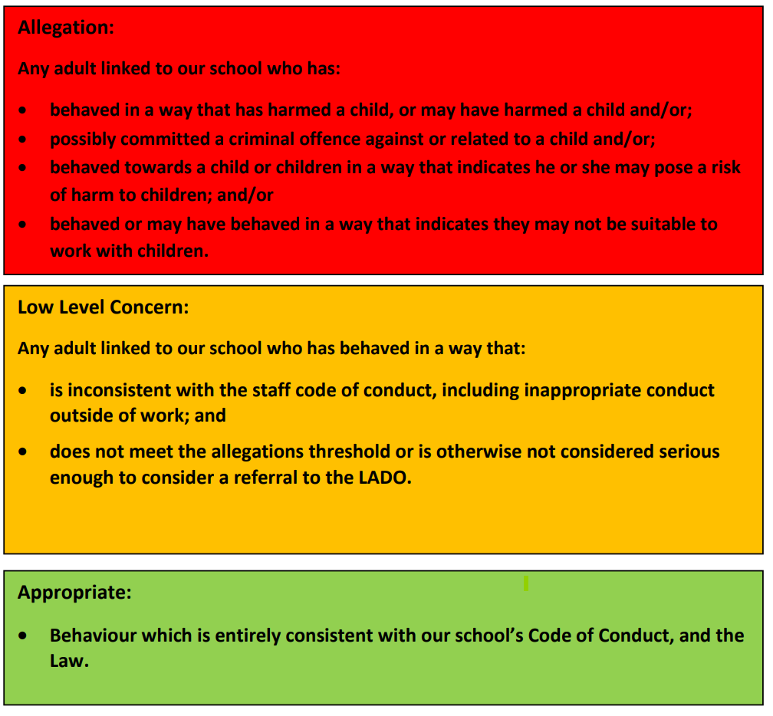

Anonymity

If the staff member who raises the concern does not wish to be named, then Alvaston Infant and Nursery School will respect that person’s wishes as far as possible. However, there may be circumstances where the staff member will need to be named (for example, where it is necessary in order to carry out a fair disciplinary process) and, for this reason, anonymity will never be promised to members of staff who share low-level concerns. Where possible, the school will try to encourage staff to consent to be named, as this will help to create a culture of openness and transparency.

Self-Reporting

Occasionally a member of staff may find themselves in a situation which could be misinterpreted or might appear compromising to others. Equally, a member of staff may, for whatever reason, have behaved in a manner which, on reflection, they consider falls below the standard set out in the staff code of conduct.

Self-reporting in these circumstances can be positive for a number of reasons: it is self-protective, in that it enables a potentially difficult issue to be addressed at the earliest opportunity; it demonstrates awareness of the expected behavioural standards and self-awareness as to the individual’s own actions or how they could be perceived; and, crucially, it is an important means of maintaining a culture where everyone aspires to the highest standards of conduct and behaviour. In line with KCSIE, Alvaston Infant and Nursery School will ensure that there is an environment where staff are encouraged and feel confident to self-refer.

Sharing and Recording of Low-Level Concerns

Staff will be given the option of sharing their low-level concern verbally with the Headteacher in the first instance, or by completing a simple low-level concerns form, an example of which can be found in Appendix B. Where the low-level concern is provided verbally, the Headteacher will make an appropriate record of the conversation, either contemporaneously or immediately following the discussion.

Sound professional judgement will be exercised by the Headteacher in determining what information is necessary to record for safeguarding purposes. The name of the individual sharing the low-level concern and their role should be stated, as should the name of the individual about whom the concern is being raised, and their role within the school at the time the concern is raised.

If the latter individual has an opposing factual view of the incident, this will be fairly recorded alongside the concern. The record will include brief context in which the low-level concern arose, and concise details (which are chronological and as precise and accurate as possible) of any such concern and relevant incident(s). The record must be signed, timed and dated.

Responding to a Low-Level Concern

Once the Headteacher has received the low-level concern, they will follow the process set out (see Appendix A), not necessarily in the order but in an appropriate sequence according to the nature and detail of the particular concern shared with them.

Storing and use of Low-Level Concerns and follow-up information

Low-Level Concern forms and follow-up information will be stored securely within the schools safeguarding systems, with access only by the leadership team. This will be stored in accordance with the school’s GDPR and data protection policies. The staff member(s) reporting the concern must keep the information confidential and not share the concern with others apart from the Headteacher or those aware in the senior leadership team.

Low-Level Concerns will not be referred to in references unless they have been formalised into more significant concerns resulting in disciplinary or misconduct procedures. Whenever staff leave Alvaston Infant and Nursery School, any record of low-level concerns which are stored about them will be reviewed as to whether or not that information needs to be kept.

Consideration will be given to:
- whether some or all of the information contained within any record may have any reasonably likely value in terms of any potential historic employment or abuse claim so as to justify keeping it, in line with normal safeguarding records practice; or
- if, on balance, any record is not considered to have any reasonably likely value, still less actionable concern, and ought to be deleted accordingly

Low-Level Concerns Regarding Leadership

In the event that a low-level concern is raised against or concerns a member of the leadership team, then that staff member’s access to school safeguarding systems may be prohibiting while the Headteacher follows the process (set out in Appendix A). The Chair of Governors will be aware of this and a separate, confidential record kept by the Clerk.

Where these concerns regarding the Headteacher, then the Chair of Governors (or Vice) will support the a designated senior leader with the process and will inform the Headteacher of the prohibition. In this situation, the governing body may seek support from the local authority about how to proceed.

The review of these low-level concerns will be treated as confidentially as those of other staff members.

Reviewing the Low-Level Concerns File

The Headteacher will review the central low-level concerns file periodically to ensure that all such concerns are being dealt with promptly and appropriately, and that any potential patterns of concerning, problematic or inappropriate behaviour are identified. A record of these reviews will be made and stored alongside the file, along with any subsequent actions taken.

Governors will receive relevant data relating to low-level concerns and review anonymised samples of low-level concerns at regular intervals, in order to ensure that these concerns have been responded to promptly and appropriately.

Appendix A - Responding to a low-level concern flowchart

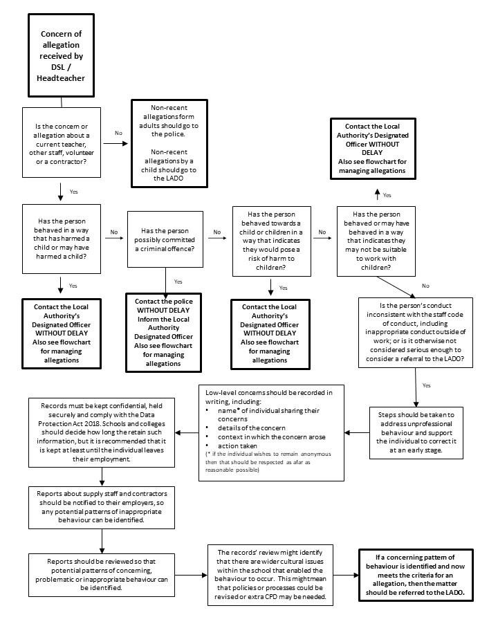

Appendix B – Example Low Level Concerns Form

Low Level Concerns Form

Your details
Name of member of staff completing this form

Role

Date and time of completing this form
Details of individual (including yourself for self-reporting) whom the concern is about
Name

Role

Relationship to the individual reporting eg manager, colleague
Details of concern
Please include as much detail as possible. Think about the following: What behaviour and/or incident are you reporting? What exactly happened? Why does the behaviour and/or incident worry you? Why do you believe the behaviour and/or incident is not consistent with our Staff Code of Conduct?

Details of any children or young people involved
Name(s)

Next Steps
Are you willing to meet with the headteacher and DSL to discuss your concern? Please circle as appropriate. | Yes | No
Please state any other information that you feel is relevant to the
processing of this concern.
Signature

For use by HT/safeguarding team upon receipt of the concern
Date and time concern received

Signature

Role

Actions to be taken and follow-up.

