Intimate Care and Toileting Policy

Date of policy publication:

Author/s of policy:

Date of last review: January 2023

Date of next review: January 2024 (or sooner)

Review date | By whom | Summary of changes made | Date implemented | Date ratified
17.3.20 | C. Mabbutt | This replaces the previous Toileting Policy 2017 and Intimate Care Policy 2016 | March 2020
9.12.21 | T.Darby | No changes made. | December 2021
13.12.22 | C. Mabbutt | Concerns about safeguarding  Visuals added to Appendix E | December 2022
1.03.24 | T.Darby | Removed wearing an apron.  pg 5 - Health and Safety  Added parents signing agreement pg 6  Adapting symbol sheet to make it simpler – TD to complete. | March 2024

Alvaston Infant and Nursery School

Aim

We have a duty to safeguard children and school personnel at all times. We must develop independence in each child but on those occasions when children need assistance they must feel safe, have personal privacy, feel valued, are treated with dignity and respect, are involved and consulted about their own intimate care with school personnel that are specially trained in intimate care procedures.

All children have the right to be treated:
- with sensitivity and respect in such a way that their experience of intimate care is a
positive one;
- by professionals suitably trained and assessed to be competent to undertake procedures
in intimate care.

This Intimate Care and Toileting Policy applies to everyone involved in the intimate care and toileting of children.

We as a school community have a commitment to promote equality. This policy is in line with the Equality Act 2010.

These guidelines should be read in conjunction with these policies:

- Child Protection and Safeguarding Policy
- Health & Safety Policy
- Safer Recruitment Policy
- DBS Policy
- SEND Policy

Definition of Intimate Care

Intimate care is any care which involves washing, touching or carrying out an invasive procedure that most children carry out for themselves but which some are unable to do due to physical disability, special educational needs associated with learning difficulties, medical needs or needs arising from the child’s stage of development.

Care may involve help with drinking, eating, dressing and toileting.

In most cases, intimate care will involve procedures to do with personal hygiene and the cleaning of equipment associated with the process. In the case of a specific procedure only a person suitably trained and assessed as competent should undertake the procedure.

Toileting

Starting school or nursery has always been an important and potentially challenging time for both children and the schools that admit them. It is also a time of growth and very rapid developmental change for all children. As with all developmental milestones in the foundation stage, there is wide variation in the time at which children master the skills involved in being fully toilet trained.

Children in the Foundation Stage may:

- be fully toilet trained across all settings
- have been fully toilet trained but regress for a little while in response to the stress and excitement of beginning the Foundation Stage
- be fully toilet trained at home but prone to accidents in new settings
- be on the point of being toilet trained but require reminders and encouragement
- not be toilet trained at all but likely to respond quickly to a well-structured toilet training programme
- be fully toilet trained but have serious disabilities or learning difficulties
- have delayed onset of full toilet training in line with other development delays but will probably master these skills during the Foundation Stage
- have SEND that make it unlikely that they will be toilet trained during the Foundation Stage

Admitting children who have continence problems into Foundation Stage and Key Stage 1 provision can present a challenge. The purpose of this policy and guidelines is to achieve the full inclusion of such children.

These guidelines meet the requirements of the Early Years Foundation Stage, the Disability Equality Duty (in the Disability Discrimination Act) and the Equality Act 2010 as they apply to children with toileting and continence needs.

School Responsibilities

Role of the Governing Body

The Governing Body has:
- delegated powers and responsibilities to the Headteacher to ensure all school personnel and stakeholders are aware of and comply with this policy;
- responsibility for ensuring that the school complies with all equalities legislation;
- nominated a designated Equalities governor to ensure that appropriate action will be taken to deal with all prejudice related incidents or incidents which are a breach of this policy;
- responsibility for ensuring funding is in place to support this policy;
- responsibility for ensuring this policy and all policies are maintained and updated regularly;
- responsibility for ensuring all policies are made available to parents;
- the responsibility of involving the School Council in the development, approval,
- implementation and review of this policy;
- nominated a link governor to visit the school regularly, to liaise with the Headteacher and the coordinator and to report back to the Governing Body;
- responsibility for the effective implementation, monitoring and evaluation of this policy

Role of the Headteacher

The Headteacher will:
- ensure all school personnel, pupils and parents are aware of and comply with this policy;
- ensure school personnel who provide intimate care are suitably trained to do so;
- ensure that new developments, resources and equipment are brought to the attention of the appropriate school personnel;
- monitor the effectiveness of this policy;
- annually report to the Governing Body on the success and development of this policy

Role of the Nominated Governor

The Nominated Governor will:
- work closely with the Headteacher and the coordinator;
- ensure this policy and other linked policies are up to date;
- ensure that everyone connected with the school is aware of this policy;
- report to the Governing Body every term;
- annually report to the Governing Body on the success and development of this policy

Role of School Personnel with Responsibilities for Intimate Care

School personnel will:
- receive training in Child Protection, First Aid, intimate care procedures, and Health and Safety training in moving and handling;
- be professional in their duties at all times;
- be respectful of a child’s needs;
- preserve a child’s dignity and respect with a high level of privacy, choice and control appropriate to the child’s age and situation;
- be aware of a child’s method and level of communication;
- make sure practice in intimate care is consistent;
- be aware of their own limitations;
- promote positive self-esteem and body image;
- take care (both verbally and in terms of their body language) to ensure that the child is never made to feel as if they are being a nuisance;
- work in partnership with parents/carers;
- report any concerns they have about a child;
- report any concerns they have about a colleague’s intimate care practice;
- be aware of the danger of allegations being made against them;
- take precautions to avoid risk
- ensure that there is always a member of staff nearby, when intimate care takes place.
- have an effective system to alert staff for help in emergency (i.e. telephones in classrooms)
- ensure that recording equipment such as mobile phones or cameras are not taken into areas where intimate care is carried out

All staff employed by the school have an enhanced DRB check (see Safer Recruitment and DBS policies for further information).

It is likely that most of the personal care will be undertaken by one or more of the teaching assistants. It is recommended that the adult who is going to change the child informs the teacher that they are going to do this. Alvaston Infant and Nursery School ensures that this issue is addressed as appropriate within their overall staffing.

Teachers are responsible for facilitating, supporting and releasing teaching assistants to fulfil this role. No student on a ‘placement’ will change a child without supervision.

Concerns about safeguarding

If a member of staff carrying out intimate care has concerns about physical changes in a child’s appearance (e.g. marks, bruises, soreness), they will report this using the school’s safeguarding procedures.

If a child is hurt accidentally or there is an issue when carrying out the procedure, the staff member will report the incident immediately to the Designated Safeguard Lead (DSL), Molly Allen. In her absence, this will be reported to the next senior member of the Senior Leadership Team (SLT).

If a child makes an allegation against a member of staff, the responsibility for intimate care of that child will be given to another member of staff as quickly as possible and the allegation will be investigated according to the school’s safeguarding procedures.

Training

We ensure all school personnel have equal chances of training, career development and promotion.

Periodic training will be organised for all school personnel so that they are kept up to date with new information and guidelines concerning equal opportunities

Health and Safety

Alvaston Infant and Nursery School has procedures in place for dealing with spillages of bodily fluids such as when a child accidentally wets or soils themself or is sick while on the premises. The same precautions for nappy changing. This includes:

• staff to wear disposable gloves while changing a child

• soiled nappies securely wrapped and disposed of appropriately. The school has arrangements in place for the disposal of nappies.

• changing area/ toilet to be left clean

• hot water and soap available to wash hands as soon as changing is done

• paper towels to be available to dry hands.

A suitable place for changing children, including providing the necessary resources have a high priority in terms of inclusion. The Department of Health recommends that one extended cubicle with a washbasin should be provided in each school for children with disabilities. Whenever possible it is recommended that:

- mobile children are changed standing up
- if this is not possible the next best alternative is to change a child on a purpose-built changing bed
- children in FS1 and FS2 may be changed on a mat on a suitable surface if it is not possible for them to change standing up or on a changing bed.
- If the facilities described above are not available, then children in FS1 and FS2 may be changed on a changing mat on the floor. Children in Year 1 and above should be changed either on a changing bed or in a toilet cubicle standing up.

Working with Parents

Partnership with parents is a vital principle in any educational setting and is particularly necessary in relation to children needing intimate care and toileting. Much of the information required to make the process of intimate care as comfortable as possible is available from parents, including knowledge and understanding of any religious or cultural sensitivities.

Issues around toileting should be discussed at a meeting with the parents/ carers prior to admission into the school. This will include admissions for children into FS1 and FS2. This meeting will also provide an opportunity to involve other agencies as appropriate, such as a Health Visitor or School Nurse.

If the school becomes aware that there is a disproportionate number of children arriving at school who are not, yet toilet trained, then they are advised to make contact with the Health Visiting Team in their area to discuss their concerns.

During these meetings, parents will be informed of this policy and the schools’ position in relation to changing and toileting children. Teachers will make clear how they work in partnership with parents when a child is coming to school in nappies or pull-ups. Such an agreement helps to avoid misunderstandings and helps parents/ carers feel confident that Alvaston Infant and Nursery School will meet their child’s needs.

Parents / Carers may be asked to:

• agree to change the child at the latest possible time before coming to school
• provide spare nappies, wet wipes and a change of clothes
• understand and agreeing the procedures to be followed during changing at school
• agree to inform school should the child have any marks/rash
• agree how often the child should be routinely changed if the child is in school for the day and who will do the changing
• agree to review the arrangements, in discussion with the school, should this be necessary
• agree to encourage the child’s participation in toileting procedures wherever possible.
• parents will sign to say they are happy for their child to be changed prior to starting school.

The school may agree to some of the following:

- to change the child should they soil themselves or become wet
- how often the child should be routinely changed if the child is in school for the full day and who would be changing them
- a minimum number of changes
- report to the Head Teacher or SENCO should the child be distressed or if marks/ rashes are seen
- review arrangements, in discussion with parents/ carers, should this be necessary
- encourage the child’s participation in toileting procedures wherever possible
- discuss and take the appropriate action to respect the cultural practices of the family.

Exchanging information with parents is essential to ensure consistency of approach towards toileting. This may be through discussion, telephone or correspondence. It may be due to circumstance, such as parents working, that information concerning intimate care procedures be sent home with a named person (using Appendix D), i.e. grandparent. In line with GDPR, the member of staff completing this document will not include child’s full name or any other confidential information.

Asking or telling parents to come and change their child (unless the parents have expressed a preference for this) or wanting an older sibling to change their sister/ brother is likely to be a direct contravention of the Disability Equality Duty and Equality Act 2010, as is leaving a child soiled, which could be considered to be a form of abuse since it places the child at risk of significant harm.

The process for the management of a child’s personal care needs may need to be further clarified through a ‘Individual Care Plan’ (ICP). For example, where the school has concerns about parental support, for children transferring to FS2 or for those who are not toilet trained and for children with SEND. School will complete a Risk Assessment (Appendix B) firstly and then proceed to an ICP if necessary.

In the very small number of cases where parents do not co-operate or where there are concerns that:

• the child is regularly coming to school/nursery in very wet or very soiled nappies and
• there is evidence of excessive soreness that is not being treated
• the parents are not seeking or following advice

discussions will take place with the Designated Safeguard Lead (DSL) or deputy DSL, about the appropriate action to take to safeguard the welfare of the child.

Agreeing an Individual Care Plan (ICP) in School

Alvaston Infant and Nursery School has agreed written guidelines for staff to follow when changing a child (see Appendix B), to ensure that staff follow correct procedures and also are not worried about false accusations of abuse.

Where a routine procedure is required, such as supporting a child with a complex continence need, the ICP should be agreed in discussion with the child, school staff, parents, and relevant health personnel. The ICP should be signed by all who contribute and reviewed on an agreed basis.

In developing an ICP, the following should be considered:
- Who will change the child (to include more than one person to cover for absence etc.)
- Where changing will take place
- How changing occasions will be recorded and how this will be communicated to parents
- What resources will be used and who will provide them (e.g. spare clothes and disposable gloves)
- How other wet or soiled clothes will be dealt with and/or how a nappy will be disposed of
- Awareness of a child’s discomfort which may affect learning
- The importance of working towards independence
- Strategies for dealing with pressure from peers - e.g. teasing/bullying
- What the member of staff will do if the child is unduly distressed or if marks or injuries are noticed
- Agree appropriate terminology for private parts of the body and functions to be used by staff.

Where possible the child will be allowed, subject to their age and understanding, to express a preference regarding the choice of his/her carer and sequence of care. Where possible the child, with the support of their parents, will sign a ‘Child/Staff Agreement’ (Appendix E). If this is not possible, parents will sign on the behalf of the child. This will feature on the ICP.

It may be possible to determine a child’s wishes by observation of reactions to intimate care. Where there is any doubt that a child is able to make an informed choice on these issues, the child’s parents are usually in the best position to act as advocates.

It is the responsibility of all staff caring for a child to ensure they are aware of the child’s method and level of communication. Communication methods may include words, signs, symbols and gestures. To ensure effective communication with the child, staff should ascertain the agreed method of communication and identify this in the agreed ICP.

Reviewing the Policy

The practical application of this policy will be reviewed annually or when the need arises by the SENCo, the Headteacher and/or the nominated governor.

Appendix A
Procedure for Changing a Child
(child standing or lying down)

- Consider whether the child can be changed in a toilet cubicle (standing up)
- Wash your hands
- Assemble the equipment
- Place the child on the changing mat/ table
- Put on gloves
- Remove wet/ soiled nappy
- Fold the nappy inwards to cover fecal material and place into designated covered bin
- Used wipes and gloves are to be disposed of in a bin with a disposable liner
- The bin should be emptied at least once a day and the liner replaced
- Once the child has been changed and returned safely to the, e.g. nursery area, clean the changing area with a detergent spray or soap and water
- Hands should be washed thoroughly
Appendix B Individual Risk Assessment

Child’s Name:

Name of School:

Date of Risk Assessment:

 | Yes | Notes
1. Does weight /size/ shape of pupil present a risk?

2. Does communication present a risk?
3. Does comprehension present a risk?
4. Is there a history of child protection concerns?
5. Are there any medical considerations? Including pain / discomfort?
6. Has there ever been allegations made by the child or family?
7. Does moving and handling present a risk?
8. Does behaviour present a risk?
9. Is staff capability a risk? (back injury / pregnancy)
Are there any risks concerning individual capability (Pupil)?
General Fragility
Fragile bones
Head control
Epilepsy
Other
Are there any environmental risks?
Heat/ Cold

If Yes to any of the above complete a detailed personal care plan.

Date:

Signed:

Name:

Appendix C - Individual Care Plan

Child’s Name: | DOB:
Name of School:

Completed by: _________________________________ (member of staff)

Date of Plan: ______________ Date to review Plan: _________________

Who will change the child?

How will be the child be changed? e.g. standing up in a toilet cubicle, lying down on a mat on the floor

Copies of procedure for changing given to parent where available
Who will provide the resources? e.g. wipes, nappies, disposable gloves

How will the changing occasions be recorded and how this will be communicated to child’s parent/ carer

Consider using the Record of Intimate Care Intervention Table
How will wet/ soiled clothes be dealt with?

What the member of staff will do if the child is unduly distressed or if marks or injuries are noticed

Consider referring to the schools child protection policy and procedures

Agree a minimum number of changes

How will the child be encouraged to participate in the procedure?

How will staff/the pupil work towards independence?

Any other comments/ important information:
e.g. medical information

This plan has been discussed with me and I agree to change my child at the last possible moment before he/ she comes to school, provide the resources indicated above and encourage my child’s participation in toileting procedures at home as appropriate and where possible.

Permission for school to provide intimate care

Child’s Full Name
Male/ Female
Date of Birth

Parent/ Carer’s Full Name
Address

I understand that, I give permission to the school to provide appropriate intimate care support to my child e.g. changing soiled clothing, washing and toileting.

I will advise the headteacher of any medical complaint my child may have which affects issues of intimate care

Signed ___________________________________________

Full Name _________________________________________

Relationship to Child _________________________________

Date ______________________________________________

Appendix D

Record of Intimate Care Intervention

Child’s Name ____________________________ Class/ Year Group _______

Name of Support Staff Involved ____________________________________

Date | Time | Procedure | Staff signature | Second signature

Appendix E – Child/staff agreement – Intimate Care and/or changing

My name is _____________________________ My class is ________

My helper is ____________________________________

What My Helper Will Do to Help Me:

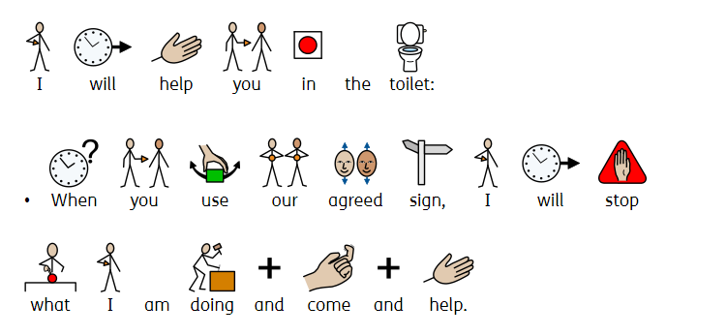
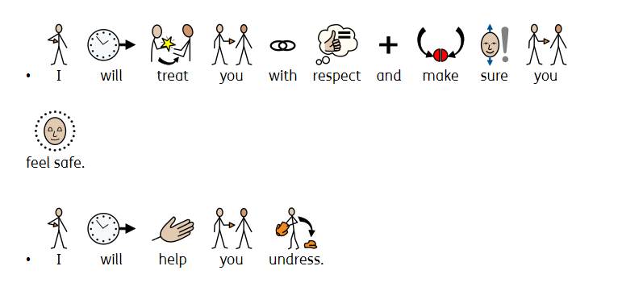
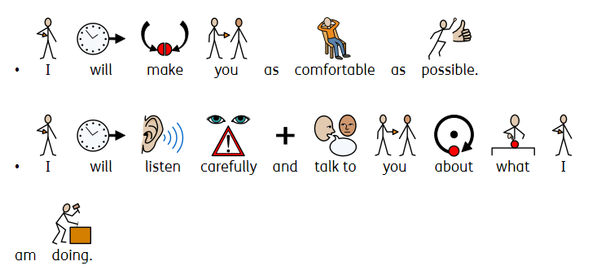

How I will help:

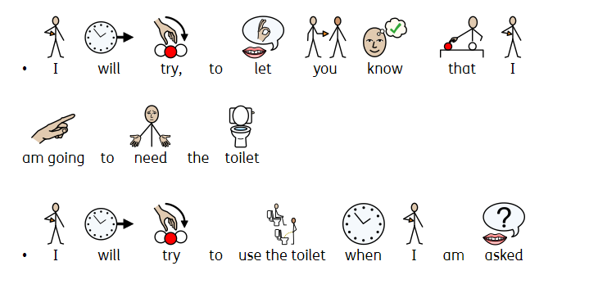

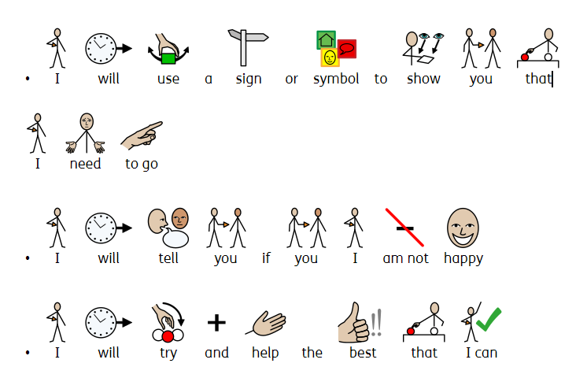

Signed ___________________________________________ Date:_________

Signed ___________________________________________ Date:_________

