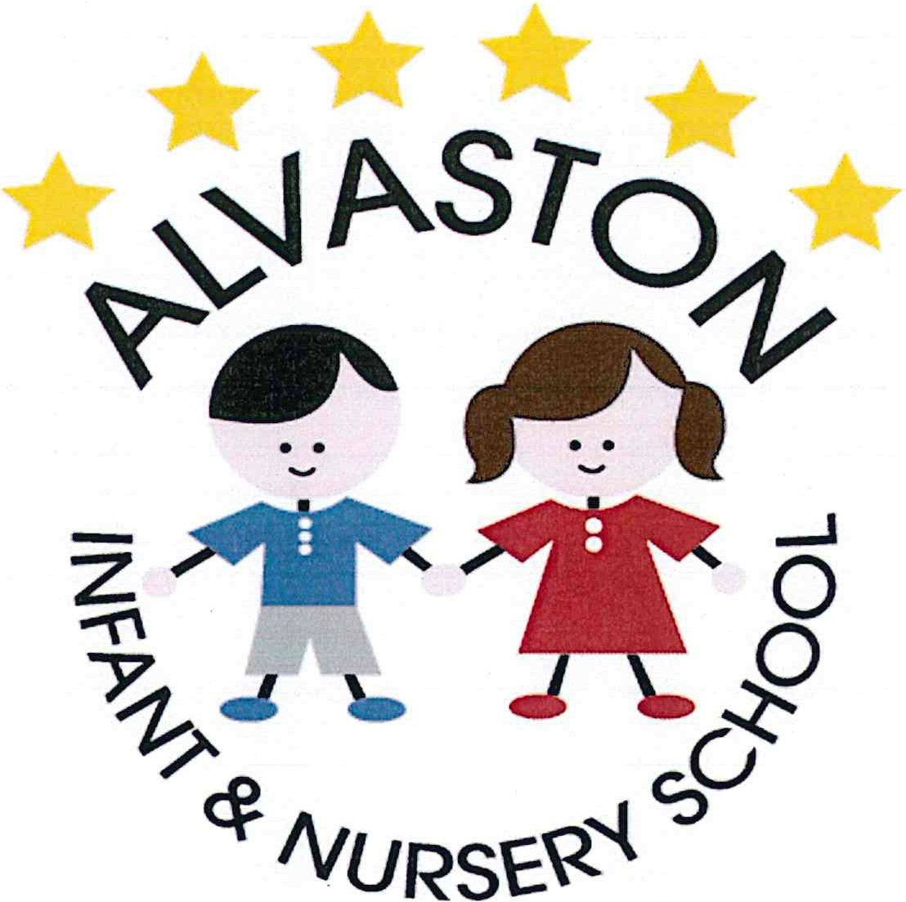

E-safety Policy

Agreed Jan 2019 by the Headteacher and Chair of Governors. A signed copy is stored in the School Office.

Author/s of policy: Katie Matthews

Date of last review: 29th February 2020
Date of next review: March 2022 (or sooner if required)

Policy review dates and changes
Review date | Version number | By whom | Summary of changes made | Date implemented | Date ratified
Spring 2 |  | KMATTHEWS | Local safeguarding children’s boards, mental health, wellbeing, curriculum updates, GDPR | 29.2.20

Alvaston Infant and Nursery School
E- Safety Policy: February 2020

Introduction:

At Alvaston Infant and Nursery School, we use a wide range of resources in order to teach the children a rich and bespoke curriculum. Children and teachers will have access to a range of different technological devices and as a school, we are committed to ensuring that they are used safely and for the correct purpose. This policy applies to all members of Alvaston Infant and Nursery School (including all staff, pupils, volunteers, parents/carers, governors and community users), who have access to, or are users of the school ICT systems both in and out of school. There is a whole school approach to online safety to address the 3 areas of risk; content, contact and conduct. This includes a policy on the use of mobile technology in the setting, appropriate filters and monitoring systems to ensure children are safeguarded from potentially harmful and inappropriate material online, including terrorist and extremist material, as well as online safety training for staff. As technology in this area evolves and changes rapidly online safety will be regularly reviewed.

This policy aims to:
- Distinguish clear guidance for how technology should be used.
- Outline the guidelines and procedures for keeping children and staff safe when using ICT systems and technology.

Roles and Responsibilities

Governors
Governors are responsible for approval of the E-safety Policy and for reviewing the effectiveness of the policy. This will be carried out by the Governors, who will receive regular information about e-safety incidents and monitoring reports. The governor responsible for Safeguarding will be informed of any incidents and will be responsible for monitoring this area.

At Alvaston Infant and Nursery School, the Headteacher has:
- a duty of care to safeguard (including e-safety) all members of the school community.
- the knowledge and knows the procedures which will be followed in the event of a serious e-safety allegation being made against a member of staff.
- responsibility for ensuring that the E-safety lead and other relevant staff receive suitable training and that all staff members follow the policy.

The Computing Lead, Headteacher and Technical staff are responsible for ensuring that the:
- school's technical infrastructure is secure and is not open to misuse or malicious attack.
- school meets the required e-safety technical requirements legally, including the advice given by the Local Authority.
- users may only access the networks and devices through a properly enforced password protection policy, in which passwords are regularly changed. This also includes all iPads used by the class teachers.
- filtering policy is applied and updated on a regular basis and that all users are responsible for its implementation.
- staff keep up to date with e-safety technical information in order to effectively carry out their e-safety role. The E-safety Lead and Heateacher may also receive further training.
- use of the network, internet, Virtual Learning Environment, remote access and email is regularly monitored so that any misuse/attempted misuse can be reported to the Headteacher and E-safety Lead.
- staff are constantly aware of their responsibility when using school laptops/iPads. This will be through an e-safety reminder, which will be displayed and shared each time a member of staff logs on.

Teaching and Support Staff are responsible for ensuring that:
- They have an up to date awareness of e-safety matters and of the current school E-safety Policy and practices.
- They have read, understood and signed the Staff Acceptable Use Policy (AUP).
- They report any suspected misuse or problem to the Headteacher for investigation.
- Ensure that children are taught about safeguarding, including mental health/well-being and online safety (this incorporates healthy online/offline relationships, sexting/‘youth produced sexual imagery’ and terrorist/extremist material), through teaching, learning opportunities and tutorials.
- All digital communications with students, pupils, parents or carers should be on a professional level and is only carried out using official school systems or Class Dojo.
- E-safety is taught so that it can be embedded in all aspects of the curriculum and other activities.
- Students/pupils understand and follow the E-safety and Acceptable Use Policies.
- Any video that is used is presented Via Safeshare to guarantee that they are suitable for use. Teachers must ensure that they have checked all videos before sharing them with the children.
- They monitor the use of digital technologies, cameras, iPads etc. in lessons and other school activities (where allowed) and that they implement current policies with regard to these devices.
- In lessons, where internet use is pre-planned, pupils are guided to sites which have been checked. This will ensure that they are suitable for their use and that processes are in place for dealing with any unsuitable material that is found in internet searches.
- If personal data has to be saved to other media, e.g. data sticks or CDs, it is to be encrypted or strong password protected.

Staff private use of social media:

All staff at Alvaston Infant and Nursery School will ensure that:
• No reference is made on social media to: students / pupils, parents /carers, school staff or issues or situations relating to the school. Should a member of staff breach this policy, this will be addressed immediately by the Headteacher.
• They do not engage in online discussion regarding personal matters relating to members of the school community.
• Personal opinions are not attributed to the school.
• Security settings on their personal social media profiles are regularly checked to minimise risk of loss of personal information.
• They do not to run social network spaces for students’/ pupils’ use on a personal basis. Teachers must always use the school’s agreed systems for communications.
• They do not maintain a Social Media relationship with any pupil, current or alumni until the pupil turns 18.

Protecting the School Community

In order to protect school staff, we require that parents do not comment on school issues or staff using social networking sites. Any concerns or complaints should be discussed directly with the school. The school will take action if there is evidence that inappropriate comments about staff have been placed on the internet in a public arena.

Child Protection and The Safeguarding Designated Lead

At Alvaston Infant and Nursery School, we are committed to ensuring that all staff are well-trained and meet the legal requirement. Therefore, our Computing Lead and Headteacher are trained in E-safety and are aware of the potential for child protection/ safeguarding issues to arise from:
- Sharing of personal data.
- Access to illegal/ inappropriate materials.
- Inappropriate on-line contact with adults/ strangers.
- Potential or actual incidents of grooming.
- Cyber-bullying.

Educating Parents/Carers

At Alvaston Infant and Nursery School, we ensure that Parents/ Carers:
- Are aware of how they can keep their child safe online.
- Understand the risks of using the internet.
- Are provided with strategies that they can implement at home.

If staff are concerned about the inappropriate use of technology at home by our pupils, parents will be contacted.

Use of digital and video images

At Alvaston Infant and Nursery School:
- Staff, Parents/ Carers and pupils are aware of the risks associated with publishing digital images on the internet.
- We ensure that we inform and educate all users about the risks regarding the use of digital and video images.
- All staff ensure that in order to safeguard the children, any photograph/ video taken of the pupils is appropriate and all pupils are appropriately dressed and are not participating in activities that might bring the individuals or the school into disrepute.
- Photographs that are published on the website, will be selected carefully and will comply with good practice guidance on the use of such images.
- Pupils' full names will not be used anywhere on a website or blog, particularly in association with photographs.
- We have an 'opt out' policy so that parents can inform school if they do not wish their child's photo to be published in a public arena. Staff should therefore be aware of the children within school who are part of this and ensure that no photographs are taken of these children.
- We ensure that during school productions, performances and workshops, photographs and videos are not taken by the audience. This will ensure that every child is safeguarded appropriately.

At Alvaston Infant and Nursery School, when using communication technologies, we ensure that:
- Users are aware that email communications are monitored.
- Staff and pupils use only the school email service to communicate with others when in school or when working on school business.
- Staff are aware that there should be no use of a child’s full name in order to coincide with new GDPR guidelines nor should any paper work with a child’s name on be taken out of school premises.
- Users immediately report any communication that makes them feel uncomfortable, is offensive, discriminatory, threatening or bullying in nature and must not respond. Instead, they must follow school policy and report to the Designated Safeguarding Lead and the Headteacher.
- Any digital communication between staff and students/ pupils or parents/ carers must be professional in tone and content. These communications may only take place on official (monitored) school systems. Personal email addresses, text messaging or social media must not be used for these communications.
- Pupils are regularly taught about e-safety issues, such as the risks attached to the sharing of personal details. They are taught strategies to deal with inappropriate communications and are reminded of the need to communicate appropriately when using digital technologies.
- Personal information is not posted on the school website.

We aim to safeguard all of our school community and if any incidences or concerns regarding E-safety arise, these will be addressed appropriately with immediate effect. This policy should be read in conjunction with the school's Safeguarding Policy.
Monitoring and Review
The E-Safety Policy at Alvaston Infant and Nursery School is a working document and evolves around annual audits and planning by pupils, staff and governors. We are aware of the need to monitor the policy, and we take account of new initiatives and research, changes in the curriculum, developments in technology and changes to the physical environment of the school.

