Alvaston Infant and Nursery School Sept 23
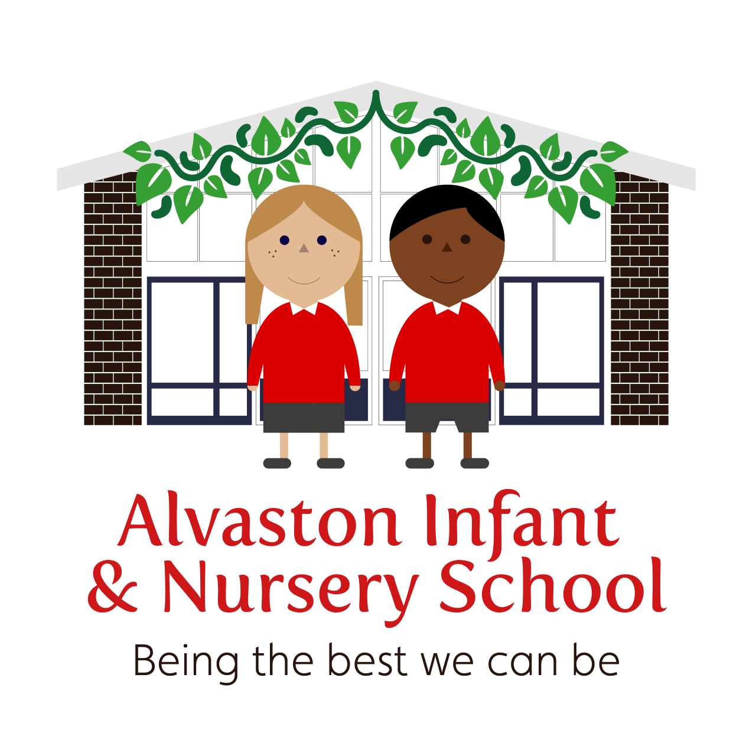
Remote Education Provision and Support and Arrangements for Children With Health Needs Who Cannot Attend School
Version | Date | Summary of changes | Date implemented
1.1 | 28.9.23 | Merged remote education and children with health needs policy

This policy has been ratified by the Governing Body
To be reviewed Sept 24

Remote Education Provision: Information for Parents
This information is intended to provide clarity and transparency to pupils and parents or carers about what to expect from remote education where national or local restrictions require entire cohorts (or bubbles) to remain at home.
For details of what to expect where individual pupils are self-isolating, please see the final section of this page. Fore details of what we can expect
This policy may also apply for children with health needs who cannot attend school (see section below).

The remote curriculum: what is taught to pupils at home
A pupil’s first day or two of being educated remotely might look different from the approach which follows while we take all necessary actions to prepare for a longer period of remote teaching.

What should my child expect from immediate remote education in the first day or two of pupils being sent home?
In the event of national or local restrictions requiring whole classes or ‘bubbles’ of children to remain at home, there will be instructions on each child’s Class Dojo Page to inform parents and carers of the details for each child’s remote education for that day (or for the following day if the announcement is made the previous evening). This will give the teaching staff sufficient time to put detailed planning in place for the remote education which will follow. The children might need access to their Purple Mash account and their Bug Club reading account to enable them to access appropriate resources. If they do not have this information, they can send a message, via Dojo, to their child’s Class Teacher. Parents and carers might be signposted to the school’s website by the child’s class teacher to pre-prepared videos and teaching resources to support the children’s learning at home.
- The Remote Learning Lead, Miss Allen, will be available via telephone, to deal with any issues regarding technology resources and help to support families without access to the internet or devices to access remote education digitally. This might include providing laptops and chargers to identified families with any usage or loan agreements necessary to help safeguard school property.
- The school will continue to maintain an up-to-date record of which pupils and families do not have sufficient devices or appropriate internet access so it can support those families appropriately as quickly as possible. If families are unable to access resources digitally during the first day or two of remote learning, the school will endeavor to provide paper-based resources, which will be made available for collection from school.

By the second day of Remote Education commencing, Microsoft Teams will be activated and pupils will be able to log on using their user name and password. If parents have any difficulties, they can contact their child’s class teacher through the Dojo platform. In the event of the class teacher being uncontactable, parents and carers can contact the Remote Learning Lead.

Following the first few days of remote education, will my child be taught broadly the same curriculum as they would if they were in school?
- Our aim for our remote education is to teach the normal planned curriculum as the children would be taught in school. We recognise that this is more challenging for subjects that would normally include significant elements of practical work in the live classroom, for example sciences, music or technology. However, in these and other cases, teachers will endeavour to find creative platforms through which meaningful teaching and learning opportunities can still take place. For example, video demonstrations could be used in place of practical work in art and design or design and technology, particularly if accompanied by teacher explanation or commentary.

Remote teaching and study time each day

How long can I expect work set by the school to take my child each day?
We expect that remote education (including remote teaching and independent work) will take pupils broadly the following number of hours each day:
 | Minimum expectations
Nursery | Nursery Teachers will decide upon the most appropriate provision / support for their children, depending upon the children and their needs.
EYFS | 2.5 hours
Key Stage 1 | 3 hours

Accessing remote education

How will my child access any online remote education you are providing?
- Microsoft Teams
- Class Dojo
- School Website https://www.alvastoni.derby.sch.uk/

If my child does not have digital or online access at home, how will you support them to access remote education?
We recognise that some pupils may not have suitable online access at home. We take the following approaches to support those pupils to access remote education:
- The school will continue to maintain an up-to-date record of which pupils and families do not have sufficient devices or appropriate internet access so it can support those families appropriately as quickly as possible.
- The Remote Learning Lead, Miss Allen, will be available via telephone, to deal with any issues regarding technology resources and help to support families without access to the internet or devices to access remote education digitally. This might include providing laptops / tablets and chargers to identified families with any usage or loan agreements necessary to help safeguard school property or lending dongles to enable internet connection.
- As a last resort, if families are unable to access resources digitally, the school will endeavor to provide paper-based resources, which will be made available for collection from the school.
- Class teachers will liaise with parents regarding how work can be submitted and feedback given, if they do not have online access. For example, a telephone conversation might be agreed to discuss progress with the remote education.

How will my child be taught remotely?
We use a combination of the following approaches to teach pupils remotely:
- Recorded teaching by class and year group teachers (e.g.videos and resources uploaded on the school website https://www.alvastoni.derby.sch.uk/ or Microsoft Teams.
- Live teaching (online lessons).
- Activities and worksheets set by the teachers, for completion on paper, in Teams workbooks or to be sent via Dojo.
- Commercially available websites supporting the teaching of specific subjects or areas, including video clips or sequences.
- The Bug Club website will be made available to parents and children so children can
continue to read books matched closely to their phonic ability easily at home. If parents do not have access to devices with internet connection, they can consult with The Remote Learning Lead, Miss Allen.

Engagement and feedback

What are your expectations for my child’s engagement and the support that we as parents and carers should provide at home?
We hope that we are able to work in partnership to provide the best possible remote learning experience. We kindly ask that you support your child with the remote learning offer that their class teacher provides. This includes:
- Ensuring your child engages with their remote learning for at least the daily minimum amount of time, as outlined in the guidance above. This might involve having a daily routine so your child is clear of the expectations for the day.
- Encouraging your child to engage with the activities asked of them and supporting them as required.
- Making contact with their class teacher if there are any queries or concerns.
- We recognise that there might be a variety of challenges, which could present themselves in these difficult circumstances, however please ensure you have an open and honest dialogue with your child’s class teacher so we can all do our best to support your child.

How will you check whether my child is engaging with their work and how will I be informed if there are concerns?
- Class teachers will monitor daily how each child is engaging with the remote education offer through work collection, marking work, giving feedback and through noting attendance during live lessons. Each child and their parents / carers will have a weekly telephone conversation or Teams meeting.
- Where engagement is a concern, parents and carers will be informed by their child’s class teacher and a longer telephone conversation / Teams meeting will be arranged so that strategies can be put in place and any barriers to a successful remote experience can be broken down.
- If engagement continues to be problematic, Miss Allen will be informed and a dialogue arranged between all parties concerned (Miss Allen, the class teacher, the parents / carers and the child, as appropriate).

How will you assess my child’s work and progress?
Feedback can take many forms and may not always mean extensive written comments for individual children. For example, whole-class feedback or quizzes marked automatically via digital platforms are also valid and effective methods, amongst many others. Our approach to feeding back on pupil work is as follows:
- The whole school feedback and marking policy will be used, as appropriate, to feedback to pupils. This might include written feedback (e.g. purple ticks to show what the children are doing well and green for growth flowers to show the children what they need to do to improve their work or next steps.
- During the weekly telephone conversation / Teams meeting, teachers will be able to feedback verbally to both the parents / carers and the children regarding what is going well and if there are specific targets or areas of development to be supported with at home.
- Mini quizzes and mini assessment tasks will be implemented during the sequence of lessons to check pupils’ understanding and inform teaching.
- Pupils will be given the opportunity to engage with their teacher and their peer group through the Teams platform on a daily basis. This will include receiving feedback about their learning.

Additional support for pupils with particular needs

How will you work with me to help my child who needs additional support from adults at home to access remote education?
We recognise that some pupils, for example some pupils with special educational needs and disabilities (SEND), may not be able to access remote education without support from adults at home. We acknowledge the difficulties this may place on families, and we will work with parents and carers to support those pupils in the following ways:
- If pupils with special educational needs or disabilities (SEND) are not able to be in school and require remote education their class teacher will know best how the pupil’s needs can be most effectively met to ensure they continue to make progress. This will differ from pupil to pupil.
- We will work collaboratively with families and put in place reasonable adjustments so that pupils with SEND can successfully access remote education. In this situation, decisions on how provision can be delivered will be informed by relevant considerations including the support families will require and types of services that the pupil can access remotely.
- Our SEND Coordinators in school, Mr Mabbutt and Mrs Darby, will work closely with the class teacher and parents / carers to put a remote education plan in place to address the needs of the child. Our aim would be to complete this plan within the first two days of remote education commencing.
- The requirement within the 2014 Children and Families Act for schools to use their best endeavours to secure the special educational provision called for by the pupils’ special educational needs remains in place.
- As an Infant School, we will work closely with the families of our younger children to ensure that they can support their children effectively at home. Through the Class Dojo, school website and Teams platform, our experienced teaching staff will ensure that appropriate activities, suitable for the home environment, are carefully planned and sequenced. Clear explanations and guidance will also be given to parents / carers to enable the youngest pupils to continue with their education remotely.

Remote education for self-isolating pupils
Where individual pupils need to self-isolate but the majority of their peer group remains in school, how remote education is provided will likely differ from the approach for whole groups. This is due to the challenges of teaching pupils both at home and in school.

If my child is not in school because they are self-isolating, how will their remote education differ from the approaches described above?
This section refers to individual pupils who are self-isolating but are ‘well enough’ to work at home (e.g. a child with a contagious illness but ‘well’ in themselves) not ‘bubbles’ / cohorts of children. This remote education offer is not intended for pupils who are absent from school because they are too poorly to be in school.
- Class teachers will contact the parents / carers of any child who falls into this category by the end of the first working day of absence via the Class Dojo or a telephone conversation. They will signpost the adult to the Class Dojo page where there should be up-to-date explanations regarding the current phonics and mathematical learning taking place in their child’s class. This will enable the parents / carers to support their child in these areas.
- To enable the child to continue to read books matched to their phonic ability, the parent / carer can either arrange to collect further books from school, or they can access the Bug Club Reading Scheme which is an online resource. The class teacher will support them with accessing the appropriate level of reading material and issuing a login / password.
- By the second day of absence, the class teacher will either prepare some paper resources or send resources via the Class Dojo matched as closely as possible to the teaching and learning which is happening in the classroom. If the parent / carer would like further explanations regarding these resources, the class teacher will telephone the parent / carer at the end of the working day.
- The Class Teacher might signpost the parent / carer to further resources which are already uploaded onto the school ‘Remote Learning’ section of the school’s website. This might include pre-recorded teaching videos made by the relevant staff members.
- The class teacher and the parent / carer will decide on a mutually convenient time to discuss the progress of the child after the third day of absence.
If my child cannot attend school because they have a medical need, what will happen?
If your child has a medical need, which means they cannot attend school, the school will always follow the Department for Education Guidance and also the guidance of the Local Authority. There will however, be a wide range of circumstances where a child has a health need but will receive suitable education that meets their needs without the intervention of Derby City Local Authority, for example, where the child can still attend school with some support. Where the school has made arrangements to deliver suitable education outside of school for the child; or where arrangements have been made for the child to be educated in a hospital by an on-site hospital school, we would not expect Derby City Local Authority to become involved in such arrangements unless it had reason to think that the education being provided to the child was not suitable or, while otherwise suitable, was not full-time or for the number of hours the child could benefit from without adversely affecting their health. This might be the case where, for example, the child can attend school but only intermittently.
In any of these circumstances, the school would always be flexible with its approaches and would work with parents and carers in order to deliver education to children who are well enough to receive it. In the first instance, the class teacher and the parent will have a meeting to discuss the child’s individual need. The may consider using elements of the remote learning offer such as Bug Club or Purple Mash, depending on the child and what is best suited to the child. The school will also share planning and / or photocopy work as well as loaning resources, where needed. There may also be check ins via telephone if this is what is agreed. Regular check-ins with the family will be offered to ensure that the work is pitched at the correct level and that it is supporting the well-being of the child.
When the child is due to return to school, there will be an agreed, personal transition plan to ensure a steady and successful re-integration back to school. This will be agreed by parents, school, medical staff and the child. It will be reviewed with the first two weeks of the child returning to school.
If the local authority makes arrangements:
If the school cannot make suitable arrangements, Derby City Council, will become responsible for arranging suitable education for these children. Within Derby City, this provision is mafe through referral to the Hopsital and Medical team, known as the ECHO team at Kingsmead School.
This work is funded from an allocation within the High Needs Block of the Dedicated Schools Grant. Where a child/young person is on the roll of a mainstream city school and is referred for an intervention under this policy then an initial 6 weeks provision will be offered for an appropriate referral and funding will then be agreed with the referring school from week 7. Where a child/young person with a Derby city address but is on the roll of a non-city school, or where they move into the city from out of the area but require provision to be made under these regulations then the individual case will be managed through the Fair Access Process and will be discussed at the Secondary Placement Panel (SPP) in the first instance. (This applies for both primary & secondary referrals). In all cases, where full time is not appropriate, a personalised education programme will be agreed between school, health professionals, The Kingsmead School, the parent/carer and the young person with a view to achieving the most realistic and positive outcomes for the young person. Any plan should be reviewed regularly. Plans should also link to other relevant information, such as Education, Health and Care Plans, safeguarding assessments etc. As part of this plan the Kingsmead School could take on the main delivery role, a shared delivery role with school and/or another provider or offer advice and guidance to the school where they might choose/it is more appropriate for them to take the lead role in delivering the programme.
The Kingsmead School will see to deliver:
- The same opportunities for children and young people with health needs as their peers, which include: A broad and balanced curriculum, which is of good quality (as defined in Alternative Provision: statutory Guidance 2013).
- An education that is flexible and appropriate to the child/young person’s health needs.
- A package that will attempt to prevent them from slipping behind their peers in school and allow them to reintegrate successfully back into school as soon as possible.
- Opportunities to take qualifications if appropriate.
- A reviewing mechanism to ensure the parental, child/young person’s needs and wishes are central to discussions around provision.
- Provision which is regularly reviewed to reflect the child/young person’s changing health status
- Effective multi-agency collaboration, which is essential in devising appropriate personalised education plans and where all professionals involved will be encouraged to cooperate fully with review meetings.
- Clearly defined exit strategies for the child/young person with support provided for any reintegration back into mainstream education.
- Understanding so education providers have a good understanding of the roles and responsibilities of both The Kingsmead School and their own setting in relation to the child/young person with medical and emotional needs.
- Cover in the event of staff absence which may result in cancellation of sessions. If there is a cancellation, this will be clearly communicated with the parent and the referring school and alternative arrangements made whenever possible.
- Teaching and support staff within the Kingsmead School with appropriate continuing professional development, including curriculum; the impact of medical/mental health conditions on barriers to and engagement with education.
- A variety of delivery options to create a personalised programme which best meets the needs of the child/young person. This will provide access to a broader curriculum and to increase the number of hours of provision – this may include access to the hospital education based on Children’s Ward at The Derby Royal Hospital *, virtual learning, access to appropriate commissioned alternative providers as well as small group or one to one tuition in the home or another setting dependant on the specific needs of each referral.
*Provision on the children’s wards at the hospital is available for children and young people who have been admitted to the hospital and are resident on a ward. Shorter term illnesses may be best met by school support through the use of work packs and/or ICT portals.
It will be the decision of the home school as to how they chose to best meet the needs of a child/young person who is unable to attend school short term.
In cases where the local authority makes arrangements, our school will:
- Work constructively with the local authority, providers, relevant agencies and parents to ensure the best outcomes for the pupil
- Share information with the local authority and relevant health services as required
- Help make sure that the provision offered to the pupil is as effective as possible and that the child can be reintegrated back into school successfully
When reintegration is anticipated, work with the local authority to:
- Plan for consistent provision during and after the period of education outside the school, allowing the pupil to access the same curriculum and materials that they would have used in school as far as possible
- Enable the pupil to stay in touch with school life (e.g. through newsletters, emails, invitations to school events or internet links to lessons from their school)
- Create individually tailored reintegration plans for each child returning to school
- Consider whether any reasonable adjustments need to be made

Online Safety Advice for Parents and Carers

How can I help to keep my child safe online?

All of our children learn about the importance of ‘staying safe’ when working online, at an age-appropriate level, and this is built into our Computing and PSHCE Curriculums, but reinforced continually during day-to-day teaching and learning. Both the Computing and PSHCE Curriculumsat Alvaston Infant and Nursery School explicitly detail what the children need to know and be able to do to help keep them safe when working online.
In order to help keep our children safe when working online, we encourage all of our parents and carers to provide age-appropriate supervision for their children when they are using the internet. Amongst other things, this should include:
- talking to their children about not accessing age-inappropriate material on devices
- not allowing the children to talk with any strangers online
- setting up age-appropriate parental controls on digital devices
Internet filters should be used to block malicious websites. These are usually free, but often need to be turned on.
The following information and resources will help to support parents and carers to keep their children safe online:
- support for parents and carers to keep children safe from online harm
- which provides extensive resources to help keep children safe online and details of specific online risks, including sexual abuse, criminal exploitation and radicalisation
- CEOP Education provides advice from the NCA on staying safe online
- Childnet offers a toolkit to support parents and carers of children of any age to start discussions about their online life, to set boundaries around online behaviour and technology use, and to find out where to get more help and support
- Internet matters provides age-specific online safety checklists, guides on how to set parental controls on a range of devices, and a host of practical tips to help children get the most out of their digital world
- London Grid for Learning (LGfL) has support for parents and carers to keep their children safe online, including tips to keep primary aged children safe online
- Keeping children safe online has support for parents and carers from the NSPCC, including guides on social media, internet connected devices and toys and online games.
- Let’s talk about it has advice for parents and carers to keep children safe from online radicalisation
- UK Safer Internet Centre has tips, advice, guides, and other resources to help keep children safe online, including parental controls offered by home internet providers and safety tools on social networks and other online services
- As set out in NHS every mind matters guidance, building positive routines are really important for children. A structured routine can give children and young people an increased feeling of safety in the context of uncertainty and it is helpful to try to maintain the same routine they would usually follow at school or college where possible.

This policy will be reviewed annually March 24

