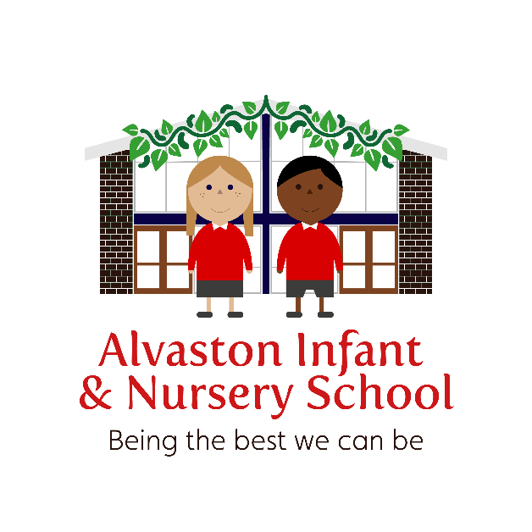

Charging and Remissions Policy

This policy has been signed / ratified by the Chair of Governors / Headteacher

Nov 2022
To be reviewed Nov 23

Review date | By whom | Summary of changes made | Date implemented
Nov 21 | SS | Added a section relating to Nursery fees | Nov 21
Sep 22 | SS | No change
Nov 22 | MA | Increase of £1 per breakfast and after school club, late fee added, change to nursery children – only able to use wrap around care as part of their funded hours, not additional, removal of milk charge

Alvaston Infant and Nursery School
Charging and Remissions Policy November 22
Introduction
This charging policy has been compiled in line with DFE requirements - DfE Charging for school activities: Departmental advice for governing bodies, school leaders, school staff and local authorities. May 2018

Basic Principles
School governing bodies and local authorities, cannot charge for:
- An admission application to any state funded school;
- Education provided during school hours (including the supply of any materials, books, instruments or other equipment);
- Instrumental or vocal tuition, for pupils learning individually or in groups, unless the tuition is provided at the request of the pupil’s parent;

Schools and local authorities can charge for:
Any materials, books, instruments, or equipment, where the child’s parent wishes him/her to own them;
- Optional extras (see details below);
- Music and vocal tuition, in limited circumstances;
- Certain early years provision; e.g. cooking/sewing etc…

Optional extras for which the school can apply a charge:
  - Extended day services offered to pupils: £6 breakfast club, £7 after-school club (From 1st April 23)
  - Education provided outside of school time that is not:
    - part of the national curriculum;
    - part of religious education.
  - Transport (other than transport that is required to take the pupil to school or to other premises where the local authority/governing body have arranged for the pupil to be provided with education)
  - Book bags – cost £3.50
If parents are ate to collect their child, from afterschool club or from Nursery, the following will apply (from Sept 22):
The first occasion, this will be overlooked.
The second occasion will be charged £5 per 15 minutes that are late. If a parent is 5 minutes late, this are still required to pay the full £5 fee and the school reserve the right to restrict access to the club until the payments are made.

Current Nursery Charges
Breakfast Club | Nursery children will not be able to use breakfast and afterschool club as additional hours. This provision will only be offered as part of FUNDED hours.
After School Club
Extra hour | £5.00 per hour

Voluntary Contributions
There is an exception to the rule about not charging for activities in school hours. Parents are invited to make voluntary contributions to extend the value of school funds. School trips, visits and practical activities enhance the pupils’ learning and broaden their knowledge and experience. These activities are made possible through the voluntary contributions of parents.

Examples where parents may be asked for a voluntary contribution include:
- School trips
- Enrichment activities e.g. external dance group, visitors into school that enhance the curriculum.
- After school clubs e.g. Dance, drama, cooking etc.

If a particular activity cannot take place without contributions from parents, this will be explained at the planning stage. If a planned activity has to be cancelled due to insufficient funds, any monies received will be returned. No pupil will be excluded from an activity because his or her parents cannot or will not make a voluntary contribution. The opportunity to pay in instalments will be offered to parents who wish to pay in this way.

Activities for which the school will apply a charge
The School may offer additional non educational services and the scale of charges will be approved by the Governing Body on an annual basis e.g. school disco (£2.50). If the service is a one-off, the Headteacher or Finance Committee may approve the charge.

Remissions Policy
Charges for chargeable activities may be fully or partially remitted for pupils in receipt of Pupil Premium*.

Details of any remission arrangements will be made clear when parents are informed of charges for individual activities.
The Head Teacher, School Business Manager, Finance Committee or Governing Body may decide not to levy charges in respect of a particular activity, if it feels it is reasonable in the circumstances.

*This does not apply in the case of pupils in receipt of the Government’s Universal Free School Meals not in receipt of Pupil Premium.

Other charges
The Headteacher, Finance Committee or Governing Body may levy charges for miscellaneous services up to the cost of providing such services e.g. photocopying or laminating.

Breakages & Damages
In cases of willful or malicious damage to equipment or breakages, or loss of school books on loan to children, the Head Teacher may decide it right to make a charge. Each incident will be dealt with on its own merit and at their discretion.

Scale of Charges
These will be approved by the Governing Body on a two-yearly cycle or sooner if necessary.

This policy and procedure is subject to The Equality Act 2010 which recognises the following categories of individual as Protected Characteristics: Age, Gender Reassignment, Marriage and Civil Partnership, Pregnancy and Maternity, Race, Religion and Belief, Sex (gender), Sexual orientation and Disability.

This policy will be reviewed in Nov 2023 or sooner if necessary.

