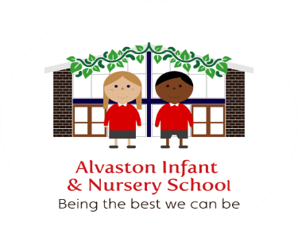

Alvaston Infant and Nursery School – Sept 23
Protection of Biometric Information of Children in schools and colleges

We do not hold this information store biometric information of children in any way, shape or form.

