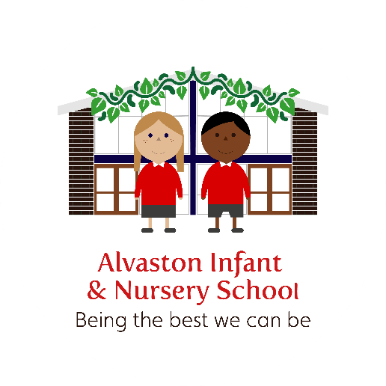
Alvaston Infant and Nursery School

Child Protection and Safeguarding Policy
This policy has been developed and updated by representatives from the Derby and Derbyshire Safeguarding Children Partnership (DDSCP) Derby and Derbyshire Education subgroups. The DDSCP education subgroups have approved and signed off the template policy.

This policy, that Alvaston Infant and Nursery School have adapted reflects Keeping Children Safe in Education (KCSIE) June 2023 as well as other relevant national guidance and local safeguarding children policies and procedures.

Our child protection/safeguarding policy is reviewed at least annually, as a minimum, and will be updated if needed to incorporate safeguarding issues as these emerge or evolve, lessons learnt and national or local changes.
For more details of DDSCP Derby and Derbyshire Education subgroups, please see the Derby and Derbyshire Safeguarding Children Partnership website www.ddscp.org.uk.

Name of school: Alvaston Infant and Nursery School
Date of policy publication: September 2023

Author/s of policy: MALLEN
Date of last review: Sept 23
Date of next review: Sept 2024 or sooner if required
Review date | By whom | Summary of changes made | Date implemented | Date ratified
4.09.19 | MALLEN | Local Safeguarding Children’s Boards, upskirting, Ofsted Framework, RSE, pupils involved in serious crime, named Mental Health Lead | 08.11.19
3/12/19 | MALLEN | After school and breakfast club arrangements | 03/12/19
10/12/19 | MALLEN | Changes to wording in breakfast/after school club
07/09/20 | MALLEN | Updated in line with KCSIE 2020 | Oct 2020 | 08/10/20
02/03/21 | CMabbutt | Updated addendum (page 41)  Changes to allegation section | March 21
15.3.21 | MALLEN | Changed poster to make easier for concerns to be reported
24.05.21 | MALLEN | Added info about safeguarding audit | May 21 | May 21
16.09.21 | MALLEN | Various updates inline with new KCSIE including: availability of DSL, minimising risk re child on child abuse, details of how to report concerns, sexual exploitation amendments, change to out of hours arrangements, phone information sharing protocols, annual safeguarding review, arrangements for transience, CME arrangements, Elective home education changes
20.10.21 | MALLEN | New poster update in appendix | Oct 21
22.03.2022 | MAllen | Reference to the prevent action plan and policy | March 22
13.9.22 | CMabbutt | More detail added to: Reference to KCSIE 2022,  Introduction (p3), Multi-agency (p6), staff expectations (p8-11), Roles and Responsibilities of DSL (p13), Opportunities to Teach (p21), Action on Concerns (p39-41), Safer Recruitment (p43), Visitors to School (p43), What is abuse? (p48), FGM (p64)  Added: Links to other school policies (p5-6), Staff induction (p7-8), Roles and Responsibilities of Headteacher (p13), Safeguarding Training (p14), Key Safeguarding Contacts (p16), Other Key Local Safeguarding Contacts (p16-17), Key National Contacts (p18), SEND pupils (p25), LGBT+ (p25), Online Safety (p25-26), Talk and Sort/Universal Support (p31), Intensive and Specialist Support (p32), Speakers (p43)  Peer on peer changed to child on child (throughout) | September 2022 | Sept 22
22.11.22 | MAllen | Searches specified and recruitment check list added | Nov 22
24.11.22 | MALLEN | Amendment to include collection at the end of the school day forms and clarification on under 18s collecting a child from school | Nov 22
16.08.23 | MALLEN | Various amendments to reflect KCSIE 23  Lieu time for attending meetings during half term, TA to champion vulnerable children and expectations added, inclusive pillars added, filtering and monitoring changes / amended with expectations of when and how this will be monitored, low level concerns regarding other staff members added, threshold document made explicit for Governors, chair of governors responsible for ensuring the HT has a statement regarding filtering and monitoring in job description, added staff safe arrangements, low level concerns expectations, referral to DBS Service added, staff safe, statement re siblings in other schools and admissions form which requests siblings / schools are shared, | Sept 23
27.9.23 | MALLEN | Added leaver check list for children | 27.9.23
This policy has been approved and ratified by the Governors and a signed copy is stored in the school office.
Contents  Section Page number  1. Introduction 4  2. What is abuse? 7  3. School staff safeguarding roles and responsibilities 8  4. Key safeguarding contacts 14  5. Ensuring a safe environment for all children 18  6. Responding to concerns about a child’s welfare 28  7. Child-on-child abuse, including sexual violence and harassment 36  8. Safer recruitment and selection of staff 41  9. What staff should do if they have a safeguarding concern or an allegation about another member of staff or concerns about safeguarding practices within the school 43 |  | Page

1. Introduction

Alvaston Infant and Nursery School recognises that we have an important role to play in multi-agency safeguarding arrangements. We are committed to safeguarding children and expect that everyone has a role to play. We expect everyone in our school to share this commitment.

This document outlines Alvaston Infant and Nursery School’s child protection / safeguarding policy. It applies to all adults, volunteers, governors, supply staff and contractors working in or on behalf of the setting.

Child protection is defined as safeguarding and promoting the welfare of children by:
- Protecting children from maltreatment;
- Preventing impairment of children’s mental and physical health or development;
- Ensuring children grow up in circumstances consistent with the provision of safe and effective care;
- Taking action to enable all children to have the best outcomes.

Children includes everyone under the age of 18.

Everyone working in, or for our school, takes all welfare concerns seriously and encourages children and young children to talk to us about anything that worries them.
We help to keep children safe by:

- Providing safe environments, with secure access, where children can learn and develop
- Acting in the best interests of children to protect them online and offline, including when they are receiving remote education
- At the earliest opportunity, identifying children who may need early help, and who are at risk of harm or have been harmed. This can include, but is not limited to, neglect, abuse (including by other children), grooming or exploitation
- Taking timely and appropriate safeguarding action for children who need extra help or who may be suffering, or likely to suffer, harm. This includes, if required, referring in a
timely way to those who have the expertise to help
- Using safe recruitment processes and managing allegations that may meet the harm threshold and allegations/concerns that do not meet the harm threshold, referred to as low-level concerns

We will ensure that parents and our partner agencies are aware of our Child Protection/ Safeguarding Policy by ensuring that it is displayed in both nurseries, in the staff room in the Reception Area. This will enable us to raise awareness at initial meetings with parents of new pupils and at parent teacher meetings and ensuring that it is on the school website. The school website will also have information about how parents/children/other agencies can contact the Designated Safeguarding Lead (DSL) and their deputy and include their availability during out of hours and school holidays. This is available via the Key Information Tab, under the Safeguarding Heading. Or via this link: https://www.alvastoni.derby.sch.uk/safeguarding
If there is an urgent need, dial 999 immediately or contact careline on 01332 956606.

There is a whole school approach and ethos to safeguarding and protecting children. At Alvaston Infant and Nursery School, we appreciate that ‘small pieces’ of information help to build up the whole ‘jigsaw.’ We use Child Protection Online Manager (CPOMS) to report concerns but these written reports do not replace conversations with the Designated Safeguarding Lead. A conversation must be had with the DSL for all concerns reported. Where a concern is deemed as urgent, the staff member, volunteer or contractor must seek out a DSL as a matter of urgency. If the DSL is in a meeting, they must enter the room and ask to speak privately.

All adults working in, or on behalf of the school have a responsibility to safeguard and promote the welfare of children and prevent radicalisation and extremism. This includes;
- Responsibility to provide a safe environment in which children can learn.
- Creating a culture of vigilance where we always act in the best interests of the child.
- Taking all welfare concerns seriously and encouraging children and young people to talk to us about anything that worries them.
- Identifying children who may be in need of extra/early help, have complex or serious needs or who are suffering, or are likely to suffer significant harm. All staff then have a responsibility to take appropriate action, working with services as needed.

Safeguarding and child protection policy statement
Alvaston Infant and Nursery School operates a whole school approach and ethos to safeguarding and protecting children. Where safeguarding is concerned, we maintain an attitude of “it could happen here”. We recognise that everyone in the school has a role to play to keep children safe; this includes ensuring children feel heard and understood, identifying concerns, sharing information, and taking prompt action. Safeguarding and child protection is incorporated in all relevant aspects of processes and policy development. All systems, processes and policies operate with the best interests of a child at their centre.

We ensure that all children are safeguarded while on or off school premises and are proactive about anticipating and managing risks that children face in the wider community and online. To support this the school assesses the risks and issues in the wider community when considering the well-being and safety of its learners. Due to the context of our school our children may be at greater risk of emotional harm due to the high number of domestic abuse incidents that are recorded within the school’s setting. Staff are aware that we must look for changes in the child’s behaviour e.g. withdrawn, quiet, displaying violent behaviour themselves. We are part of the Stopping Domestic Abuse Together initiative and this information is displayed on the school website. Our bespoke curriculum ensures that children are educated about healthy relationships and teachers are able to refer children to our Talk and Sort Champion, as and when they feel this is appropriate. In addition, there are a high number of disadvantaged families within the school (over 30%) and therefore, some families may suffer financial hardship, which may lead to neglect. The school works with the community in order to provide a network of support from uniform to food swaps / sharing.

To protect our learners, we have a Prevent action plan/risk assessment and are part of the Stopping Domestic Abuse Together (SDAT) initiative (Derby and Derbyshire’s local version of Operation Encompass). The curriculum has been carefully thought out so children are taught about their rights and how to keep themselves safe. The Safeguarding Lead has worked with the Computing Lead and Personal, Social, Health, Citizenship, Economic (PSHCE) Lead in order to decide key social phrases that children will be taught how to say. Half termly safeguarding monitoring occurs and patterns and concerns are analysed and shared so the school can implement strategies / approaches to mitigate these, if appropriate. The school also completes an annual safeguarding audit and will send the key actions to the authority once per year. These actions will be discussed with staff and Governors, as appropriate.

To support key multi-agency safeguarding communications we have a dedicated secure safeguarding email address: safeguarding@alvastoni.derby.sch.uk, which is accessible by at least three members of our safeguarding staff. During the school term and in school hours, this is checked daily. An ‘out of office’ message is operational during other times and in school/ holidays to advise partner agencies if and how often messages will be checked/responded to and when the school will reopen. Where possible, all Designated Safeguarding Leads will check their emails for urgent Child Protection emails at least every 2 days. The Designated Safeguarding Lead will always endeavour to attend Initial Child Protection Conferences and reviews even during holiday periods, as well as core group and network meetings. Where this is not possible, the school will look to seek out a designated safeguarding lead who may be able to attend. Time will be given back in lieu for the hours worked during holiday periods. Reports will always be written and shared via the appropriate channels.

Alvaston Infant and Nursery School is also aware of and implements any local learning where appropriate, such as those as outlined in DDSCP Briefing note: safeguarding school age children and learning from case reviews and other DDSCP briefing notes located in the multi-agency safeguarding children procedures document library. Updates will be shared with all staff as they come through. Each week, the weekly planner will include a snappy update in relation to KCSIE in order to act as a refresher for staff. We will always endeavour to support any external agency by offering a safe and confidential meeting space to host/hold meetings.

Context

This policy enables Alvaston Infant and Nursery School to carry out our functions to safeguard and promote the welfare of children and must be read alongside key guidance:
- Department for Education’s statutory guidance publications for schools and local authorities, including:
  - Working Together to Safeguard Children (2018)
  - Keeping children Safe in Education (June 2023)
  - Designated teacher for looked-after and previously looked-after children (2018)
- Human Rights Act (1998) and Equality Act (2010), including the Public Sector Equality Duty
- Data Protection Act (2018) and UK GDPR
- Prevent Duty Guidance (2015)
- Derby and Derbyshire Multi-agency Safeguarding Children procedures

Safeguarding is not just about protecting children from deliberate harm, neglect, or failure to act, it relates to broader aspects of care and education. This policy therefore complements and supports a range of other school policies relating to:
- Children’s health and safety and well-being, including their mental health (SMSC/PSHCE Policy)
- Relationship policy (formally known as the behaviour policy) including how we engage learners struggling to engage in school, mental health and behaviour, acceptable and non-acceptable behaviours, how we prevent and respond to bullying including cyber bullying, prejudiced based and discriminatory bullying and child-on-child abuse. This policy also outlines the school’s screening, searching, and confiscating powers and how they will be used safely, proportionately, and appropriately, including police strip searches
- Reduced timetables, suspension, and permanent exclusion (Exclusion Policy and Relationship Policy)
- Use of reasonable force/physical intervention, including the increased vulnerability of children with special education needs (SEN) or disabilities and equality duties (Positive Handling Policy)
- School attendance, including children who are absent from education particularly on repeat occasions and/or prolonged periods or go missing from education, home, or care
- Meeting the needs of learners with medical conditions (Children with medical needs who cannot attend school policy)
- Providing first aid (First Aid Policy)
- Educational visits Policy
- Intimate care Policy
- Online safety, including use of mobile and smart technology, online safety at school and at home and other associated issues, including sharing nudes and semi-nudes, use of mobile phones/devices in school, appropriate filtering and monitoring, and how children can be kept safe from terrorist and extremist materials
- Safer recruitment and selection, including single central record
- Staff behaviour (code of conduct), including low level concerns, managing allegations against staff, including supply staff, contractors and volunteers incorporating ‘duty to refer’ and whistleblowing, acceptable use of technologies/mobile devices, staff/learner relationships and communications, including the use of social media
- Policy/agreement for visiting speakers
- SEND annual information report
- Relationships education (RE)/relationships and sex education (RSE) and health education (physical and mental well-being) – PHSCE Policy
- Home School Agreement
- Complaints procedure
- Information sharing

What is abuse?

Abuse is a form of maltreatment of a child which may be caused by an adult, adults or by another child or children inflicting harm or by failing to prevent harm. The abuse can be physical, sexual, neglect or emotional, including witnessing the ill treatment of others, such as domestic abuse. Children can be at risk of abuse inside and outside of their home, in their community, inside and outside the school and online.

Safeguarding issues can put children at risk of harm. Behaviours linked to drug taking and or alcohol misuse, deliberate absence from or going missing from education, serious violence (including county lines), radicalisation, consensual/non-consensual sharing of nude and semi-nude images can be signs that children are at risk Whilst this may not be as prevalent in a infant school, many have older siblings and is important the school staff remain vigilant and aware. Abuse, neglect, and safeguarding issues are rarely stand-alone events; in most cases multiple issues will overlap with one another.

Safeguarding action may be needed to protect children from the following risks, which include abuse perpetrated by other children as well as by adults (this is a generic list and whilst some areas may not directly link to our infant aged children, it is important staff are aware and remain vigilant due to elder siblings and / or parents who may be sharing information in front of children):
- Any concerns that a child has suffered or is at risk of suffering physical abuse, sexual abuse, emotional abuse, or neglect
- Bullying, including online bullying and prejudice-based bullying, racist, disability and homophobic or transphobic abuse
- Gender-based violence/violence against women and girls
- Sexual harassment, online sexual abuse, and sexual violence between children. Online abuse can include sending abusive, harassing, and misogynistic or misandrist messages; sharing nude and semi-nude images and videos; and coercing others to make and share sexual imagery
- Radicalisation and/or extremist behaviour
- Child sexual exploitation and child criminal exploitation, including county lines
- Risks linked to using technology and social media, including online bullying; the risks of being groomed online for exploitation or radicalisation; and risks of accessing and generating inappropriate content, for example youth produced sexual imagery
- Abuse within intimate personal relationships between children (sometimes known as ‘teenage relationship’ abuse). Whilst this may not apply to our infant aged children, there may be some disclosures relating to older siblings
- Upskirting (taking a picture of someone’s gentiles or buttocks under their clothing without them knowing – this is a criminal offence)
- Substance misuse – drugs and alcohol
- Gang activity and serious violence, particularly affecting young males who have been excluded, have experienced trauma and have been involved in offending
- Domestic abuse
- Forced marriage, marriage/civil partnership under the age of 18, virginity testing or hymenoplasty, female genital mutilation and so-called ‘honour-based’ abuse
- Children with Perplexing Presentations (PP) in whom illness is fabricated or induced (FII).
- Homelessness
- Other issues not listed here but that pose a risk to children

Further information about indicators of abuse and neglect as well as safeguarding risks noted above are located in Keeping Children Safe in Education (June 2023).

School Staff Safeguarding roles and responsibilities

Staff and governors at Alvaston Infant and Nursery School will have an induction appropriate to their roles, which will include organisation vision/ethos, aspirations, and expectations of all staff, as well as what is considered acceptable and what is not. This will be shared in the form of a Staff Induction Check List, which must be signed and handed to the SBM on the day the induction is undertaken. All Governors will receive a Governor Induction Pack, with relevant information and policies to read. Governor induction will remain the responsibility of the Headteacher and Staff Governor. Governors will have an induction check list which encompasses child protection arrangements and the Governors’ Code of Conduct. New staff will also receive information about systems within the school which support safeguarding, including online safety and copies of policies; this includes:

- Child protection/ safeguarding policy, which includes how the school deals with child-on-child abuse
- School relationship policy (inclusive of behaviour and anti-bullying)
- Staff behaviour (code of conduct) policy, which includes acceptable use of technologies/mobile devices, online filtering and monitoring processes utlised and expectations associated with this, staff/learner relationship and communications, including the use of social media. The policy also incorporates low-level concerns, allegations against staff and whistleblowing
- The safeguarding response to children who are absent from education
- The safeguarding response to child-on-child abuse
- The role and names of the designated safeguarding lead, their deputy/ies, the designated teacher for looked after children, the senior mental health lead, and the designated governors who have safeguarding responibility

Volunteers will be briefed about the steps to take if children make a disclosure and how to record these incidents. This will always be on the first day of attending the school and may be done in a group, particularly if there are many university students. The staff / volunteer induction will be carried out by a member of the Senior Leadership Team. Staff / volunteers will be informed about the safeguarding response to children who go missing from education, child on child abuse, and the role and names of the designated safeguarding lead (DSL), their deputies, the designated teacher for Looked After Children, the Senior Mental Health Lead as well as the name of the designated Safeguarding Governor and named Mental Health Governor. Staff/ volunteer inductions will also cover how we are ensuring children with allergies are kept safe. It will be made clear that no volunteer or staff member must access the wi-fi using any personal device.

Staff expectations

All staff will:
- Receive a paper/electronic copy of the safeguarding policy, they will read and sign to say that they have received, read, and understood this, this will be in paper form and will be kept on file. There will be a tick list of staff members at the front to ensure every staff member has signed and read the relevant information. This will be checked against the most up to date / current employers on the system half termly by the Business Manager and Headteacher/DSL. The school will ensure that:
  - Those who work directly with children will read at least Part one of Keeping Children Safe in Education: for school and staff and Annex B: Further information (June 2023)
  - School leaders, including governors and designated safeguarding leads/deputies will read all of Keeping Children Safe in Education (June 2023)
  - Staff who do not work with children directly will read at least Keeping Children Safe in Education: for school and staff (part 1) (June 2023) or Annex A Safeguarding information for school and staff – this may be for contractors who are not working directly with children – this is a Governor decision, which will be reviewed annually.
  - Staff receive regular safeguarding and child protection (including online safety) updates at least annually via email, e-bulletins and staff meetings to help provide them with an awareness of safeguarding issues that can put children at the risk of harm (including private fostering arrangements, drug taking, alcohol abuse, family members who offend or are in prison, deliberately missing education, homelessness, sexting also known as ‘youth produced sexual imagery’, ‘honour based’ abuse/violence including FGM and forced marriage, sexual exploitation, serious violent crime, criminal exploitation/county lines, child on child on child abuse and radicalisation/extremism), ensuring they have the relevant skills and knowledge to safeguard children effectively.
  - The Computing Lead will provide a half termly information sharing update regarding any new apps for parents and staff members, or if necessary, will post and share issues as they arise.
All staff will:
Be aware of:
- The Stopping Domestic Abuse Together initiative (known nationally as Operation Encompass), a police-led early domestic abuse notification to schools
- The safeguarding response to children who are absent from education
- The safeguarding response to child-on-child abuse
- The early help process for low level and emerging needs and understand their role in it
- The process for making a referral to local authority children’s social care, the statutory assessments that may follow this and the role they may play in such assessments
- Ask if they are unsure about any processes, actively looking to seek out the answers
- Know what to do if a child tells them they are being abused, exploited, or neglected and will be able to reassure children they are being taken seriously, will be supported, and kept safe
- Know what to do if a child shares, produces or receives a sexual communication, including sharing nudes/ semi-nudes
- Know what to do if a parent or carer shares any concerns about a child
- Not assume a colleague or another professional will take action and share information that might be critical in keeping children safe.
Be aware:
  - Children may not feel ready or know how to tell and/or might not recognise their experiences as harmful and that certain children may face additional barriers to telling
  - Any child may benefit from early help and be alert to the need for early help for some groups of children
  - Of the indicators of abuse, exploitation, and neglect, understand that children can be at risk inside and outside of the school, in their home, institutional or community setting and online
  - Children can abuse other children, referred to as child-on-child abuse
  - Children with special education needs or disabilities (SEND), particularly those with neurodevelopmental conditions such as autism, as well as those with certain medical or physical health conditions are particularly vulnerable to online and offline abuse, exploitation, and neglect - and also face additional barriers to the recognition of this abuse
  - In addition to children with SEND, that some groups of children are potentially at greater risk of harm, including children who need a social worker, children absent or missing from education or who are electively home educated, children requiring mental health support, looked after/previously looked after children and children who are, or may be, lesbian, gay, bi, or trans (LGBTQ+)
  - Technology is a significant component in many safeguarding and well-being issues
  - Mental health problems can, in some cases, be an indicator that a child has suffered or is at risk of suffering abuse, neglect or exploitation
  - That children’s poor behaviour may be a sign that they are suffering harm or that they have been traumatised by abuse
  - Of the ‘one chance’ rule with suspected or actual victims of forced marriage and so called ‘honour-based’ abuse. That is, they may only have one opportunity to speak to a victim or potential victim to offer appropriate support and advice
  - Of the possible indicators, alongside other factors, and contexts, that a child is likely to be susceptible to an extremist ideology
  - Of the indicators which may signal children are at risk from, or involved with, serious violent crime
In addition, staff will:
- Have the skills, knowledge and understanding to keep looked after children and previously looked after children safe
- Discuss any concerns including emerging needs, complex/serious needs or child protection issues with the Designated Safeguarding Lead (DSL) or their deputy to agree a course of action. If staff members are unsure, they should always speak to the designated Safeguarding Lead or their deputy. This must also be followed up in writing, via CPOMS and the DSL / Deputy DSL should be ‘alerted’ It is important staff notice the ‘small’ signs and log these in order to intervene early
- Speak to the designated safeguarding lead or deputy about any concerns about so called ‘honour-based’ abuse, breast ironing, female genital mutilation (FGM), virginity testing and hymenoplasty
- Work with the designated safeguarding lead and do everything they can to support social workers to help them carry out a statutory assessment
- Be mindful that early information sharing is vital to identifying and tackling all forms of abuse and neglect and in promoting children's welfare, including in relation to their educational outcomes
- Be mindful that early information sharing is vital for the effective identification, assessment and allocation of appropriate service provision
- Not share information over the phone without making certain that the person at the end of the line should have access to the information requested. If any staff member is in doubt, they should ask the person on the end of the line to send a professional email, from their work account stating who they are. This will confirm the professional status of the person at the end of the line
- Know what to do if a child tells them about welfare concerns or that he/she is being abused or neglected and how to share information appropriately only involving those who need to be involved such as the designated safeguarding lead (or a deputy) and social care
- Know what to do if a child shares, produces or receives a sexual communication, including sharing nudes / semi-nudes (also known as sexting /‘youth produced sexual imagery)’
- Know that children’s poor behaviour may be a sign that they are suffering harm or that they have been traumatised by abuse.
- Always report any low level concern regarding any colleague and understand the difference between personal and professional relationships, always acting in the best interest of the child, rather than being worried they may ‘upset’ a friend or cause trouble’
- Understand that low level concerns will be logged on record via Staff Safe and in most cases, staff will be made aware a concern has been logged

We will engender the principle that safeguarding is 'everyone's responsibility'.

All staff and volunteers should raise any concerns they have about poor or unsafe practice and potential failures in the school safeguarding regime. These concerns will be taken seriously by the Senior Leadership Team. See the school Whistleblowing Procedures (including the option to report to the Chair of Governors who will investigate in Staff Safe) for how such concerns can be raised with the Senior Leadership Team and the other whistleblowing channels open to staff. If a concern is raised and serious harm is alleged, the school will ensure that this is formally documented on the staff member’s personnel file.

Roles and Responsibilities of Governors
As outlined in Keeping Children Safe in Education (2023), The Governing Body have a strategic responsibility for our school’s safeguarding arrangements and has the responsibility to ensure that the school complies with safeguarding duties under legislation and will identify a senior board level lead to take leadership responsibility for the establishment’s safeguarding arrangements. Safeguarding is a standing item at all governing body meeting and is included as a separate agenda item, titled Safeguarding Report. Issues and themes that come from analysis are always monitored and shared with Governors.

The governing body, the senior leadership team and designated safeguarding lead are aware of and follow local arrangements. This includes understanding and applying the Threshold document (criteria for action), local Protocol for Assessment in Derby and Derbyshire, Derby or Derbyshire Child Protection Conference Professionals Dissent process and Dispute Resolution and Escalation policy. Arrangements have been made to set out information sharing processes and principles within the school and with local authority children’s social care, safeguarding partners (Derby and Derbyshire Safeguarding Children Partnership/DDSCP) and other agencies. The school will supply information as requested by the DDSCP which enables and assists partners to perform their functions to safeguard and promote the welfare of children in their area, including information related to local and national child safeguarding practice reviews.

Alvaston Infant and Nursery School use DDSCP annual audit tool – key actions will be shared with Governors, annually. In addition, an annual review and risk assessment of the school’s approach to online safety, policy and practice is undertaken using the free 360 Degrees Safe Online Safety Self-Review Tool for Schools.

The Chair of Governors will also ensure that the Headteacher’s job description references the lead responsibility to safeguard children and is responsible for the filtering and monitoring processes.

Roles and Responsibilities of the Headteacher
The school headteacher will ensure that the policies and procedures, adopted by the governing body, are understood, and followed by all staff. This includes working with other Designated Safeguarding Leads (DSL), their deputy, and other senior leaders, to ensure the effectiveness of safeguarding within the school and ensuring that educational outcomes of children who have or have had a social worker are promoted.

The Roles, Responsibilities of the Designated Safeguarding Lead (DSL)
The Designated Safeguarding Lead (DSL) is a senior member of staff (the Headteacher) who takes lead responsibility for safeguarding and child protection (including online safety and understanding the filtering and monitoring systems and processes in place).

The DSL will co-ordinate the setting’s safeguarding and child protection arrangements by providing advice and support to other staff on child welfare, safeguarding and child protection matters, including Stopping Domestic Abuse Together (SDAT) notifications, takes part in strategy discussions/ meetings and inter-agency meetings – and /or supports other staff to do so - and contributes to the assessment of children. All Domestic Abuse Notifications will be logged on CPOMS by the DSL and will be followed up by a staff member who knows the child. This will be recorded as an action, even where the child does not disclose anything of any concern.

The establishment also has a deputy Designated Safeguarding Lead (DSL) to cover for when the Designated Safeguarding Lead (DSL) is not available; the lead responsibility however remains with the Designated Safeguarding Lead.

The designated safeguarding lead actively liaises with other school staff with safeguarding responsibilities, teachers, Talk and Sort lead, school nurses, SENCo, the inclusion team and senior mental health leads on matters of safety and safeguarding to ensure safeguarding and promoting children’s well-being are effective.

The designated safeguarding lead or a deputy is always available during school hours for the staff in the school to discuss any safeguarding concerns. During Holiday Clubs / non term time care, there will always be a DSL available on site or via telephone.

More information about the role and responsibilities of the designated safeguarding lead can be found in Keeping Children Safe in Education (June 2023) Annex C: Role of the designated safeguarding lead.

Availability of the Designated Safeguarding Lead (DSL)

The Designated Safeguarding Lead (DSL) or a deputy is always available during school hours (8am-5:30pm) for the staff in the school to discuss any safeguarding concerns. During out of hours, staff can call or send a message to the Designated Safeguarding Lead, Miss Molly Allen, via telephone. No information must be disclosed when sending a message. The message must state that a call is needed urgently due to an urgent safeguarding concern. The Designated Safeguarding Lead will endeavour to respond within a few minutes. Should there be no response, the staff member should contact a Deputy Designated Safeguarding Lead, Mrs Tracy Darby or Suzie Simpson. Where these channels do not work, staff should contact Careline, based at the Royal Derby Hospital, on: 01332 956606.

Where parents, carers or members of the community have concerns, they can email head@alvastoni.derby.sch.uk or safeguarding@alvastoni.derby.sch.uk requesting a call and stating that it is an urgent matter. They should leave a telephone number so that a phone call can be made and the concern dealt with swiftly. If calling the school office to report concerns, we ask that parents/carers/members of the public do not leave answerphone messages containing sensitive information and that instead they state they have an urgent safeguarding concern and that they require an urgent call back.

At present, the Headteacher is the DSL and therefore, the list below may need amending, should this change. The key roles of the Designated Safeguarding Lead (DSL) and Headteacher include:

- Referring cases of suspected abuse or neglect to children’s social care or where radicalisation is a concern to the Channel programme - or supporting staff who refer cases. They are also responsible for referrals to the Disclosure and Barring Service and the police. As the DSL is the Headteacher, this may change should the headteacher relinquish the DSL post.
- Working with staff as a source of support, advice and expertise, a point of contact with safeguarding partners, liaise with other headteachers (e.g. siblings in other schools), ‘case manager’ and relevant staff (i.e. teachers, pastoral support, IT leads, senior mental health leads/mental health support team and SENCos) to ensure children are effectively safeguarded and protected.
- Listening and understanding the views of children.
- Promoting supportive engagement with parents.
- Taking lead responsibility for promoting the educational outcomes of children who have or who have had a social worker.
- Holding and sharing of information, sharing and managing safeguarding/child protection files, including the effective transfer of files when a child moves to a new provider. When a child from Alvaston Infant and Nursery School is taken off role, the DSL will make contact with the DSL at the receiving school. Concerns will be shared and a record of the date and time this information was passed on will be kept. Files will be sent securely using a password, or delivered in paper form to any school who will receive a child with a child protection file. When a new child starts in the school, the DSL will ensure that a telephone call is made to confirm if there have been any safeguarding concerns at the previous setting. If there are concerns shared, these will be logged via the school system, CPOMS.
- Raising awareness of and ensuring staff understand the school’s safeguarding/ child protection policies and procedures, ensuring it is reviewed and updated at least annually. Staff will be notified in person or via email of any changes.
- Having the knowledge and skills to carry out the role, including understanding and working knowledge of local assessment processes for providing early help and statutory assessments, child protection conferences, supporting and protecting children, information sharing, specific needs of vulnerable children, impact of adversity and trauma, Prevent Duty and online safety.
- Ensuring the admissions form, completed by parents and carers, asks whether the child has any other siblings and if so what schools they attend, in order to share information readily, if needed.

Safeguarding training
In addition to the safeguarding training at induction, all staff and governors will receive safeguarding training appropriate to their roles and responsibilities which is regularly updated as well as Prevent Duty, child-on-child abuse and online safety training (which includes effective responses to sharing nudes/semi-nudes and an understanding of the expectations, applicable roles and responsibilities in relation to filtering and monitoring), so they are equipped with the knowledge and skills to keep children safe. They will also receive regular safeguarding and child protection (including online safety) updates at least annually to help provide them with an awareness of safeguarding issues that can put children at the risk of harm ensuring they have the relevant skills and knowledge to safeguard children effectively.

All staff will receive training on attendance, with dedicated attendance training for any staff with a specified attendance function in their role, including administrative, pastoral or family support staff, and senior leaders.

The governors’ safeguarding training and updates will enable them to have the knowledge to provide strategic challenge to test and assure themselves that safeguarding processes and procedures are effective and robust and a whole school/ approach to safeguarding is in place.

Those involved with the recruitment and employment of staff to work with children will have received appropriate safer recruitment training.

Key safeguarding contacts

Safeguarding Role | Name and Role | School/ contact details
Designated Safeguarding Lead | Molly Allen, Headteacher | 01332 571704 head@alvastoni.derby.sch.uk
Deputy Designated Safeguarding Lead | Tracy Darby – Assistant Headteacher  Suzie Simpson – School Business Manager | 01332 571704 tdarby@alvastoni.derby.sch.uk  sbm@alvastoni.derby.sch.uk
Senior Leaders available for contact in the absence of Designated Safeguarding Lead | Lisa Doherty – Assistant Headteacher  James Heesom – Assistant Headteacher | ldoherty@alvastoni.derby.sch.uk  jheesom@alvastoni.derby.sch.uk
Other staff with safeguarding responsibilities | Kelly Goodman – Talk and Sort Lead | kgoodman@alvastoni.derby.sch.uk
Attendance admin support | Joe Babicki and Deb Wright | admin@alvastoni.derby.sch.uk
Attendance Lead / Education Welfare Officer | Fiona Tizzard | Fiona.tizzard@derby.gov.uk and 01332 64172
SENCo | Tracy Darby Assistant Headteacher  Consultant SENDco – Kathy Wheatley | 01332 571704  tdarby@alvastoni.derby.sch.uk  kwheatley@alvastoni.derby.sch.uk
Designated Safeguarding Governor | Amy Jones Holt  Julia Steele  Mary Gillingham | 01332 571704  ajholt@alvastoni.derby.sch.uk  jsteele@alvastoni.derby.sch.uk  mgillingham@alvastoni.derby.sch.uk
Designated Teacher for Looked After/ previously Looked After Children | Molly Allen, Headteacher | 01332 571704  head@alvastoni.derby.sch.uk
Senior Lead for Mental Health and Well-being | Sarah Carnall | scarnall@alvastoni.derby.sch.uk  01332 571704
Governor for Mental Health and Well-being | Sarah Bonshor | 01332 571704  sbonshor@alvastoni.derby.sch.uk

Other Key Local Safeguarding Contacts

 | Derby |  | Derbyshire
Early Help Advice | Early Help Advisors vcm2@derby.gov.uk |  | Transition Team vcm2@derby.gov.uk
Targeted Early Help requests | Locality Vulnerable Children Meeting (VCM) for requests for targeted early help via multi-agency team (MAT) or non-urgent social care referrals via Locality Based Single Point of Access (SPA) Clerks:  Locality 2 Sinfin, Alvaston, Boulton, Chellaston, Osmaston and Allenton  Email: vcm2@derby.gov.uk |  | Requests for support from professionals, should be made via the online request for support unless a child is at risk of Significant Harm
Speak to a Social Worker for thresholds advice and consultation | Children's Services Professional Consultation Line 07812 300329 |  | Starting Point Consultation and Advice Service for Professionals 01629 535353
Referrals to Local Authority Children’s Social Care | Initial Response Team  Urgent: 01332 641172 or out of hours via Careline 01332 956606  Non urgent: Derby Children's Social Care Online Referral system |  | Starting Point  Urgent: 01629 533 190  Non urgent:  Starting Point online
Local Authority Designated Officer (LADO) | Derby and Derbyshire LADO referral form  Email: CPMduty@derby.gov.uk |  | Derby and Derbyshire LADO referral form  Email:  professional.allegations@derbyshire.gov.uk
Derbyshire Police | - 999 for emergencies or 101 for non-emergencies  - Mandatory reporting of Female Genital Mutilation (FGM) via 101  - School Police link officer - Mark Cox
Prevent (radicalisation and extremism) | - Police Prevent (radicalisation/extremism) Team on 101 or directly via 0300 1228694  - Prevent/channel referral form  - For advice contact:  Derbyshire - 01629 538473 or prevent@derbyshire.gov.uk  Derby - 07765 222032 or sally.siner@derby.gov.uk
Education Welfare and  Local Authority Children Missing Education CME) Officer | - Derby Education Welfare Service  - CME: 01332 641448 or cme@derby.gov.uk  - See Children Missing Education for further information and CME referral form and for notification forms for child on roll, removal from roll and removal from roll to Elective Home Education (EHE) |  | - Derbyshire Education Welfare Services  - CME: CS.CMECoordinators@derbyshire.gov.uk  - See Children missing from education (CME) policy and guidance and removal from school roll for further information
Virtual School for Looked After Children | - Virtual School Head - 07812 301044 or graeme.ferguson@derby.gov.uk |  | - Rachel Moore, Head of the Virtual School for Children in Care  07798 882876 or rachel.moore@derbyshire.gov.uk
Public Health Nurse/other health contact/s | - Jo Price joanna.price1@nhs.net
Emotional Health and Well-being Services | - Emotional Health and Well-being Services - https://hubofhope.co.uk/concerns?latitude=52.9395815&longitude=-1.5163811
Domestic Abuse | - Derby city life links  - Safer Derby City  - Derbyshire constabulary - information and advice about domestic abuse webpages  - Domestic abuse support services | - Safer Derbyshire domestic abuse webpage  - Derbyshire constabulary - information and advice about domestic abuse webpages
Harmful Sexual Behaviour Service | Action for Children Pathway Programme Service for harmful sexual behaviours. Please note this service is for children in Derbyshire who are living with their birth family. pathwayservice@actionforchildren.org.uk
Cyberchoices | For children at risk of being drawn into cybercrime via East Midlands Cyber Secure
Homelessness or at risk of homelessness | Derby city council homelessness webpages |  | Derbyshire county council Preventing homelessness webpages

Key National Contacts
Organisation | Description and contact details
NSPCC helpline for adults | Helping adults protect children 24 hours a day. For help and support, including anyone needing advice about female genital mutilation, young people affected by gangs, concerns that someone may be a victim of modern slavery contact the NSPCC trained helpline counsellors on:  - Text 88858  - 0808 800 5000  - help@nspcc.org.uk
NSPCC helpline Report Abuse in Education | Bespoke helpline for children and young people who've experienced abuse at school, and for worried adults and professionals who need support and guidance:  - 0800 136 663  - help@nspcc.org.uk
NSPCC Whistleblowing Advice | Free advice and support for professionals concerned about how child protection issues are being handled in their organisation:  - 0800 028 0285  - help@nspcc.org.uk
UK Safer Internet Centre professional advice line | Helpline for professionals working with children and young people in the UK with any online safety issues they may face themselves or with children in their care:  - 0844 381 4772  - helpline@saferinternet.org.uk
Police Anti-Terrorist Hot Line number | 0800 789 321
National Domestic Abuse Helpline | Hosted by Refuge, Helpline 0808 2000247
Operation Encompass | Resources for schools include free advice from an Education Psychologist about how best to support children via National Helpline 0204 513 9990
Report harmful online content | - UK Safer Internet Centre – report online harm. A national reporting centre that has been designed to assist anyone in reporting harmful content online  - CEOP – to report online sexual abuse or the way someone has been communicating online
Report Abuse in Education helpline | - Young people who have experienced abuse at school and parents and teachers who are concerned about sexual abuse in education settings can call the Report Abuse in Education helpline on 0800 136 663 or email help@nspcc.org.uk
Harmful Sexual Behaviour Support Services | - SWGfL Harmful Sexual Behaviour Support Service for the children’s workforce 0344 2250623 or email hsbsupport@swgfl.org.uk  - Stop it now! For worries about a child’s sexual behaviour, 0808 1000 900

Ensuring a safe environment for all children

Alvaston Infant and Nursery School provides a safe environment where children can learn and develop. This is an essential part of our whole school approach to safeguarding which incorporates a culture of vigilance where children’s welfare is promoted, timely and appropriate safeguarding action is taken for children who need extra help or who may be suffering, or likely to suffer harm. At Alvaston Infant and Nursery School, we appreciate that ‘small pieces’ of information help to build up the whole ‘jigsaw.’

The school environment is safe and secure and protects our learners from harm or the risk of harm and there are a variety of channels in place to ensure that this can occur. Positive behaviours are consistently promoted, and abusive or inappropriate behaviour challenged. A positive and supportive environment is promoted which gives learners a sense of being valued.

Alvaston Infant and Nursery School will therefore ensure that:
- All staff remain vigilant to the indicators of abuse, neglect and specific safeguarding issues such as child criminal exploitation, child sexual exploitation and child on child abuse.
- Staff are aware that technology is a significant component in many safeguarding and well-being issues; abuse may occur online and/or offline.
- There is a whole school approach to online safety to address the 4 areas of risk; content, contact, conduct and commerce.
- An ethos is established and maintained where children feel secure and are encouraged to talk and are listened to, taken seriously and responded to appropriately. Where teachers identify a child to be vulnerable, they will be referred to our Talk and Sort Champion and will have regular weekly or bi-weekly sessions. Meetings between the DSL and Talk and Sort Champion occur weekly.
- Children are involved in the decision-making which affects them.
- Children know that there are adults in the school whom they can approach if they are worried or have difficulties and the setting has well developed listening systems. These include worry boxes, a buddy system and providing children with the opportunity to talk.
- Information is provided to children and their families and posters are displayed which detail contact numbers for appropriate support services and child protection helplines.
- Curriculum activities and opportunities (including any remote learning) are planned/provided to equip children with the resilience and skills they need to stay safe from abuse, exploitation and radicalisation.
- All remote learning activities will incorporate safeguarding procedures and follow the same principles set out in the school’s Staff Behaviour Policy (Code of Conduct) and online safety policy.
- School trips are thoroughly risk assessed to ensure that children’s safety is never jeopardised.
- There is a clear written statement of the standards of behaviour and the boundaries of appropriate behaviour expected of staff and pupils that is understood and endorsed by all.
- There is an awareness that where children have suffered abuse or neglect, or other potentially adverse childhood experiences, this can have a lasting impact throughout childhood, adolescence and into adulthood. These experiences can impact on children’s mental health, behaviour and education and they may require additional support. This will be given through the DSL, Class Teacher and Talk and Sort Champion.
- Positive and safe behaviour is encouraged among children; staff are alert to changes in a child’s behaviour and recognise that changes in behaviour may be an indicator of exploitation, abuse or neglect and/or an indicator the child may be experiencing a mental health problem or be at risk of developing one. Staff can refer a child to the Talk and Sort Champion by logging their concern on CPOMS.
- Effective working relationships are established with parents and colleagues from partner agencies.
- There is an awareness that there may be wider environmental factors present in a child’s life that are a threat to their safety and welfare (contextual safeguarding/ place based risk). For example, personal and family circumstances and lifestyles of some children lead to an increased risk of neglect and or abuse.
- There is a recognition that children who do not attend regularly are particularly vulnerable and at increased risk of neglect, exploitation and abuse. Attendance forms part of weekly PPA sessions and is tracked closely by teachers, Year Group Leads and the Headteacher.
- Staff are appropriately trained in safeguarding, according to their roles and responsibilities, have regular opportunities for safeguarding briefings and records are kept of all training undertaken. Bulletins are shared via email. Support Staff have regular meetings with the Headteacher / DSL in order to refresh knowledge.
- Robust safer recruitment procedures are used to make sure that all appropriate checks are carried out on staff (including supply staff and volunteers) who work with children.
- Volunteers and visitors are appropriately supervised and are not left alone with children unless they have an enhanced DBS Check.
- The environment is safe and secure; this includes ensuring that all visitors to the setting are suitable and checked and monitored as appropriate. The school “Visitors’ Policy” sets out how visitors will be checked and monitored. Also see DDSCP Access to Schools by Staff from Other Agencies Briefing Note.
- Where the school has invited external agencies in i.e. to support delivery of subjects such as online safety, relationships /relationships and sex education and health education, there will be an agreement made in advance of the session on how a safeguarding report should be dealt with by the external visitor.
- Any groups using school premises for the provision of services to children have their own safeguarding policies, or adopt the school policy, and have satisfactorily completed all appropriate checks. Where possible, a DSL from school will always be on site.
- All visiting speakers present materials appropriate to the age and maturity level of pupils, that do not insult or promote intolerance of other faiths or groups, adhere to the school’s equality duties and are not permitted to incite hatred, violence, call for the breaking of the law or promote any acts of terrorism or extremism.

Vulnerable children
We recognise that some groups of children are potentially at greater risk of harm than others and have agreed arrangements to ensure the safety of these children:

- Children who need a social worker (Child in Need and Child Protection Plans). As a matter of routine, the designated safeguarding lead will hold and use the information that the child has a social worker to ensure that as a matter of routine, decisions can be made in the best interests of the child’s safety, welfare and educational outcomes. In addition, the school will work with the virtual head as appropriate, regarding the educational attendance, attainment, and progress of children with a social worker. The school ensures every child with a social worker is seen by our Talk and Sort Lead who is a mental health first aider and is trained to work with children who may have experienced trauma, at least bi weekly. In addition, the school has a designated teaching assistant who supports the DSL / Headteacher in securing the best outcomes for children who have social workers. There are individual plans to support these children with their learning and their progress is reviewed half termly.

- Children who are absent from education. We proactively manage and take steps to improve attendance across our community. Attendance is the essential foundation to positive outcomes for all of our learners and is everyone’s responsibility in school.

Our response to children who are absent from education, particularly on repeat occasions and/or prolonged periods, supports identifying a range of safeguarding issues and abuse; it also helps prevent the risk of absent children becoming a child missing education in the future. This includes when problems are first emerging but also where children are already known to local authority children’s social care and need a social worker, where being absent from education may increase known safeguarding risks within the family or in the community. We support and monitor attendance and absence carefully to identify learners or cohorts that require support with their attendance and put effective strategies in place.

This includes:
- Building strong relationships with families, listening to, and understanding barriers to attendance and working with families to remove them.
- Sharing information and work collaboratively with other schools in the area, the local authority, and other partners when absence is at risk of becoming persistent or severe.

The DSL creates an attendance register half termly which identifies any child who has attendance below 91%, who we have concerns about. It sets to identify patterns and trends and outlines how the school are attempting to listen and understand and facilitate support. It also seeks to document any barriers the family may face. This is reviewed each half term. Should the Headteacher not be the DSL, this duty may change.

Bi weekly, the attendance admin lead and DSL/headteacher meet to analyse the attendance across the school. Where there are concerns, children are placed in an ‘amber group’ – which means their attendance is typically 96% or below. If there continue to be concerns/no improvement, the child will be placed in a red group (typically 91% and below). In addition, attendance will be analysed in every PPA session and should a child be placed into ‘amber group’ the year group lead will make a phone call home or call a meeting with the parents of the child to identify how we can help to improve attendance. The Headteacher will be responsible for calling any child who falls into the red group. All records of conversations will be logged on our online child protection system, CPOMS. (Child Protection Online Management System). The school will work with the Educational Welfare Officer (EWO), where appropriate. Parents/ carers are made aware that school or EWO will conduct home visits and they will inform the EWO if attendance continues to deteriorate.

If a home visit is conducted and the family are not home, the DSL will leave a note at the child’s house, contact any additional contacts and notify the EWO, Social Care and the Police (if appropriate). The school will continue to work closely with all relevant agencies and should the child be suspected as being ‘missing’, the police will always be contacted.

Alvaston Infant and Nursery School always endeavours to ensure that children can attend school every day, despite any challenges that they may have with regulating their behaviours. However, we recognise that when children are not in school, such as when a learner is on a reduced timetable, suspended or excluded, they miss the protection and opportunities that education can provide, and can become more vulnerable to harm. Learners who have a social worker, including looked-after children, and previously looked-after children, are especially vulnerable. In the very rare occasion that a child is suspended or excluded, the school will always proactively support learners in the school environment and decision-making processes about reduced timetables, suspension or exclusion and operate in the best interest of children as outlined in local and national guidance. Part time timetables will only ever be implemented to enable a safe risk assessment to be put in place and / or if this is in the best interest of the child to help keep themselves or others safe. Where a child is on a reduced timetable, there will be a plan to increase this back up to full time, should it be appropriate, within two weeks. The local authority will be notified of all children at risk of exclusion and those who are on reduced timetables.

See national guidance Behaviour in Schools (2022), Suspension and Permanent Exclusion from maintained schools, academies and pupil referral units in England, including pupil movement (2022), Supporting pupils at school with medical conditions (2015) and local guidance Derby part-time timetable guidance and a protocol and Derby In Year Fair Access (IYFA) and Exclusions or Derbyshire part-time timetables and Derbyshire attendance management and exclusions)

- Elective home education. Where a parent/carer has expressed their intention to remove a child from school with a view to educating at home, the school will seek to co-ordinate a meeting with the parents/carers, Local Authority, and other key professionals where possible. This would be before a final decision has been made, to ensure the parents/carers have considered what is in the best interests of each child and is particularly important where a child has SEND, is vulnerable, and/or has a social worker or is vulnerable. Where a child has an Education, Health and Care Plan (EHCP) the local authority should review the plan with parents/carers. Where a child is taken off roll, we will inform the Local Authority of the deletion from our admission register via the system outlined on the Derby or Derbyshire Education Welfare webpages.

- Children who require mental health support. Mental Health and wellbeing is at the heart of our school and we recognise for our children to achieve their best, they need to be fully supported emotionally and mentally. Our curriculum aims to educate children about the importance of looking after their bodies and their mind. We also try to ensure that the curriculum promotes positive mental health and well-being and we use the Arts as a vehicle in order to encourage children to express themselves freely. This is reflected in our educational provision e.g. the curriculum, forest school, talk and sort. Mental health concerns can be an indicator that a child has suffered or is at risk of suffering abuse, neglect, or exploitation. We have clear systems and processes in place for identifying possible emotional well-being issues and mental health problems, seek advice from external agencies where appropriate and have clear referral and accountability systems. Our school has a variety of children’s mental health first aiders and a teaching assistant provides 3 days of targeted support for children who we have concerns about. Parents and staff can refer children to talk and sort and this support is carefully planned to meet the needs of individuals or groups of individuals. These are reviewed half termly and a full analysis is completed to consider if there are any other pathways that can be explored / referred to, if needed. Derby Direction is used as a resource in order to signpost support. https://derbydirection.org.uk/ Any child who has a social worker will be offered talk and sort in order to support their mental health and wellbeing as well as helping them to develop their self confidence. Notes from these sessions will be recorded on CPOMS. In addition, staff will analyse behavioural incidents, weekly and will discuss concerns and next steps with their Year Group Lead. This may result in the child being referred to Talk and Sort, discussions with groups of children, educating the children regarding a certain area etc. Alvaston Infant and Nursery School have recently become an ‘Inclusion School’ and one of these pillars is social, emotional, mental health and there are half termly inclusion meetings. Please see below for our inclusion pillars.

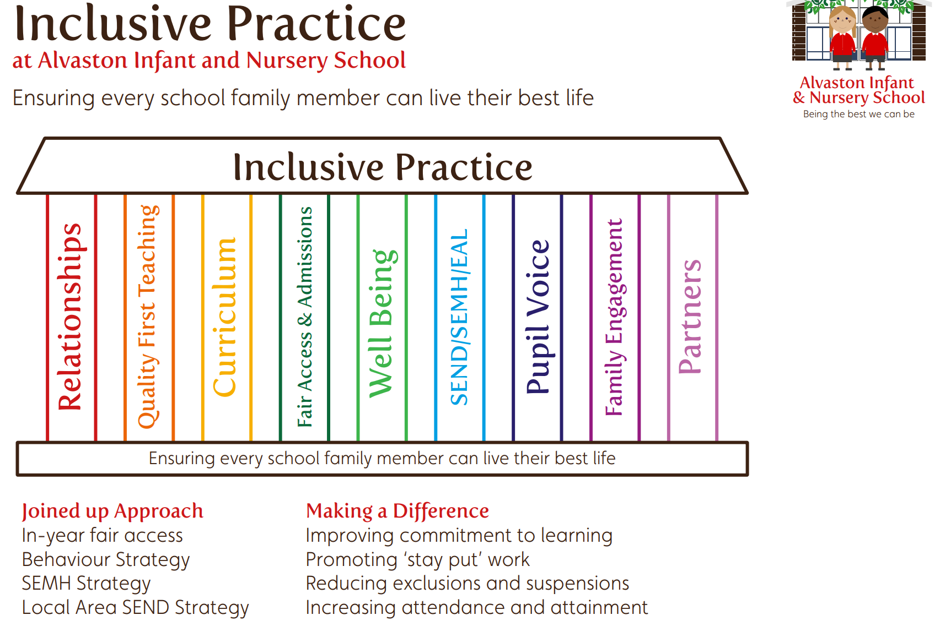

During these meetings, professionals discuss individual children to ensure that they are receiving the right support, in the right place, at the right time.

The school also provides additional forest school . outdoor learning sessions for our most vulnerable learners who may need some additional time to learn about regulation and to provided with a safe space to talk. These are reviewed half termly.

We appreciate that trauma in a family home may initially impact the parents/carers and then the children. Therefore, our Talk and Sort Lead also works with and supports parents and carers and has undertaken the Freedom Project Training in order to support families. Support for parents and carers can be arranged by contacting Mrs Goodman or Miss Allen (see safeguarding contacts).

- Looked after children and previously looked after children. Alvaston Infant and Nursery School ensures that appropriate staff have the information they need in relation to a child’s looked after legal status, contact arrangements with birth parents or those with parental responsibility, care arrangements and the levels of authority delegated to the carer by the authority looking after him/her. The designated safeguarding lead has:
- Details of the child’s social worker, and:
  - the name and contact details of the virtual school head and the relevant support officer in the authority that looks after the child
  - The name of the Personal Advisor appointed to support a child who has left care
  - A record of all children who have ever had a social worker and their allocated contact details. This is stored in a secure location and can be accessed by the DSLs in the absence of the Headteacher

When dealing with looked after children and previously looked after children, the school will work with all local authority children’s social care, health and other relevant agencies and take prompt action when necessary to safeguard these children, who are a particularly vulnerable group. The school has a named designated teacher, Miss Allen, who works with the Virtual School, to promote the educational achievement of learners who are looked after, have left care through adoption, special guardianship, or child arrangement orders, or adopted from state care outside of England and Wales. The designated teacher has appropriate training, relevant qualifications, and experience. In addition, we have a designated teaching assistant, Miss Jeffers, who works with children who are looked after or who have been previously looked after. Together, with the child’s class teacher, Miss Jeffers and Miss Allen create individual plans for children in order to provide additional support for these children, where necessary so that they can make accelerated progress. Any child who has been looked after or previously looked after will also be supported by the talk and sort lead, Mrs Goodman.

- Children who are, or may be, lesbian, gay, bi, or trans (LGBTQ+). Whilst we are an Infant and Nursery School, the school will take steps to reduce the additional barriers these children face and provide a safe space for them to speak out or share their concerns with staff. We have ensured that our curriculum teaches this protected characteristics at in an age appropriate manner so that children are aware that families can be made up of a range of different individuals and that families have different dynamics. This has been mapped out in our PSHCE (Personal, Social, Health, Citizenship and Economic) education documentation.

- Private fostering
In addition to the above Alvaston Infant and Nursery School recognises the additional vulnerability of children in private fostering arrangements. A private fostering arrangement is essentially one that is made privately (without the involvement of a local authority) for the care of a child under the age of 16 (under 18, if disabled) by someone other than a parent or close relative with the intention that it should last for 28 days or more. See Children Act 1989: private fostering. When such arrangements come to our attention, we will advise the local authority.

We also recognise that in addition to the above, other factors can increase a child’s vulnerability to abuse, exploitation, or neglect such as:
- In a family circumstance presenting challenges for the child, such as parental substance (drugs and/or alcohol) misuse, adult mental health issues and domestic abuse
- Misusing drugs and or alcohol
- Being an asylum seeker/refugee
- Being from our new communities
- Living away from home, including private fostering arrangements, or have returned home to their family from care
- Are at risk of homelessness or living in temporary accommodation
- Living in chaotic, neglectful, and unsupportive home situations
- Vulnerable to discrimination and maltreatment on the grounds of age, gender reassignment, marriage/civil partnership, pregnancy/maternity leave, disability, race (including colour, nationality, ethnic or national origin), religion/belief, gender, sex, or sexual orientation
- Being a young carer
- Not speaking or not having English as a first language
- Being involved in the court system
- Children affected by parental offending or with family members in prison

Our inclusion pillars (see above) and inclusion leaders come together half termly to discuss the strategies we are taking and the impact these are having. Due to a range of professionals taking responsibility for a range of areas, coming together provides a strategic approach towards ensuring the children are included and that their safety is never jeopardised.

Teaching safeguarding

We are committed to offering our learners preventative education to ensure that learners are aware of safeguarding risks, recognise when they are at risk and how and where to get help and support, if they need it. Our curriculum has been carefully mapped out and specific topics and phrases have been specified so all children receive the highest quality of education in relation to this. Certain topics are also shared via Class Dojo, where appropriate.

The following areas are addressed within PSHE/Relationships Education/) and Health Education and in the wider curriculum:
- Bullying, including cyber-bullying
- Drugs, tobacco and alcohol use/abuse
- Online/e –safety sharing nudes and semi-nudes
- Road, fire and water safety
- Physical health and mental well-being, including prevention i.e. fitness, healthy eating and sleep, basic first aid.
- Emotional well-being and mental health
- Relationships, including families, caring/respectful friendships, respectful, healthy offline/online, being safe and the law
- The naming of external body parts, using scientific names
- Relationships, including families, caring/respectful friendships, respectful, healthy offline/online, being safe and the law
- Through the Rights of the Child, we will explore themes such as child exploitation, (CSE) and child criminal exploitation and children will be educated about the fact sometimes, children are asked to carry out inappropriate tasks. They will learn about healthy relationships and their rights so that they are aware of the right to say ‘no’. They will be made aware of who they can turn to in order to ask for help through the ‘safety circles’ promoted in school.
- Through British Values, our school values and our Picture News programme, children understand that everyone has a right to life and all humans should be treated as equals and this prevents hate crime, radicalisation and extremism. Children are actively encouraged to debate topics to create well rounded individuals who are positive citizens in the world.
- Children will also learn and practise key phrases which will help give them the vocabulary to share concerns or share they feel unsafe.

See our PSHCE knowledge and skill progression document and specific document for more information on how this is done.

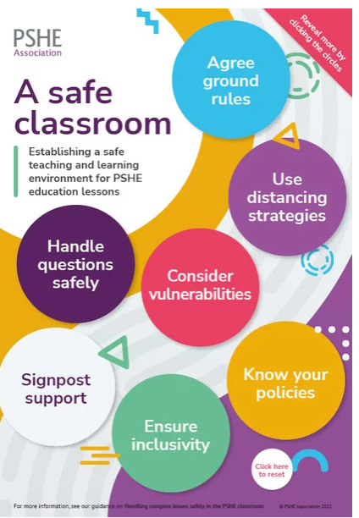
To be effective, we employ best practice principles to help create a safe classroom environment and to plan and teach effectively. The school recognises this will need to be tailored to the specific needs and vulnerabilities of individual children, including those who have been victims of abuse and children with special educational needs and disabilities.

Our preventative education forms part of our whole school approach to prepare our learners for life in modern Britain, encourages open debate about different points of view and beliefs and creates a culture of zero tolerance for sexism, misogyny/ misandry, disablism, racism, homophobia, biphobia and sexual violence and harassment. It is responsive to contextual, local and national data, issues and trends to ensure it is meeting the challenges that children/young people are facing.

The school’s core values and standards, alongside the fundamental British Values, are upheld and demonstrated throughout all aspects of the school in an age appropriate manner. This is underpinned by the school’s relationship policy, pastoral support system and our planned evidence-based relationships education/relationships and health education and reinforced throughout the whole curriculum.

Our learners are helped to talk about their feelings, know about their rights and responsibilities, understand and respond to risks, to deal assertively with pressures and know who they can turn to for advice and help both in and out of the school and how to make a complaint. This means that they are able to recognise when they are at risk and are able to get help when they need it.

Online safety
Online safety and protecting learners from potentially harmful and inappropriate online material forms part of the whole school approach to safeguarding, including policies, curriculum, staff training, roles and responsibilities of the designated safeguarding lead and parental engagement. The school has filtering and monitoring systems in place, which meet DfE filtering and monitoring standards. This includes:
- Identifying and assigning roles and responsibilities to manage filtering and monitoring systems
- Reviewing filtering and monitoring provision at least annually
- Blocking harmful and inappropriate content without unreasonably impacting teaching and learning
- Having effective monitoring strategies in place that meet safeguarding needs

The school protects and educates learners and staff in their use of technology, including where they are learning remotely, and has mechanisms to identify, intervene and escalate any concerns where this is needed. This is evident in our Computing and PSHCE Curriculum documentation.

In order to safely filter and monitor our systems, no staff member will be permitted to access the Wi-fi from their mobile phone, without authorisation from the Headteacher – this will be documented in the staff code of conduct. The school (DSL) will receive instant alerts via Smooth Wall when a site has been attempted to have been accessed. The DSL will then look into this and make any recommendations / take appropriate action. The DSL and Deputy DSL, alongside the IT technician, will review the breaches half termly and this will be formally signed and shared with Governors.

The school’s online safety policy outlines how the four areas of risk, content, contact, conduct and commerce, will be addressed to protect and educate learners and staff. It also incorporates the use of mobile and smart technology and appropriate filtering and monitoring on school devices and networks. Security protection procedures which meet the Cyber security standards for schools are in place in order to safeguard the systems, staff and learners and review the effectiveness of these procedures to keep up with ever evolving cyber-crime technologies. The school is also in regular communication with parents and carers and uses these communications to reinforce online safety and the systems the school use to protect children from online harms.

To ensure that online safety is effective, especially as technology and the associated risks and harms evolve and change, the school undertakes an annual review and risk assessment and the nominated Governor is involved in this.

For more information see school’s online safety policy.

Systems for children to report abuse
Our school recognises the importance of ensuring that all children feel heard and understood. We have a culture of listening to children and taking account of their wishes and feelings. Whenever there are any concerns, the child’s wishes will be taken into account when determining what action to take and what services are provided. The welfare and safety of a child is of paramount concern and staff will act in the best interests of the child.

We understand the difficulties that children may have in approaching staff about their
circumstances and any concerns they may have. Some children may feel unable to report their concerns or abuse, others may have additional barriers to telling someone or may not recognise what is happening is abusive.

The school has an open and accepting attitude towards children and promotes a positive and supportive environment as part of our responsibility for pastoral care. Our school ethos promotes trusted relationships between learners and all staff which supports children to tell staff about any concerns they may have. We believe that healthy, positive relationships are at the heart of keeping children safe and all staff ‘buy into this’. Each morning, the day begins with a ‘calm start’ whereby adults provide a safe space for children to enter the school / classroom and an adult is always on hand should a child need to talk. This protected time creates an opportunity for children to share any worries they have with a trusted adult. In addition, children are able to visually share their feelings in order for an adult to initiate conversations. The school also have a worry box in each classroom as we appreciate that sometimes children wish to express their feelings and worries in a variety of different ways. Children are educated that the Headteacher’s role is to keep them safe, happy and to make sure they get the best learning and many opportunities to revisit what this looks like are planned into assemblies.

Children, parents/carers, and all staff will be free to talk about any concerns and see the school as a safe place. Many children can show signs or act in ways they hope adults will notice or react to, others may make indirect reports via a friend or staff may overhear conversations. All staff are alert to this and to the potential need for early help and are aware of the indicators of abuse, exploitation and neglect and know what actions they should take.

The school has systems in place for children to complain and/or confidently report their concerns, including any form of abuse or neglect, including child-on-child abuse, and know that their concerns will be treated seriously.

Working with Parents and Carers (please also see home school agreement)

We recognise the importance of working together with parents/carers to educate as well as safeguard and promote the welfare of children.

Alvaston Infant and Nursery School will ensure that;
- We work with parents positively, openly and honestly and develop excellent working relationships with them all.
- Parents are encouraged to discuss their issues or concerns about safety and welfare of children, including any worries about a child’s emotional well-being or mental health. They will be listened to and taken seriously.
- We will provide parents with information about safeguarding issues, such as child exploitation (sexual and criminal), child on child abuse, emotional well-being/mental health and online safety, including sharing nudes and semi nudes (known as sexting/‘youth produced sexual imagery’), harmful sexual behaviour and terrorist/extremist material. We will also outline the support available to keep children safe within the school, locally and nationally.
- Up to date and accurate information is kept about learners i.e.
  - names and contact persons with whom the child normally lives;
  - those with parental responsibility;
  - where reasonably possible hold more than one emergency contact number;
  - if different from the above those authorised to collect the child from the setting;
  - name and contact details of GP;
  - any relevant court orders or any other factors which may impact on the safety and welfare of the child.
- Information about pupils/students given to us by children themselves, their parents or carers or by other agencies will remain confidential. Staff will be given relevant information on a 'need to know' basis in order to support the child.
- Parents and carers are informed that the school is part of the Stopping Domestic Abuse Together initiative. There is a clear section dedicated to this on our school website.
- It is made clear to parents and carers that the school has a duty to share information when there are any safeguarding concerns. Also that there is a duty to keep records which relate to safeguarding work by the school, or partner agencies. These will be kept securely, kept apart from the main pupil record and only accessible to key members of staff. Copies of these records will be securely sent to any education provider to which the child transfers within 5 days. The school will ensure that the ‘receiving school’ confirm to say that Child Protection notes have been transferred.
- Where we have reason to be concerned about the welfare of a child we will always seek to discuss this with the child's parents or carers first, however there may be occasions where we are not able to do this.
- Upon joining the school, staff will ask parents to name who can collect their children from school, on which days. No child will be dismissed to anyone who is not on the list, unless consent has been given by the parent/carer. In the event someone not on the list comes to collect a child, the school office and DSL will try to contact parents. Patience from the person collecting will be expected as we are fulfilling our duty to safeguard children. It will be the parent/carers responsibility to ensure that if there are any changes to this, they must contact the school office and / or a staff member as soon as possible.
- Alvaston Infant and Nursery School ask that someone who is 18 or over collects children at the end of the school day. However, if a parent would like someone who is 16 or 17 to collect their child, they must put in writing that they will allow this to happen and they must also state that they believe the 16 or 17 year old, who will be collecting, is sensible, trustworthy and responsible enough to care for them.

Responding to concerns about a child’s welfare

Key points to remember for any member of staff (including volunteers or supply staff) or visitors whenever they have any concerns about a child’s welfare:
- In an emergency take the action necessary to help the child, for example, call 999
- Do not assume a colleague or another professional will take action and share information that might be critical to keeping a child safe. Early information sharing is vital in keeping children safe, whether this is when problems first emerge, or when a child is already known to local authority children’s social care
- Report your concern, including any possible private fostering arrangements, to the designated safeguarding lead or their deputy as soon as you can and by the end of the day at the latest. All concerns must be communicated verbally and then followed up on CPOMS (Child Protection Online Management System), in writing, tagging the appropriate categories
- If you are unsure speak to the designated safeguarding lead or their deputy
- If the designated safeguarding lead or their deputy is not around, ensure the information is shared with the most senior person in the school/ that day. The concerns and any action taken must then be shared with the designated safeguarding lead as soon as it is possible
- If the concerns are about sharing nudes and semi-nudes do not view, copy, print or share the images
- Share information on a need-to-know basis only – do not discuss the issue with colleagues, friends, or family
- If CPOMS is down, complete a concerns form (appendix 1)
- Seek support for yourself if you are distressed by seeking out the designated safeguarding lead or mental health governor – remembering not to share any information that may disclose the identity of a child / family, in order to maintain confidentiality

Staff must always immediately inform the designated safeguarding lead or their deputy if there are any:
- Concerns that a child is presenting signs or symptoms of abuse or neglect, including suspicion that a child is injured, marked, or bruised in a way which is not readily attributable to the normal knocks or scrapes received in play
- Searching incidents where there are reasonable grounds to suspect a learner was in possession of a prohibited item or where a search has revealed a safeguarding risk
- Behaviour or changes in presentation, including changes in school attendance, which gives rise to suspicions that a child may not be receiving adequate care or may be suffering harm
- Hint or disclosure of abuse about or by a child
- Concerns that a person(s) who may pose a risk to children is living in a household with children present
- Concerns about online abuse including cybercrime, exploitation, harmful sexual behaviour, sharing nudes and semi nudes and/or where any adult appears to be sexually communicating (e.g., email, text, written note or verbally) with a child
- Concerns about child-on-child abuse, including sexual violence and harassment
- Information which indicates that the child is living with someone who does not have parental responsibility for them (this is known as private fostering)
- Concerns that a child is at risk of domestic abuse or so-called ‘honour-based’ abuse, including forced marriage, marriage or civil partnership under the age of 18, female genital mutilation (FGM), breast ironing, virginity testing or hymenoplasty
- Concerns that a child is at risk of radicalisation, child sexual exploitation or criminal exploitation, including county lines; or that a child or their parent/carer may be a victim of modern slavery (trafficked)

There will also be occasions when you suspect that a child may be at risk, but you have no ‘real’ evidence or that the child may need support with their mental health. The child’s behaviour and or appearance may have changed, their attendance at school/ may have reduced, their ability to concentrate and focus may have altered, or you may have noticed other behavioural and or physical but inconclusive signs. In these circumstances, you should try to give the child the opportunity to talk. The signs you have noticed may be due to a variety of factors and it is fine to ask the child if they are alright or if you can help in any way. Any concerns of this nature must still be recorded on CPOMS, and logged under ‘change of behaviour’.

It is not the responsibility of the school staff to determine the truth of any disclosure or allegation; this is the responsibility of local authority children's social care. All staff however have a duty to recognise where extra support is needed or where there are complex needs or child protection concerns requiring intensive or specialist support.

If a child or adult does begin to reveal that a child is being harmed, you should follow the advice in the section ‘If a child chooses to tell a member of staff about a concern or abuse’ (see below).

If a child chooses to tell a member of staff about a concern or abuse
It takes a lot of courage for a child, parent, carer, or other significant adult to disclose that they are worried or have concerns. They may feel ashamed, the abuser may have threatened what will happen if they tell, they may have lost all trust in adults, or they may believe, or have been told, that the abuse is their own fault. It is important they are reassured that they are being taken seriously, and that they will be supported and kept safe. They should not be made to feel they are creating a problem, blamed or ashamed for making a report. Reports, particularly those about sexual violence and harassment, if possible, should be managed with two members of staff present (preferably one being the designated safeguarding lead or a deputy), however this might not be possible in all cases.

If a child or adult talks to you about any risks to a child's safety or wellbeing you will need to let them know that you must pass the information on – you are not allowed to keep secrets. The point at which you do this is a matter for professional judgement.

During your conversation with the child (or their parent/carer):
- Allow them to speak freely, listen to what is being said without interruption and without asking leading questions
- Keep questions to a minimum and of an open nature (‘TED questions’ tell me, explain, describe) i.e., 'can you tell me what happened?' rather than 'did x hit you?'
- Remain calm and do not overreact – the child (or their parent/carer) may stop talking if they feel they are upsetting you
- Give reassuring nods or words of comfort – ‘I’m so sorry this has happened’, ‘I want to help’, ‘This isn’t your fault’, ‘You are doing the right thing in talking to me’
- Avoid admonishing the child or adult for not disclosing earlier. Saying ‘I do wish you had told me about this when it started’ or ‘I can’t believe what I’m hearing’ may be your way of being supportive but they may interpret it that they have done something wrong
- Do not be afraid of silences – remember how hard this must be for the child or adult
- Under no circumstances ask investigative questions – such as how many times this has happened, whether it happens to siblings too, or what do other family members think about all this
- At an appropriate time tell the child or adult that to help them you must pass the information on to Miss Allen, whose job it is to help keep them safe
- Do not automatically offer any physical touch as comfort; it may be anything but comforting to a child who has been abused
- Tell the child or adult what will happen next. The child or adult may agree to go with you to see the designated safeguarding lead. Otherwise let them know that someone will come to see or contact them before the end of the day
- Report verbally to the designated safeguarding lead
- Write up your conversation as soon as possible via CPOMS, using the words of the child. If more than staff member was present, both staff members must write up their accounts
- Children should not be asked to write statements about abuse or any concerns that may have happened to them or sign the staff record
- Seek support if you feel distressed. This may be sometime after the disclosure. Staff are all able to access support from the School’s independent counsellor, Janet Fergason but confidentiality of any incidents must always be upheld.

Role of the Designated Safeguarding Lead and their deputy following identification of concerns

Whenever the designated safeguarding lead or their deputy receive information regarding concerns about a child, including via police domestic abuse notifications (Stopping Domestic Abuse Together/SDAT) they will:
- Review information received and assess if any urgent actions are needed, i.e. medical, child’s immediate safety
- Check what is known about the child when they arrived (or not) at school today, how they are presenting physically and emotionally and if there are any changes in their behaviour
- Consider what is already known about the child and their family, including whether any previous concerns have been raised by staff or if they are already known to local authority children’s services (targeted early help or social care)
- Check in with the child, not asking any leading questions, but teachers will provide a quiet space to ask if the child is okay – this will be logged as a follow up on CPOMS
- Consider what ‘checks’ need to be carried out and how best these can be achieved
- Inform relevant school staff who have a specific need to know i.e. class teacher and relevant support staff, talk and sort lead
- Where appropriate use relevant national, local and education-based risk identifying, assessment tools and guidance to support the identification of needs and decision making, such as:
  - School based records, assessments, and chronologies, including any contextual factors/placed based risks
  - DDSCP multi-agency guidance, tools and briefing notes, for example Vulnerability of children not in school guidance, Children and Young People Missing from Home or Care protocol, Self-harm and Suicidal Behaviour Guidance, Briefing Note: Harmful Online Challenges and Hoaxes, Guidelines for gathering information and assessing the needs of children whose parents have drug/alcohol issues, Practice Guidance Child Sexual Abuse within the Family, Practice Guidance for responding to Adults and Child Victims of Modern Slavery, Male Circumcision guidance, Was not brought guidance, Childhood Obesity: Health, Wellbeing and Safeguarding guidance for practitioners, Guidance for responding to Adults and Child Victims of Modern Slavery, Schools Stopping Domestic Abuse Together Guidance, Domestic Violence Risk Identification Matrix (DVRIM), Safelives DASH Risk Identification Checklist (domestic abuse risk to adults), Children at Risk of Exploitation assessment, Graded Care Profile (neglect); see DDSCP safeguarding children procedures documents library
  - National guidance and assessment tools e.g. Stop it now (sexual behaviours), Contextual safeguarding tools, Sharing nudes and semi-nudes: advice for education settings working with children and young people
- Not directly approaching a child or parent/carer about an incident when the school have received a domestic abuse notification (SDAT) and instead make general enquiries with the child about how they are. If a child initiates a conversation about the incident the guidance outlined in the section ‘If a child chooses to tell a member of staff about a concern or abuse’ will be followed. These check ins will be recorded on CPOMS by the child’s class teacher
- Following the Derby and Derbyshire Safeguarding Children Procedures and using the DDSCP Threshold document to support decision making about the child’s needs and the appropriate level of support and intervention. Possible options include internal support via school pastoral systems (talk and sort / nurture / nature outdoors), early help assessment and referral to statutory services such as local authority children’s services
- Considering whether the matter should be discussed with the child's parents or carers or whether to do so may put the child at further risk of harm, see Notifying parents
- If unsure about the action to take, including if a child protection referral should be made, seeking advice from local authority children's social care or another appropriate agency
- If the concerns are about radicalisation or violent extremism, making a referral to the police Prevent Team
- Where the child has complex needs or where there are child protection concerns, referring as appropriate to Local Authority Children’s Services via agreed processes, providing a copy of the early help assessment, action plan and any other relevant assessments
- Notify the appropriate Local Authority Children’s Services of any private fostering arrangements, to allow the local authority to check the arrangement is suitable and safe for the child
- If a child is at risk of immediate harm, and/or where it is believed a criminal offence has been committed, including sexual violence and harassment, referring to the police. See NPCC When to call the police; guidance for schools. Safeguarding considerations must take priority and include how screening, searching, and confiscating powers will be used safely, proportionately, and appropriately, including undertaking a police strip search on a child and the requirement for children to have an appropriate adult.; see Searching, screening and confiscation at school guidance (2022)
- In all cases where children are believed to be at risk of exploitation, complete and submit an Information Sharing Form for Professionals Operation Liberty / Operation Blofeld to raise concerns and share information

Notifying Parents

The school will normally seek to discuss any needs or concerns about a child with their parents or carers. This must be handled sensitively. Where an Early Help Assessment would benefit the child and their family, the most appropriate member of staff should approach the parent/carer to take this forward. In situations where there are serious needs or child protection concerns the Designated Safeguarding Lead (DSL) will make contact with the parent or carer. However, if the setting believes that notifying parents could increase the risk to the child or exacerbate the problem, then advice will first be sought from Children’s Social Care first.

Talk and Sort/school-based support (universal support/ low level needs)
In all cases the school will consider what support could be offered within the setting via pastoral support processes. Talk and Sort support will be kept under constant review to ensure that it is effective.

Early help support and assessment (emerging needs)
Where a child is likely to require co-ordinated support from a range of early help services, or where there are concerns for a child's well-being or a child's needs are not clear, not known or not being met, the designated safeguarding lead or their deputy will support the completion of an early help assessment (EHA) and if needed, co-ordinate a team around the family (TAF).

Whenever a child and their family are supported via an early help assessment, the school will keep this under constant review and should the child’s situation appear not to be improving or getting worse, consideration will be given to a referral to local authority children’s services.

For more information about the early help assessment process see Derby and Derbyshire Safeguarding Children; Providing early help procedure.

Referral to LA
Referral to local authority children’s social care (intensive and specialist support)
Concerns about a child’s welfare will be referred to local authority children’s social care using the agreed referral process as outlined in Derby and Derbyshire Safeguarding Children; Making a referral to Children’s Social Care procedure.

If at any point there is a risk of immediate serious harm to a child, an immediate referral should be made to local authority children’s social care and/or if appropriate, the police

Anybody can make the referral

Where it is believed that there are urgent child protection concerns, the designated safeguarding lead or deputy will make a referral to local authority children’s social care by phone and follow this up in ‘writing’ via the local authority Online Referral System. Non-urgent cases will be referred via the local authority Care Online Referral System. In Derby submission of an early help assessment, or equivalent assessment, to the weekly Vulnerable Children meeting (VCM) in the relevant locality can also be made. A copy of all referrals will be kept on the child’s child protection file.

In exceptional circumstances, such as in an emergency or a genuine concern that appropriate action hasn’t been taken, any staff member can refer their concerns directly to local authority children’s social care; however, they should inform the designated safeguarding lead or deputy as soon as possible.

Female genital mutilation (FGM)
If the referral is about a ‘known’ case of female genital mutilation (FGM), in addition to a referral to local authority children’s social care, the individual teacher also has a mandatory reporting duty; see Mandatory Reporting of Female Genital Mutilation; procedural information (2015). Under this duty, ‘known’ cases of FGM where a girl under 18 informs the person that an act of FGM has been carried out on her, or where physical signs appear to show that an act of FGM was carried out, this must be reported to the police on 101. This is a personal responsibility in addition to the referral to local authority children’s social care and the professional who identifies FGM and/or receives the disclosure should make the report by the close of the next working day.

Action following referral
The designated safeguarding lead, their deputy or other appropriate member of staff will:
- Where a referral was made by phone follow up the referral in writing using the online referral system within 48 hours and attaching any existing assessment e.g. early help assessment. In all cases the school will also include information held about any place-based risks (harm outside of the home)
- Be aware that local authority children’s social care should make a decision within one working day of the referral being made about what course of action they are taking and let the school/ know the outcome. If the information is not forthcoming, the designated safeguarding lead or another appropriate member of staff should follow this up
- Maintain contact with the allocated social worker and support them or other agencies following any referral
- Contribute to any strategy discussion or meetings
- Support any Section 47 enquiries or statutory assessments that are carried out
- Provide a report for, attend, and contribute to any initial and review Child Protection Conference. This includes sharing any reports with parents/carers and where appropriate, the child, due to being an infant school, in most cases, this isn’t appropriate
- Share the content of this report with the parent/carer and if appropriate the child, prior to the meeting
- Attend core group meetings for any child subject to a Child Protection plan or Child in Need meeting for any child subject to a Child in Need plan
- Whenever there are concerns about the outcome of a Child Protection Conference, use the appropriate Derby or Derbyshire Child Protection Conference Professional Dissent Process
- Where a child on a Child Protection plan, Child in Need plan or who is Looked After moves from the school or if there are unexplained absences from school, immediately inform the child’s social worker/key worker in local authority children’s social care
- If after the referral the child’s situation does not appear to be improving the designated safeguarding lead should press for re-consideration to ensure their concerns have been addressed and the child’s situation improves. See Derby and Derbyshire Multi-Agency Dispute Resolution and Escalation Policy

Confidentiality and sharing information
The school recognises the importance of information sharing between the school and local agencies to effectively safeguard our learners. The setting operates with regard to HM Government Information Sharing; Advice for practitioners providing safeguarding services to children, young people, parents and carers (2018) (Note: this is currently under consultation) and DDSCP Information Sharing Guidance for Practitioners (2022).

All staff will be mindful of the seven golden rules to sharing information (See Appendix 3) and Data Protection Act (2018) and UK General Data Protection Regulation (UK GDPR) obligations. Staff are aware that the Data Protection Act 2018 and UK GDPR do not prevent or limit the sharing of information for the purposes of keeping children safe and promoting their welfare.

School staff should be proactive in sharing information as early as possible to help identify, assess, and respond to risks or concerns about the safety and welfare of a child, whether this is when problems are first emerging, or where a child is already known to local authority children’s social care.

If in any doubt about sharing information, staff should speak to the designated safeguarding lead or a deputy. Fears about sharing information must not be allowed to stand in the way of the need to promote the welfare, and protect the safety, of children. If the DSL takes a telephone call and the caller / social worker is unknown, we will ask for the social worker or professional to send a professional email or will hang up and return the call.

Staff should only discuss concerns with the Designated Safeguarding Lead (DSL) or Deputy (or the most senior person on the premises if they are unavailable), Headteacher or Chair of Governors (depending on who is the subject of the concern). That person will then decide who else needs to have the information and they will disseminate it, via ‘tagging’ on CPOMS or verbally on a ‘need-to-know’ basis.

Wherever possible, consent will be sought to share information, however where there are safeguarding concerns about a child, information will be shared with the appropriate organisations such as Children's Social Care. In most cases concerns will be discussed with parents and carers prior to the referral taking place unless doing so could increase risk.

The school’s policy on confidentiality and information-sharing is available to parents and children on request.

Record keeping
All concerns, discussions and decisions made and the reasons for those decisions should be recorded in writing using the school’s agreed processes. If in doubt about recording requirements staff should discuss with the designated safeguarding lead or their deputy.

Records of concerns documentation, referrals and other written safeguarding information are kept in a child protection file (on CPOMS) for each child and stored separately from each child’s education file; this file is ‘tagged’ to indicate that separate information is held. Child protection files are confidential and stored securely and only made available to relevant individuals. This is done online. Where another school does not have CPOMS the file will be printed and delivered in person (where possible) to the school. Where this is not possible, it will be scanned and sent electronically.

Records will include:
- A clear and comprehensive summary of the concern
- Details of how the concern was followed up and resolved
- A note of any action taken, decisions reached and the outcome, as well as a review of any progress made. Any professional differences of opinion about the safety of a child will also be recorded; see DDSCP Multi Agency Dispute Resolution and Escalation Policy and Derby or Derbyshire Child Protection Conference Professional Dissent Process

When a child leaves the school, the designated safeguarding lead will ensure a copy of these records will be sent securely as soon as possible (within 5 days for an in-year transfer or within the first 5 days of the start of a new term) to any school or other education setting to which the child transfers and a confirmation of receipt obtained. The child protection file transfer will be separate to the main pupil file. This will allow the new provider to continue supporting the child and have the support in place for when the child arrives.

The designated safeguarding lead will also consider if it would be appropriate to share any information with the new education provider in advance of the child leaving e.g. children who have or who have had a social worker and those receiving support through the Channel programme.

The designated safeguarding lead, their deputy and key staff such as special education needs co-ordinators will be informed when a child’s safeguarding/child protection file is received.

The school has a check list for new leavers and new starters and the admin team will work with the Headteacher in order to ensure that this check list is adhered to, in the time frames specified. Whereby a child enters the school from another setting and records are not sent, the Headteacher / DSL will send a formal email documenting we are awaiting this information.

Support for those involved in a safeguarding/child protection issue
Child neglect, abuse and exploitation are devastating for children and can also result in distress and anxiety for staff who become involved. We will support the children and their families and staff by:
- Taking all suspicions and disclosures seriously
- Nominating a link person who will keep all parties informed and be the central point of contact
- Nominating a ‘case manager’ where a member of staff is the subject of an allegation made by a child
- Responding sympathetically to any request from a child or member of staff for time out to deal with distress or anxiety
- Maintaining confidentiality and sharing information on a need-to-know basis only with relevant individuals and agencies
- Storing records securely
- Offering details of helplines, counselling, or other avenues of external support, counselling will be part funded by the school. The school will pay a maximum of 50% towards this however, the maximum school will pay is £18.
- Review of the per session.
- Following the procedures laid down in our whistleblowing, complaints and disciplinary procedures
- Co-operating fully with relevant statutory agencies

If a staff member needs to use positive handling in order to protect other child or a certain child from risk of harm, this will be logged and parents will be informed (please see positive handling policy).

If a child receives an injury to their private parts or to their head, a telephone call will be made to the parent / carer so that they can assess the situation.

Note: The actions where there are concerns about a child flowchart (KCSIE June 2023) is included in Appendix 2.

Section 7: Child-on-child abuse, including sexual violence and harassment

All staff working in or on behalf of the school maintain an attitude of ‘it could happen here’ – this is especially important when considering child-on-child abuse. Even if there are no reports it does not mean it is not happening.

The school recognises that children may abuse their peers physically, sexually and emotionally. There is a zero tolerance approach towards child on child abuse. Abuse is abuse and this will not be tolerated or passed off as ‘banter’, ‘just having a laugh’, ‘boys being boys’ or ‘part of growing up’, as this can lead to a culture of unacceptable behaviours and an unsafe environment for children. Any child on child abuse will be logged on CPOMs under the correct category ‘Child on child abuse’. Staff members must specify the type of child on child abuse e.g. physical, emotional, and bullying and must also clearly state how it has been followed up and this should involve a discussion with a parent/carer. Year Group Leads (Deputy DSLs) should monitor this to ensure that this does not reoccur.

If staff have any concerns regarding child-on-child abuse, they should speak to the designated safeguarding lead or their deputy

In addition, we also recognise that children who abuse others and any other child affected by child on child abuse are also likely to have considerable welfare and safeguarding issues themselves.

The setting will take child-on-child abuse as seriously as abuse perpetrated by an adult and address it through the same processes as any safeguarding issue. We will respond to all reports and concerns, including those that have happened outside of the school and / or online.

What is child on child abuse?

- Keeping Children Safe in Education (June 2023) defines child-on-child abuse as most likely to include but not limited to:
  - Bullying (including cyberbullying, prejudice based and discriminatory bullying)
  - Abuse within intimate personal relationships between children (sometimes known as ‘teenage relationship abuse’)
  - Physical abuse such as hitting, kicking, shaking, biting, hair pulling or otherwise causing physical harm (this may include an online element which facilitates, threatens and /or encourages physical abuse)
  - Sexual violence, such as rape, assault by penetration and sexual assault (this may include an online element which facilitates, threatens and /or encourages sexual violence)
  - Sexual harassment, such as sexual comments, remarks, jokes and online sexual harassment, which may be standalone or part of a broader pattern of abuse
  - Causing someone to engage in sexual activity without consent, such as forcing someone to strip, touch themselves sexually, or to engage in sexual activity with a third party
  - Consensual and non-consensual sharing of nudes and semi-nude images and or videos
  - Upskirting, which typically involves taking a picture under a person’s clothing without their permission, with the intention of viewing their genitals or buttocks to obtain sexual gratification, or cause the victim humiliation, distress, or alarm
  - Initiating/hazing type violence and rituals (this could include activities involving harassment, abuse or humiliation used as a way of initiating a person into a group and may also include an online element)
- It can also include causing someone to engage in extremist or radicalising behaviour
- Child-on-child abuse exists on a continuum and different forms of abuse may overlap
- It can affect any child/young person of any age and sex and can occur between two children or through a group of children abusing a single child or group of children
- Sometimes vulnerable children are targeted. For example:
  - Those living with domestic abuse or with intra-familial abuse in their histories
  - Young people in care
  - Those who have experienced bereavement through the loss of a parent, sibling, or friend
  - Black and minority ethnic children are under identified as victims but are over identified as perpetrators
  - There is recognition it is more likely that girls will be victims and boys are likely to be perpetrators. However, both girls and boys can experience child-on-child abuse, but they are likely to experience it differently e.g. girls being sexually touched/assaulted or boys being subject to homophobic taunts/initiation/hazing (rituals and other activities involving harassment, abuse or humiliation used as a way of initiating a person into a group)
  - Evidence also shows that children with SEND, and LGBTQ+ children are at greater risk
- It is influenced by the nature of the environments in which children/young people spend their time - home, school, peer group, online and community - and is built upon notions of power and consent. Power imbalances related to gender, social status within a group, intellectual ability, economic wealth, social marginalisation etc, can all be used to exert power over a peer
- Child-on-child abuse involves someone who abuses a ‘vulnerability’ or power imbalance to harm another and has the opportunity or is in an environment where this is possible
- While perpetrators of child-on-child abuse pose a risk to others, they are often victims of abuse themselves

Preventing child-on-child abuse
There is a whole school approach to preventing child-on-child abuse, including child-on-child sexual violence and sexual harassment; this forms part of the whole school approach to safeguarding. The school will seek to minimise the risk of child-on-child abuse by ensuring an approach that prepares learners for life in modern Britain. The establishment has a clear set of values and standards which are upheld and demonstrated throughout all aspects of school life, including our curriculum. Our PSHCE curriculum and values will be an integral part of school life and all staff will model high standards of courteous behaviour and positive relationships.

The school provides a safe environment, promotes a culture of positive standards of behaviour, takes steps to address inappropriate behaviour, has effective systems in place where children can confidently raise concerns knowing they will be taken seriously and provides safeguarding through the curriculum via relationships education, online safety, and other curriculum opportunities. This may include targeted work with children identified as vulnerable or being at risk and developing risk assessment and targeted work with those identified as being a potential risk to others. This is often done through a bespoke intervention either 1:1 or in a small group with Mrs Goodman our Talk and Sort Lead or through our Outdoor Nurture / Forest School provision.

All staff understand the importance of challenging inappropriate behaviours between peers that are abusive in nature. Downplaying certain behaviours will not be tolerated or passed off. Staff will maintain an attitude of ‘it could happen here’ and all inappropriate behaviour will be addressed.

The setting deals with a wide continuum of children’s behaviour on a day-to-day basis and most cases will be dealt with via school based processes. These are outlined in the following policies:
- Alvaston Infant and Nurser School’s Relationship Policy (inclusive of behaviour and anti bullying)
- Online safety policy and other associated issues, including sharing nudes and semi-nudes and extremist material
- Attendance policy
- Relationships education/ relationships and sex education
- SMSC/PSHCE Policy

Systems for children to report abuse
Even if there are no reports, all staff understand it does not mean it is not happening; it may be the case that it is not being reported. We recognise that children may not find it easy to tell staff about the abuse, that certain children may have additional barriers to telling someone and children can show signs or act in ways they hope adults will notice or react to. In some cases, victims may make indirect reports via a friend or staff may overhear conversations. All staff recognise the indicators and signs of child-on-child abuse and know how to identify it.

If staff have any concerns regarding child-on-child abuse, they should speak to the designated safeguarding lead or deputy

Action on concerns
Child-on-child abuse may be a one-off serious incident or an accumulation of incidents. Staff may be able to easily identify some behaviours as abusive, however, in some circumstances it may be less clear. In particular, reports of sexual violence and harassment are likely to be complex and require difficult professional decisions to be made, often quickly and under pressure. In all cases the initial response to a report is very important. Members of staff will take the concerns seriously and reassure the child that they will be supported and kept safe, regardless of how long it has taken them to come forward. If possible, reports should be managed with two members of staff present (preferably one being the designated safeguarding lead or a deputy), however, this might not be possible in all cases. The victim will not be given the impression they are creating a problem or made to feel ashamed for making a report or their experience minimised. Abuse which has occurred online or outside of the school will be treated just as seriously as that which has occurred within the education environment. All child on child abuse will be logged via CPOMS and clear actions will also be recorded.

Staff must follow Section 6. Responding to concerns about a child’s welfare and discuss the concerns and seek advice from the designated safeguarding lead.

When an allegation is made by a pupil/student against another pupil/student, members of staff should consider if the issues raised indicate that the child and/or alleged perpetrator may have low level, emerging needs, complex/serious needs, or child protection concerns and follow the process outlined in Section 6. Responding to concerns about a child’s welfare.

Considerations for cases where child-on-child abuse is a factor include:
- What are the wishes of victims in terms of how they want to proceed?
- What is the nature, extent and context of the behaviour including verbal, physical, sexual (including sharing of nudes/semi-nudes) and/or online abuse? Was there coercion, physical aggression, bullying, bribery or attempts to ensure secrecy? What was the time, location, duration, and frequency? Is the incident a one off or a sustained pattern of abuse? (Remember there may be other forms of abuse in addition to what has been reported) Were other children and /or adults involved? Has a crime been committed and/or have any harmfully sexual behaviours been displayed?
- What is the child’s age, development, capacity to understand and make decisions (including anything that might have had an impact on this e.g. coercion), and family and social circumstances? What is the nature of the relationship between the children involved? Are they in a current or previous intimate personal relationship, do they live in the same household or setting, attend the same school/, classes, or transport?
- What are the relative chronological and developmental ages of the children? Does the victim or perpetrator have a disability or learning difficulty? Are there are any differentials in power, social standing, or authority?
- Is the behaviour age appropriate or not? Does it involve inappropriate sexual knowledge or motivation?
- Are there any risks to the child victim or alleged perpetrator themselves and others e.g. other children in school, adult students, school/ staff, in the child’s household (particularly siblings or other children related to the household), extended family, peer group or wider social network? Are there any links to child sexual exploitation, child criminal exploitation or gang related activity?

Immediate consideration should be given to how best to support and protect the victim and alleged perpetrator and any other children involved/impacted. Where the report involves rape and assault by penetration, the alleged perpetrator must be removed from any classes they share with the victim. There must also be careful consideration on how best to keep the victim and alleged perpetrator apart on school/ premises (including any before or after school activities) and on transport to and from the setting.

For all other reports of sexual violence and sexual harassment and forms of child-on-child abuse, the proximity of the victim and alleged perpetrator and considerations regarding shared classes, school premises and transport should be considered immediately.

All decisions will be made in the best interests of the children involved and should not be perceived to be a judgement on the guilt of the alleged perpetrator. In all cases, the initial report should be carefully evaluated on a case-by-case basis with the designated safeguarding lead taking a leading role and using their professional judgement, supported by other agencies, such as local authority children’s social care and the police as required. The designated safeguarding lead will refer to relevant assessment tools and guidance as appropriate such as:
- Keeping Children Safe in Education (June 2023) part five
- Sharing nudes and semi-nudes: advice for education settings working with children and young people
- Searching, screening and confiscation at school
- Behaviour in schools
- School suspension and permanent exclusion
- Stop it Now Sexual Behaviours Traffic Light Tool
- DDSCP Thresholds Document
- DDSCP Safeguarding Children Procedures, in particular Children who present a risk of harm to others and Online Safety and Internet Abuse procedures
- When to call the police – guidance for schools and s

Whenever there is an allegation of abuse, including concerns about sexual harassment and violence, made against a child, the designated safeguarding lead and other appropriate staff will draw together separate risk and needs assessments and action plans to support the victim and the alleged perpetrator. These will consider:
- The victim, especially their protection and support
- Whether there have been other victims
- The alleged perpetrator/s
- All the other children (and if appropriate university students and staff) at the school, especially any actions that are needed to protect them from the perpetrator/s, or from future harms
- The time and location of the incident and any action required to make the location safer
- When information can be disclosed to staff and others, including the alleged perpetrator and parents/carers

Whenever local authority children’s social care and/or the police are involved, the school will work in collaboration to ensure the best possible support and protection is provided for both the victim and the alleged perpetrator.

All reports of child-on-child abuse (including sexual harassment and/or sexual violence) will be recorded in the child’s safeguarding/child protection file. This will include all decision making, risk and needs assessment and plans recorded in writing as outlined in Section 6.

Where appropriate incidents may be managed internally (low level needs), via early help (emerging needs) or through local authority children’s social care (complex/serious needs or child protection concerns); reports to the police will be run in parallel with children’s social care as outlined in the Derby and Derbyshire multi-agency safeguarding procedures, in particular Children who Present a Risk of Harm to Others and Online Safety and Internet Abuse procedures.

All risk and needs assessment and action plans whether internal or multi-agency will be reviewed and updated on a regular basis. If things do not improve or deteriorate the situation should be reconsidered.

The school uses the Contextual Safeguarding School Beyond Referrals Self-Assessment Toolkit & Guidance to self-assess our response to harmful sexual behaviour. All relevant policies will be updated to reflect the lessons learnt and consideration given to the wider cultural issues within the school that enabled the behaviour to occur.

Where the victim or alleged perpetrator transfers to another education setting, the designated safeguarding lead will ensure the new provider will be made aware of any on-going support needs (and will discuss this with the victim and where appropriate their parents, as to the most suitable way of doing this) as well as transferring the safeguarding/child protection file. In the case of the alleged perpetrator, where appropriate, this will also include potential risks to other children and staff. See Section 6. Responding to concerns about a child’s welfare - record keeping.

Any suspicion or allegations that a child has been sexually abused or is likely to sexually abuse another child (or adult) or where there are concerns about any other form of abuse, a referral must be made immediately to local authority children’s social care and where appropriate, the police

Section 8: Safer recruitment and selection of staff

. Safer Recruitment and Selection of Staff

The school uses best practice and has adopted robust recruitment procedures as outlined in Keeping Children Safe in Education (2023) to deter and prevent people who are unsuitable to working with children from applying, securing employment or volunteering opportunities in the school/. We apply all appropriate measures for our staff, including volunteers, agency and third-party staff (supply staff) trainees/student teachers, governors/trustees, and contractors. This forms a vital part of the whole school/ approach to safeguarding and is an essential part of creating a safe environment for our learners. We will conduct a full social media search (Twitter, Facebook, Instagram) of any candidates before they are invited to a job interview / offered a volunteering place. We will also conduct a google search of the candidate’s name. We may also explore other social media forms. (Please see Safer Recruitment Check List, below).

The school has a culture which safeguards and promotes the welfare of children in the setting. As part of this, we ensure that all appropriate measures are applied in relation to recruitment procedures that deter and prevent people who are unsuitable from working with children from applying for or securing employment or volunteering opportunities in the establishment, including volunteers, trainee teachers, supply staff and staff employed by contractors. This is an essential part of creating a safe environment for children and young people. Any volunteer will be asked to complete an application form and provide references and the process is just as rigorous as it would be for an incumbent staff member.

Safer practice in recruitment means thinking about and including issues to do with child protection and safeguarding children at every stage of the process. This includes obtaining and scrutinising comprehensive objective and factual information about applicants. For example obtaining professional references, verifying academic or vocational qualifications, previous employment history, verifying health and physical capacity for the job as well as resolving any discrepancies or anomalies in references. The school will accept emailed references but will ensure that the referee does work at the work place and that their position is genuine.

It also includes ensuring that advertising, job descriptions, application forms, person specifications, short listing, selection and interview processes include safeguarding and right to work in England checks.

Everyone who works in the school, including volunteers and school governors will have appropriate Disclosure and Barring (DBS) and teacher status checks. Governors and all relevant staff will also require section 128 checks. (Please note: all schools s providing childcare must ensure that appropriate checks are carried out to ensure that individuals employed to work in reception classes or wraparound care for children up to aged 8 are not disqualified under Childcare Disqualification Regulations 2018, see Statutory guidance
Disqualification under the Childcare Act 2006).

Other checks that may be necessary for staff, volunteers, and others:
  - Individuals who have lived or worked outside the UK – will undergo the same checks as all other staff in the school/ and further checks deemed appropriate to ensure suitability
  - Agency and third-party staff (supply staff) - the school will obtain written notification from any agency or third party organisation provider that they have carried out checks on an individual who will be working at the school/ that we would otherwise perform.
  - Contractors - where the school uses contactors to provide services the contact will set out their safeguarding requirements.
  - Trainee/ student teachers – applicants salaried by the school will undergo all necessary checks by the school. The initial teacher training provider will carry out necessary checks on fee funded trainee teachers and will provide written confirmation that these have been carried out and judged suitable to work with children.
  - Volunteers - the school will ensure volunteers are appropriately supervised as outlined in statutory guidance on supervising the activities of workers and volunteers with children. In addition, risk assessments will be undertaken, and professional judgment/ experience used when deciding whether to obtain an enhanced DBS certificate for any volunteer not engaged in regulated activity. The details of the risk assessment will be recorded.

The school maintains a single central record of pre-appointment checks consistent with Keeping Children Safe in Education (2023). The school also ensures there is a question at interview regarding any gaps in employment.

See the school ‘Safer Recruitment Policy’ and supervision of volunteer’s statement.

If the school has reason to believe a practitioner should not work with children, they will refer to the DBS service.

Visitors
The school premises provide a safe learning environment with secure access. We recognise there are different types of visitors, those in a professional capacity, children’s relatives or others visiting for school activities or visitors via a third party and have processes in place to ensure they are suitable, are checked and monitored as appropriate.

We recognise the importance of allowing access for local authority children’s social care to conduct, or to consider whether to conduct an assessment and that staff from other partner agencies may need to visit to see a child or young person to either safeguard or promote their welfare. To support our decision making about appropriate checks regarding any professional visitor we operate using guidance outlined in the DDSCP Briefing Note - Professional Visitors to Schools. See school security and visitors policy.

External speakers/visitors
The school may ask external speakers or visitors to work with children or provide assemblies on subjects such as online safety, relationship education and health education. On these occasions, there will be an assessment of the educational value, the age appropriateness of what is going to be delivered and whether relevant checks will be required, and an assessment made of what will be appropriate supervision. There will also be an agreement made in advance of the session/s on how a safeguarding report should be dealt with by an external visitor. See school’s agreement for visiting speakers.

Alternative provision
In the rare event a child accesses alternative provision, we will continue to be responsible for any learner placed with an alternative provision provider. Learners in alternative provision often have complex needs and are vulnerable to additional risk of harm. We will ensure that the provider meets the needs of the learner and obtain written confirmation from the provider that appropriate safeguarding checks have been carried out on their staff and individuals working for the provider. The school would also have arrangements in place to ensure attendance is monitored and that there are effective safeguarding arrangements within the provision.

'Extended school' and off site arrangements

Where ‘extended school’ activities are provided by and managed by the setting, our own Safeguarding Policy and procedures apply. For Breakfast and After School Clubs, the office staff will keep registers, so that it is clear which children are due to be attending. A further register will also be taken during the Breakfast and After School Club. This should also be able to view via the SchoolMoney app. Any parent wishing to send their child to Breakfast or After School Club will fill in separate registration forms, which will be stored in the office and in a secure place where the Breakfast and After School Club takes place. Parents must sign their child up to breakfast or after school club using the online system at least a day in advance. Should there be an unforeseen circumstance / emergency, parents can telephone the office to see if a space is available. Under no circumstance will we admit a child to the club without the permission of a parent or carer. If a DSL is not on site during these hours, the Headteacher / DSL and/or Deputy DSLs will always be contactable by phone.

If any child within the school attends another Breakfast or After School Club, any supervising adult must sign in using our signing in system. If other organisations provide services or activities on our site, we will check that they have appropriate procedures in place, including safer recruitment checks. There will always be a designated member of staff to assist the visitor/facilitator when dismissing children.

Agency, Supply Staff, Training Providers and Contractors
The school will obtain written notification from any agency, third party organisation or initial teacher training provider that they have carried out checks on an individual who will be working at the school that we would otherwise perform. Where contactors are used to provide services, safeguarding requirements and the checks needed will be set out in the contract.

Volunteers
The setting will ensure volunteers are appropriately supervised as outlined in statutory guidance on supervising the activities of workers and volunteers with children. A DBS check will be carried out on anyone wishing to volunteer at Alvaston Infant and Nursery School. The school will also ask for a written application form and two references. An induction will be given on the first day of the volunteer starting so that they are aware of all safeguarding procedures and expectations.

See the school/ Recruitment and Selection Policy/Disclosure and Barring (DBS) Policy and Student and Volunteer Policy.

Section 9: What staff should do if they have a safeguarding concern or an allegation about another member of staff or concerns about the safeguarding practices within the school

As part of our whole school approach to safeguarding there are processes in place for continuous vigilance, maintaining an environment that deters and prevents abuse and challenges inappropriate behaviour. Our culture and environment supports all of our staff to discuss matters that concern them in the workplace and, where appropriate, outside the workplace (including online) which may have implications for the welfare and safety of children.

Everyone in the school will:
- Create and embed a culture of openness, trust and transparency
- Help to identify concerning, problematic or inappropriate behaviour at an early stage
- Minimise risk of abuse
- Ensure that school staff are clear about professional boundaries and act within these, in accordance with the ethos and value of the institution

The school recognise there are two levels of allegation/concern
- Allegations that may meet the harms threshold
- Allegations/concerns that do not meet the harms threshold, also known as ‘low level concerns’

All concerns and or allegations about adults working in or on behalf of the school (including supply teachers, contractors, and volunteers) will be reported, recorded, and dealt with promptly and appropriately. In line with the agreed code of conduct and expected behaviours, all staff must report concerns, including low level concerns. This will feature as part of staff/volunteer inductions on the first day of starting, or before starting to ensure all expectations are clear. Concerns will be logged via Staff Safe, an online system and must be reported to the Headteacher / DSL in a timely manner. All staff must recognise that we are here to support the children and will buy into the fact personal and professional relationships must not be blurred and we expect all staff to speak up if they think something is ‘not right,’ or if something has made them feel uncomfortable. Where concerns are reported about the headteacher, staff must contact the Chair of Governors, Julian Bland via email and this will then be logged on the headteacher’s staff safe file. In most cases, staff will be notified about the concern and the headteacher will work with individuals in order to resolve and rectify any concerns that have been raised. The headteacher will report low level concern incidents to the board of Governors via headteacher reports but the identify of staff will be protected, unless there has been a serious concern and an investigation may need to occur. In which case, Governors will know on a need to know basis.

Should there be a concern about a contractor, Governor or visitor, the Headteacher will ensure this is followed up with relevant personnel and a paper trail of the actions is retained. The Chair of Governors will be made aware of any incidents of this nature.

Our response to concerns/allegations is consistent with the DDSCP Safeguarding Children Allegations against Staff, Carers and Volunteers procedure.

Allegations that may meet the harms threshold

This is where an allegation might indicate that a person would pose a risk of harm if they continue to work in their present position, or in any capacity with children in our school. Where it is alleged that anyone working in the establishment, including supply teachers, contractors and volunteers has:

- Behaved in a way that has harmed a child, or may have harmed a child and / or;
- Possibly committed a criminal offence against or related to a child and/or;
- Behaved towards a child or children in a way that indicates he or she may pose a risk of harm to children and/or;
- Behaved or may have behaved in a way that indicates they may not be suitable to work with children.

This includes any behaviour that may have happened outside school and is known as transferable risk. The school will risk assess whether there is a need to report the staff member to the DBS service.

If you have concerns about another staff member
Staff who are concerned about the conduct of a colleague (including supply staff, contractors, and volunteers) must remember that the welfare of the child is paramount.

All concerns of poor practice or concerns about a child’s welfare brought about by the behaviour of colleagues should be reported without delay to the headteacher. Where an allegation is made against the Headteacher, the chair of Governors, Julian Bland must be contacted as soon as possible. If emailing, the email should be titled ‘URGENT SAFEGUARDING’. This should be sent to julianbland@alvastoni.derby.sch.uk. A telephone call can be made to the school office and a call back can be arranged. In a situation where there is a conflict of interest in reporting the matter to the headteacher this should be reported directly to the Local Authority Designated Officer (LADO). The member of staff should make a record which will include time, date, place of incident, persons present, what was witnessed, what was said etc; this should then be signed and dated.

If there is a serious concern about a staff member, then this will be reported to LADO and the school will be advised regarding the next steps of the investigation / process. Where necessary, the school will refer to the DBS service.

Looking after the welfare of the child
Where a child has been harmed, or there is an immediate risk of harm to a child or if the situation is an emergency, local authority children’s social care should be contacted and where appropriate the police. It is the Headteacher’s (who is also the DSL) responsibility to ensure the child is not at risk and refer cases of suspected abuse to children’s social care. Should the Headteacher be unavailable, it will be the responsibility of the Assistant Headteacher who is on non contact on that day to ensure that this is carried out. This has been shared with all staff so they are clear on who is ‘in charge’ on relevant days.

For further information about how concerns which may meet the harms threshold will be investigated, recorded and managed, including non-recent allegations by a child and referrals to the Local Authority Designated Officer (LADO) see Alvaston Infant and Nursery’s staff behaviour (code of conduct) policy, which incorporates low-level concerns, managing allegations against staff and whistleblowing.

Concerns that do not meet the harm threshold
Allegation/concerns that do not meet the harms threshold are referred to as ‘low-level concerns”. A low-level concern does not mean it is insignificant, rather that the behaviour towards the child does not meet the harm threshold as outlined above.

A low- level concern is any concern, no matter how small, that an adult working in or on behalf of the school may have acted in a way that is:
- Inconsistent with the staff behaviour (code of conduct) policy, including inappropriate conduct outside of work, or
- Does not meet the harm threshold or is not serious enough to consider a referral to the Local Authority Designated Officer (LADO)

The behaviour can exist on a wide spectrum. Further information about distinguishing expected and appropriate behaviour from concerning, problematic or inappropriate behaviour can be found in the staff behaviour (code of conduct) policy.

Staff should share low-level concerns in confidence with the headteacher, ideally face to face or via email as soon as possible.

Low-level concerns about the headteacher should be reported to the chair of governors, see above.

Staff are also encouraged to self-refer where they have found themselves in a situation which could be misinterpreted, might appear compromising to others and/or on reflection they believe they have behaved in a way that they consider falls below the expected professional standards. If staff wish to do this, they should come to seek out the DSL, Miss Allen, who will ensure there is a confidential space to talk.

The headteacher will be the decision maker in respect of all low-level concerns; however, this may be undertaken in collaboration with another member of the SLT, or another designated safeguarding lead and / or the Chair of Governors. Legal advice may be sought to decide if there does need to be a formal investigation.

Reports about supply staff or contractors will be notified to their employers.

All low-level concerns will be recorded in writing to include details of the concern, the context and the action taken, this will be done via an online, secure system, Staff Safe.

Reports about supply staff or contractors will be notified to their employers.

All low level concerns will be recorded in writing by the Designated Safeguarding Lead. The records will be kept confidential, held securely and comply with data protection legislation.

Concerns about safeguarding practices within the school
All staff are encouraged to raise concerns about poor or unsafe practice and potential failures in the school safeguarding regime. These concerns will be taken seriously by the senior leadership team. In the event that staff feel there is unsafe practice, they must raise concerns via the whistle blowing channels or the Chair of Governors.

Investigating and supporting the person subject to the allegation
Where concerns meet a threshold, a case manager will lead the investigation. This will be the headteacher or another member of the senior leadership team. Where the headteacher is the subject of the allegation, the chair of governors will lead the investigation.

Allegations will be dealt with
- By applying common sense and judgement
- Quickly, fairly and consistently
- Providing effective protection for the child and support the person subject to the allegation

Before contacting the Local Authority Designated Officer (LADO) the Headteacher will conduct basic enquiries in line with DDSCP procedures to establish the facts to help them determine whether there is any foundation to the allegation; being careful not to jeopardise any future police investigation.

- The Headteacher, or Chair of Governors should immediately complete the Derby and Derbyshire LADO Referral Form and email to the responsible local authority; see other key safeguarding contacts list on page 12. The LADO on duty will then contact them within one working day to discuss their referral. The discussion will consider the nature, content and context of the allegation and agree a course of action.
- When to inform the individual will be on a case by case basis, with guidance from the LADO, and where appropriate children’s social care and the police.
- Where the subject of the allegation is a member of supply or contracted staff, the employment agency should be fully involved in any enquiries, however, the school will usually take the lead.
- Consideration will be given throughout to the support and information needs of pupils, parents and the subject of the allegation.
- Details of the allegation, any investigation, actions taken and the outcome category will be recorded as outlined in national and local guidance. Records will be kept confidential, held securely and will comply with data protection legislation.
- If consideration needs to be given to the individual's employment, advice will be sought from HR or equivalent.

Non recent allegations
Non-recent allegations by a child will be reported to the LADO in line with DDSCP multi-agency safeguarding procedures. Where an adult makes an allegation to a school they were abused at, as a child, the DDSCP Adults who Disclose Non Recent Abuse procedure should be followed.

For further information about concerns which may meet the harms threshold see Managing Allegations against Staff Policy, Complaints and Whistleblowing Policy.

For further information about the procedure for responding to low level concerns see our Staff Code of Conduct, Managing Allegations against Staff Policy, Complaints and Whistleblowing Policy.

The following definitions will be used when determining the outcome of allegation investigations:
- substantiated: there is sufficient evidence to prove the allegation;
- malicious: there is sufficient evidence to disprove the allegation and there has been a deliberate act to deceive;
- false: there is sufficient evidence to disprove the allegation;
- unsubstantiated: there is insufficient evidence to either prove or disprove the allegation. The term, therefore, does not imply guilt or innocence;
- unfounded: where there is no evidence or proper basis which supports the allegation being made.

Appendix 1 Concerns Form

Education settings must ensure that volunteers, staff and governors are able to record concerns about:
- The welfare of a child or young person; and
- The behaviour of a volunteer, member of staff, governor or person connected with the school.

The following headings illustrate the minimum information that should be included in the local arrangements that is agreed within the individual education setting.

Principles
A statement should be included on the form used in the setting that confirms:

"Any member of the staff, including volunteers, must record any concerns about a child or young person. This form must be completed as soon as possible after the discovery of the concern. If the concern is about:
- The welfare of a child it must be sent to the Designated Safeguarding Lead (DSL).
- The behaviour of any member of staff it must be sent immediately to the Headteacher, or the Chair of Governors/Management Committee or equivalent if the allegation is against the Headteacher or where the Headteacher is the sole proprietor of an independent school the allegations should be reported directly to the Local Authority Designated Officer.

If the concerns are immediate, please inform an appropriate person straight away.”

Concerns about a child or young person
Child's name: |  | Date of Birth:
 |  | Class/Year/Form:
Concern identified by: |  | Role:
Date of concern: |  | Time of concern:
Witness/es: |  | Place of incident:
Name of alleged person (s) responsible for the harm:
Not Known
Pupil in this school
Pupil in another school (Please specify)
Family member
Volunteer
Member of staff
Governor/Trustee
Other
(Please specify)

Concern/Incident/Disclosure: Why are you concerned about this child? What have you observed and when? What have you been told and when?
Please provide a description of any incidents or anything you have been told by a child, or another person. Remember to make clear what is fact and what is hearsay/opinion. Note the language/terminology used by the child, or adult, and be clear about who has said what. Continue on a separate sheet if necessary.

Has any action already been taken in relation to this concern?
For example child taken out of class, first aid

Name of person concerns reported to | Date

Action to be taken / recommendations from DSL

Name of person completing form | Signature | Date and time
Appendix 2 Actions where there are concerns about a child

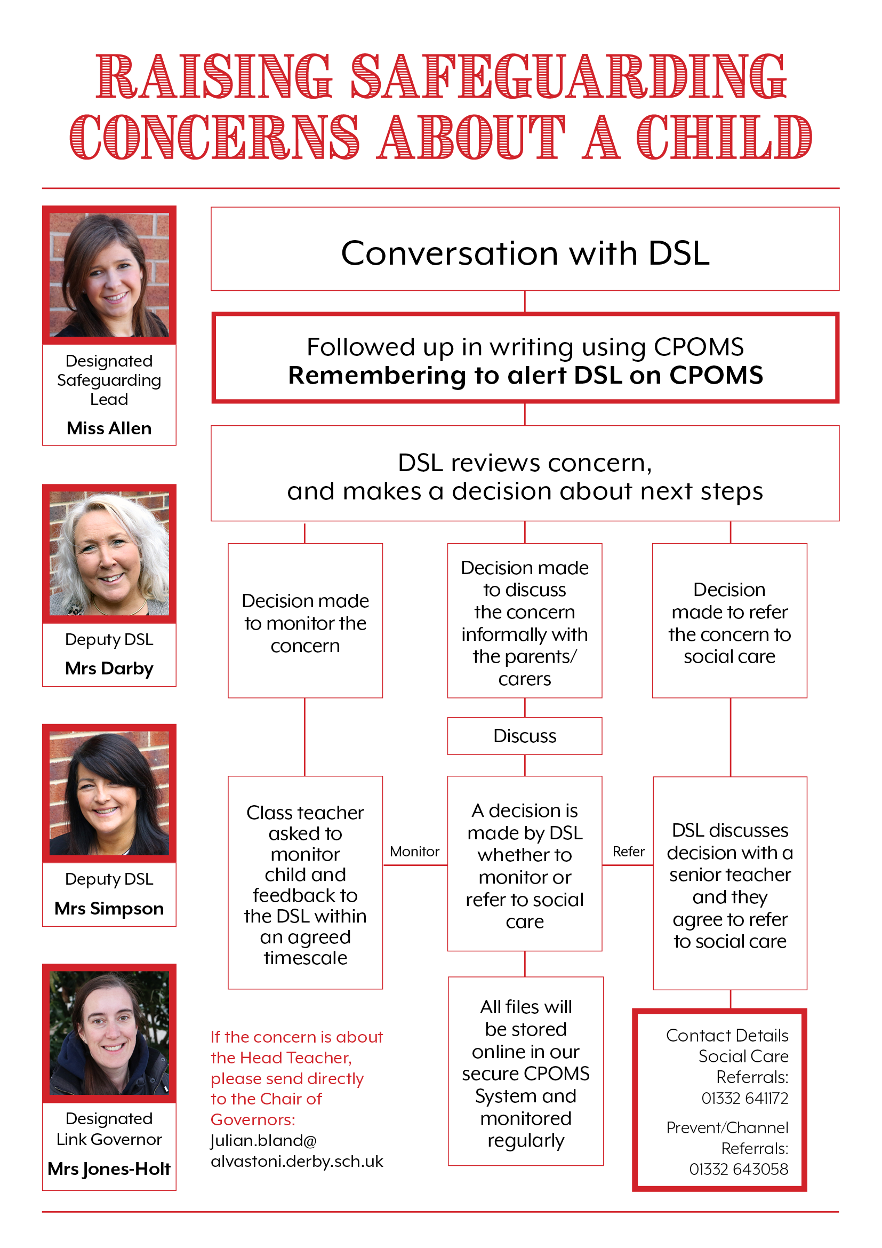

Appendix 3 - 7 golden rules for safeguarding

- Remember that the UK General Data Protection Regulation (UK GDPR), Data Protection Act 2018 and human rights law are not barriers to justified information sharing, but provide a framework to ensure that personal information about living individuals is shared appropriately.

- Be open and honest with the individual (and/or their family where appropriate) from the outset about why, what, how and with whom information will, or could be shared, and seek their agreement, unless it is unsafe or inappropriate to do so.

- Seek advice from other practitioners, or your information governance lead, if you are in any doubt about sharing the information concerned, without disclosing the identity of the individual where possible.

- Where possible, share information with consent, and where possible, respect the wishes of those who do not consent to having their information shared. Under the UK GDPR and Data Protection Act 2018 you may share information without consent if, in your judgement, there is a lawful basis to do so, such as where safety may be at risk. You will need to base your judgement on the facts of the case. When you are sharing or requesting personal information from someone, be clear of the basis upon which you are doing so. Where you do not have consent, be mindful that an individual might not expect information to be shared.

- Consider safety and well-being: base your information sharing decisions on considerations of the safety and well-being of the individual and others who may be affected by their actions.

- Necessary, proportionate, relevant, adequate, accurate, timely and secure: ensure that the information you share is necessary for the purpose for which you are sharing it, is shared only with those individuals who need to have it, is accurate and up-to-date, is shared in a timely fashion, and is shared securely (see principles).

- Keep a record of your decision and the reasons for it – whether it is to share information or not. If you decide to share, then record what you have shared, with whom and for what purpose.

Taken from Information Sharing: advice for practitioners providing safeguarding services to children, young people, parents and carers (2018) HM Government

Body Maps
Appendix 4

Medical assistance and first aid should be sought where this is required.

All concerns and actions must be recorded using the concerns form or other safeguarding recording systems in use within the setting.

Body Maps should be used to document and illustrate visible signs of harm and physical injuries. They must be completed at time of observation using a black pen; correction fluid or any other eraser should not be used.

Do not:
- Remove or lift clothing for the purpose of the examination unless the injury site is freely available because of treatment, or;
- Take photos of injuries. If photos of injuries are required for evidence purposes, then this should be done by the Police.
Do:
Record any visible injuries or ask the child/young person to point to where else it is sore/hurts

When you notice an injury to a child, try to record the following information in respect of each mark identified e.g. red areas, swelling, bruising, cuts, lacerations and wounds, scalds and burns:
- Exact site of injury on the body, e.g. upper outer arm/left cheek
- Size of injury - in appropriate centimetres or inches
- Approximate shape of injury, e.g. round/square or straight line
- Colour of injury - if more than one colour, say so
- Is the skin broken?
- Is there any swelling at the site of the injury, or elsewhere?
- Is there a scab/any blistering/any bleeding?
- Is the injury clean or is there grit/fluff etc.?
- Is mobility restricted as a result of the injury?
- Does the site of the injury feel hot?
- Does the child feel hot?
- Does the child feel pain?
- Has the child’s body shape changed/are they holding themselves differently?

Importantly the date and time of the recording must be stated as well as the name and designation of the person making the record. Add any further comments as required.

A copy of the body map should be kept on the child/young person’s safeguarding/child protection file.
Body Map

Name of Child: |  | Date of Birth:
Name of person completing the Body Map: |  | Role:
Date and time of observation:

Name of Child: |  | Date/time of observation:
FRONT |  | BACK
RIGHT |  | LEFT

Name of Child: |  | Date/time of observation:
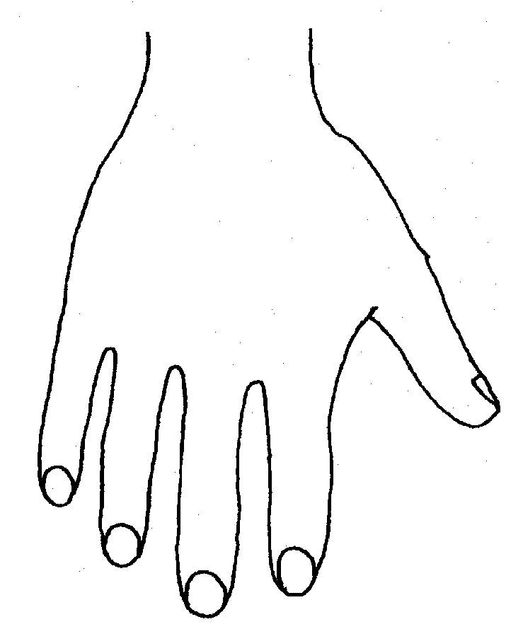 |  | 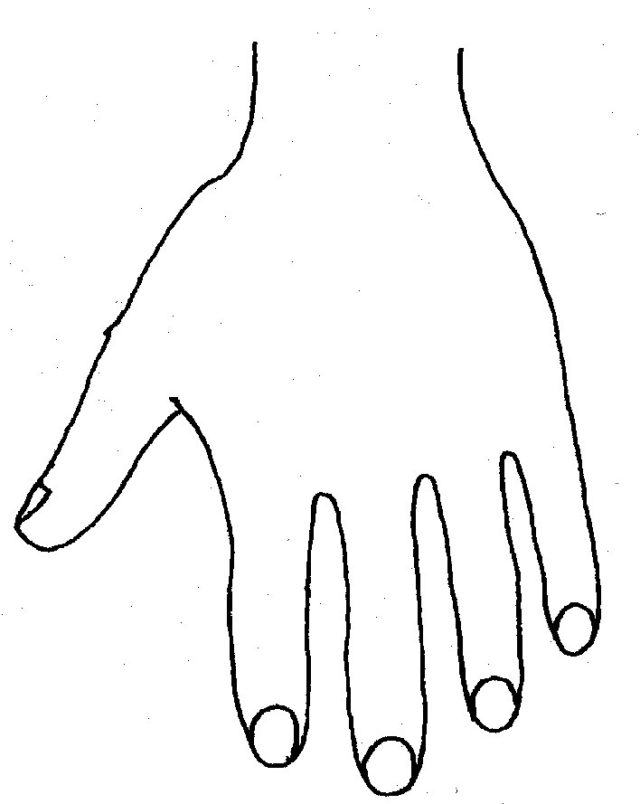
RIGHT |  | LEFT
BACK
RIGHT |  | LEFT
PALM

 | Name of Child: |  |  |  |  |  | Date/time of observation:
RIGHT |  | TOP |  |  | LEFT | RIGHT |  |  | BOTTOM |  |  | LEFT
RIGHT |  |  |  |  |  | LEFT
INNER
RIGHT |  |  |  |  |  | LEFT
OUTER
Printed name |  |  |  |  |  |  |  | Date:
Signature |  |  |  |  |  |  |  | Time:

Appendix 5 Guidance/Further Information

Local safeguarding information

Key local information about safeguarding children is located on Derby and Derbyshire Safeguarding Children Partnership website (www.ddscpscb.org.uk). This includes Derby and Derbyshire Safeguarding Children Partnership safeguarding children procedures. Key chapters’ include:
- Providing early help
- Making a referral to children’s social care
- Child protection section 47 enquiries
- Child protection conferences
- Children who present a risk of harm to others
- Children abused through sexual exploitation
- Safeguarding children at risk of abuse through female genital mutilation (FGM)
- Safeguarding children and young people against radicalisation and violent extremism
- Allegations against staff carers and volunteers
- Runaway or Missing from Home or Care Protocol

The procedures also have key guidance document and information, including:
- Derby and Derbyshire Thresholds document
- Derby and Derbyshire Dispute Resolution and Escalation policy
- DDSCP Information Sharing Guidance for Practitioners
- Derby Assessment Protocol
- Derby Child Protection Conference Professional Dissent Process
- Local contacts

The DDSCP website has a specific page for education providers, including a safeguarding children audit tool for schools and s to support schools their annual review of safeguarding practice and in their development of a safeguarding action plan. There is also a training pathway for education providers, template polices and information about the DDSCP Derby Education Hub and safeguarding update service.

There is a range of useful information and resources on the website, including:
- Private Fostering
- Domestic Abuse, including the domestic violence risk identification matrix (DVRIM)
- Early Help, including how to use the Early Help Assessment, forms and support
- Neglect, including graded care profile guidance and assessment tool template
- Child at Risk of Exploitation, including the Child at Risk of Exploitation (CRE) risk assessment toolkit
- Missing Children
- Online Abuse
- Safeguarding Training Courses and Events
- Safeguarding Forms and Assessments

Other sources of safeguarding information and guidance can be obtained via:
- www.gov.uk/schools-s-childrens-services/safeguarding-children
- www.nspcc.org.uk
- www.tes.com
- www.minded.org.uk
- www.uea.ac.uk/ican/

https://www.alvastoni.derby.sch.uk/policies

Appendix 6– Safer Recruitment Check List
Action Date | Completed (Y/N) | Date
Application fully completed
Internet Searches Complete – Name into search engine/Social Media Searches(Facebook, Instagram,Twitter)

Signed- Signed-
Headteacher SBM

Reference 1 requested
Reference 2 requested
Reference 1 received
Reference 2 received
References checked by Head

Signed –

Gaps in work history checked
Evidence of Qualifications obtained
Copies of identification documents taken
DBS initiated date:
DBS received
Entered on SCR
Complete HMRC New starter form
Complete DCC New starter form
Complete bank Details form
Send paperwork to Payroll via Egress
Complete Emergency Contacts Form
KCSIE Read
Staff code of Conduct Issued
Set up on Integris
Action | Completed (Y/N) | Date
ID Badge ordered
Set up on School Money
Self-declaration completed
Staff Induction attended
HR File set up
Recruitment Privacy Notice Issued
Email set up
Added to website

Appendix 7 – Prevent Plan
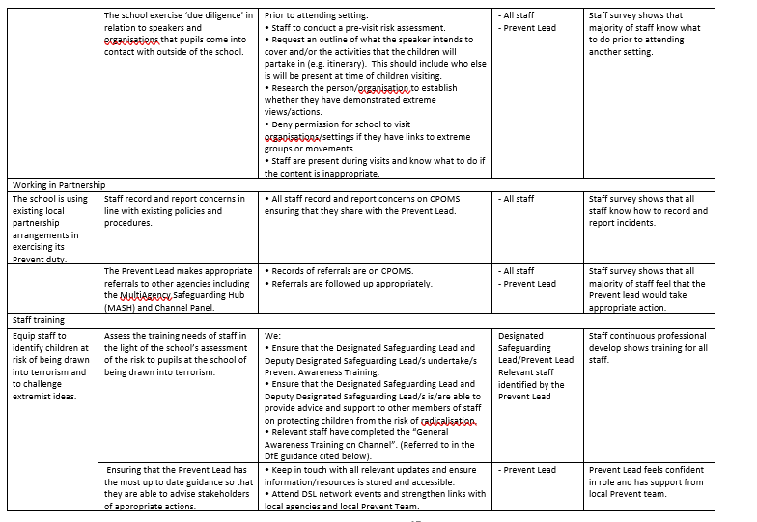
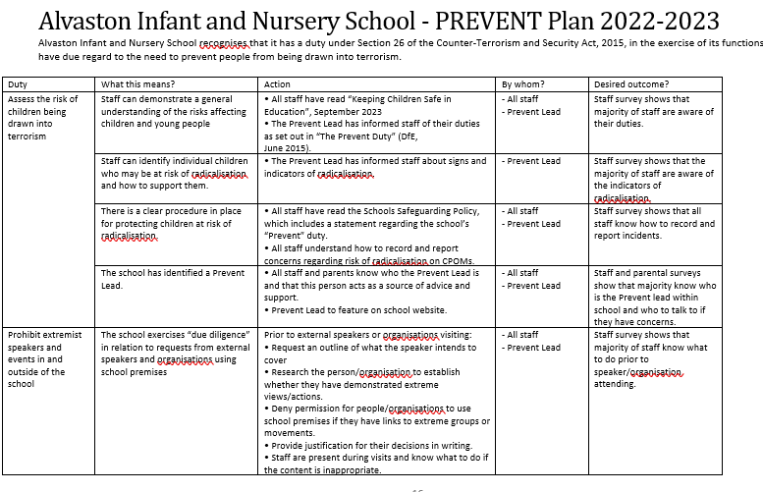

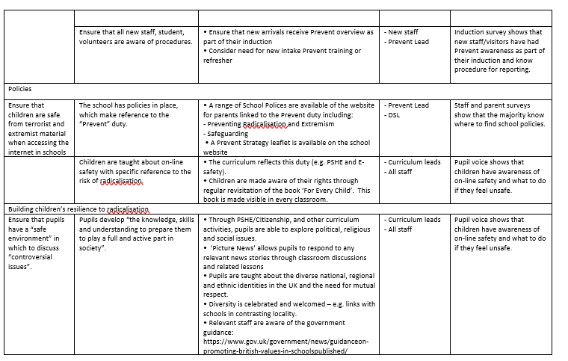

.
Leavers Checklist
Pupil Name
Class

Action Date | Completed (Y/N) | Date
Notification received
Destination School (Please include address and telephone number)

Proposed leaving date
Contact made with School – please give details of any telephone conversations

SEND Records
CP Records
Pupil file
Telephone call to check pupil has arrived at new school
This must be done on the day the child is expected to start
Recorded issues – If child has not started for any reason please refer to Head and contact parents to ascertain reason.
Please make daily contact until child arrives at destination school and record via CPOMS
CTF Sent
CML File actioned – see Guidance
Derby City Council SIP - Notification of removal from roll (Form 11)
Paper records sent – Post/Hand delivered (please delete at applicable)
Pupil removed from Integris
Pupil removed from Dojo
Pupil removed from School Money (please ensure there are no debts outstanding)
Signed authority received confirming safe receipt of pupil records (please attach)

Date Completed – Signed -

There is a specific legal duty on teachers to report acts of FGM on girls under 18 to the police
It is illegal to carry out, offer or aid and abet virginity testing or hymenoplasty in any part of the UK; see multi-agency guidance for more information
See DDSCP multi-agency training pathway on the training page of www.ddscp.org.uk
Prohibited items include knives and weapons, alcohol, illegal drugs, stolen items, tobacco, cigarette papers, fireworks pornographic images; any article that the member of staff reasonably suspects has been, or is likely to be used, to commit an offence, or to cause personal injury to, or damage to property of; any person (including the learner). (Amend as per school/ behaviour policy)
The Voyeurism (Offences) Act (2019) – upskirting is a criminal offence and anyone of any gender can be a victim

